CDIS Initial group set up process
Victorian Maternal and Child Health (MCH) Child Development Information System (CDIS)
December 2020

Contents
Creating a new group template –an overview 1
Creating a new group template 2
Editing an existing group template 3
Hiding inactive existing group templates 4

Creating a new group template –an overview
The initial group set-up (known in CDIS as ‘Creating a new group template’) is designed to be performed by specifically designated staff, such as MCH Coordinators or Team Leaders or Admin staff only.
It is important to note that once a group template has been created, it cannot be deleted.
Editing of group templates should also only be performed by specifically designated staff, such as MCH Coordinators, Team Leaders or Admin staff.
Hint: if your organisation has already created group templates by mistake or have templates that aren’t being used, it may beneficial to edit them by changing the ‘Council group name to ‘Do not use’, make them ‘inactive’ and ‘hide’ them from the group template list. This is to ensure that staff do not add a new group by setting dates to these templates or adding clients to these waitlists. See ‘Hiding inactive existing group templates’.
Group templates are the basic structure of a group.
Group templates comprise:
- group type
- council group name
- target age
- recommended group size
- number of sessions
- session topics planned
A waitlist is available for use for every group template.
Specific groups are formed by Add a group to that group template.
A client (child) can be:
- added directly to the relevant specific group
- added to a group template waitlist and then added to a specific group.
For example, if a Council has 2 MCH Centres:
- Collins St centre –three sites or offices have planned groups, so they book clients directly into specific groups
- Bourke St centre –one site or office places clients onto the group template waitlist. Once there are enough clients on the group template waitlist to warrant a group, a group is added to the group template and the clients are moved from the waitlist to that group.
This is illustrated in Figure 1.
Figure 1: Adding to a group and adding to a waitlist
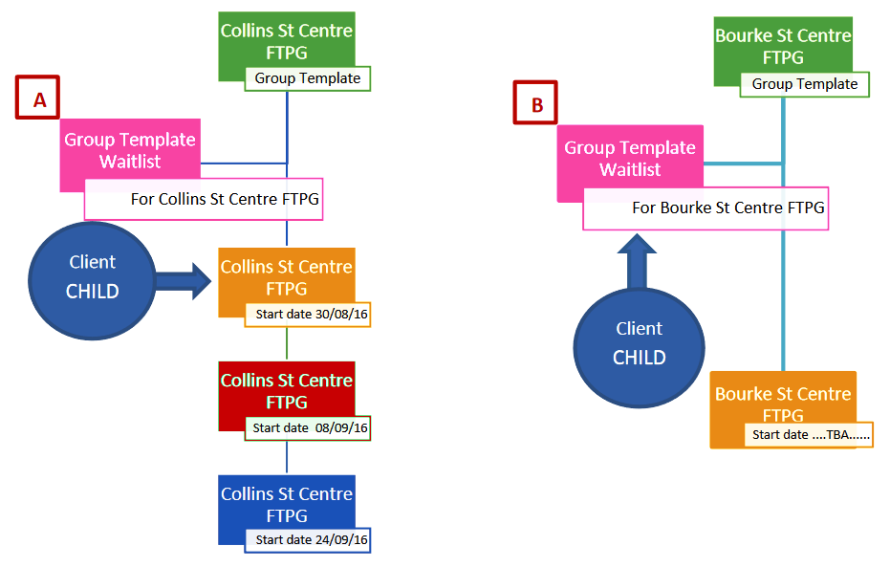

Creating a new group template
- Open the Home (Search) screen
- Select ‘Schedule’
- Select ‘Groups’
- Select ‘Group templates’
- Select the ‘Create new group’ button
- Enter data fields – mandatory fields are marked with a red asterisk (*)
- Group type: - Please note the inclusion of Enhanced MCH and sleep and settling group types.
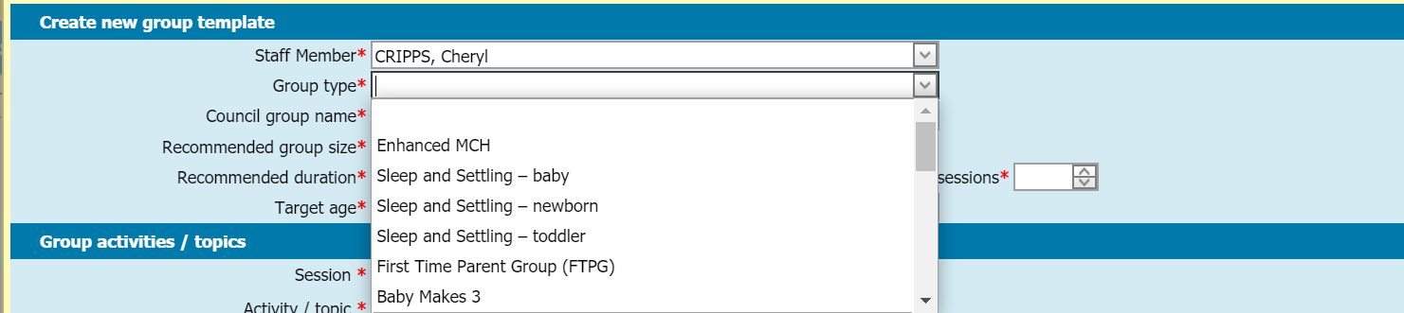
- Consider ‘Council group name’ (defaults to ‘group type’) – rename to easily identify group template
- It is recommended to put MCH Centre and Group type, such as Collins St – FTPG or Bourke St – Baby Makes 3
- Select Sessions and Activity/topic. Select ‘Add’ after each and repeat until completed
- This is for planning purposes only –a guide for that group template.
- Select ‘Save’.
Note: All details for a group template can be edited, but a group template cannot be deleted.
Figure 2: Select group templates
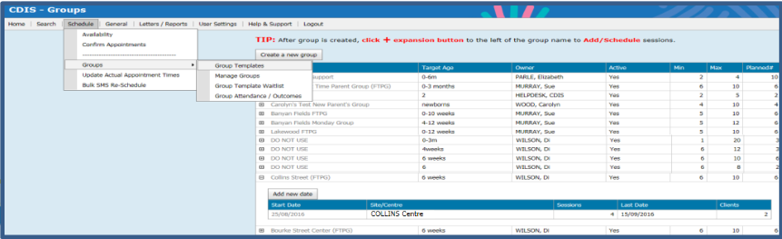

Editing an existing group template
- Open the home (search) screen
- Select ‘Schedule’
- Select ‘Groups’
- Select ‘Group templates’
- Select the greyed-out name of the relevant group template
- Select ‘Edit Group’ and edit data fields as required
- Consider ‘Council Group Name’ – uniform and easily identifiable across council
- It is recommended to put MCH Centre and Group Type, such as Collins St (FTPG) or Bourke St (Solids)
- Select ‘Save’.
Figure 3: Add new group (or edit group) window
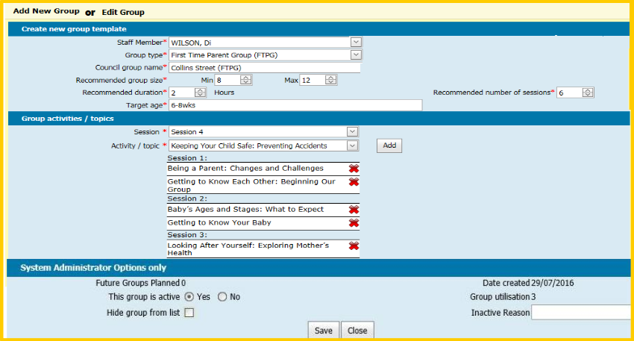

Hiding inactive existing group templates
It is recommended to edit existing group templates that were created by mistake or are not being currently used:
- Change the ‘Council group name’ to ‘Do no use’.
- Change to Inactive group.
- ‘Hide’ the template from the group templates list: This will ensure that staff do not add a new group by setting dates to these group templates or add clients to these group template waitlists.
- Follow the process for ‘Editing an existing group template’.
- Change name to ‘Do not use’ in the Council group name, if relevant.
- Go to ‘System Administrator Options only’ section.
- Select the ‘No’ radio button for ‘This group is active’.
- Select ‘Hide group from list’ checkbox.
- Enter ‘Inactive Reason’ in the free text field.
- Select ‘Save’.

To receive this publication in an accessible format phone 1300 650 172, using the National Relay Service 13 36 77 if required, or email Commissioning Performance and Improvement Aged and Community Based Health Care and Cancer Services <mch@dhhs.vic.gov.au>
Authorised and published by the Victorian Government, 1 Treasury Place, Melbourne.
© State of Victoria, Australia, Department of Health and Human Services June 2020.
ISBN 978-1-76096-024-7 (pdf/online/MS word)
Available at health.vic – Child Development Information System <https://www2.health.vic.gov.au/primary-and-community-health/maternal-child-health/child-development-information-system>

