CDIS Sleep and settling - outreach guide
Victorian Maternal and Child Health (MCH) Child Development Information System (CDIS)

To receive this publication in an accessible format phone 1300 650 172, using the National Relay Service 13 36 77 if required, or email Commissioning Performance and Improvement Aged and Community Based Health Care and Cancer Services <mch@dhhs.vic.gov.au>
Authorised and published by the Victorian Government, 1 Treasury Place, Melbourne.
© State of Victoria, Australia, Department of Health and Human Services December 2020.
Except where otherwise indicated, the images in this publication show models and illustrative settings only, and do not necessarily depict actual services, facilities or recipients of services. This publication may contain images of deceased Aboriginal and Torres Strait Islander peoples.
In this document, ‘Aboriginal’ refers to both Aboriginal and Torres Strait Islander people. ‘Indigenous’ or ‘Koori/Koorie’ is retained when part of the title of a report, program or quotation.
ISBN 978-1-76096-238-8 (pdf/online/MS word)
Available at health.vic – Child Development Information System <https://www2.health.vic.gov.au/primary-and-community-health/maternal-child-health/child-development-information-system>

Table of Contents
1 Overview 4
1.1 Integrated programs 4
1.2 Cases 4
1.3 Family enrolments, lead clients, and non-lead clients 4
2 Referring a family into the Sleep & Settling - Outreach Program 6
2.1 Referral into the Sleep & Settling - Outreach Program 6
2.2 Referral management (for managers/coordinators) 7
3 Managing a case 8
3.1 Case Summary Screen 8
3.2 Programs Active List 12
4 Delivering consultations as part of an active case 14
4.1 Creating a consultation 14
4.2 Selecting the Consultation Type 14
4.3 Family included as part of this enrolment 15
4.4 Strategies and Approaches 15
4.5 Weight and Growth 15
4.6 Nutrition 16
4.7 Sleep and Settling Program Plan 16
4.8 Assessments / Interventions 16
4.9 Counselling 17
4.10 Referrals from this assessment 17
4.11 Notes 18
4.12 Next Program Step 18
4.13 Delivering multiple consultation types at the same appointment 18
5 Delivering 'Client Not Present' actions as part of a case 20
6 Closing a case 21
6.1 Close a case via a Consultation screen 21
6.2 Close a case via the Edit Program screen 21
6.3 Reopen a case via the Edit Program screen 21
6.4 Access the Case Summary Screen of a closed case 22
7 Transferring active clients 22
8 Non-lead client redirections 23
9 Recording history / notes for Integrated Programs 24
9.1 Lead clients 24
9.2 Non-lead clients 25
10 Automatic enrolment (bypassing referral) 26

Overview

Integrated programs
CDIS has been enabled with a range of additional capabilities to support specific “Integrated” programs that are
delivered in accordance with a Model of Care
include plans and goals, which are then worked on over a series of consultations
may be delivered to multiple members of a family, including multiple clients during a single consultation.
The additional capabilities include:
the ability to link consultations and ‘Client Not Present’ records to cases
the ability to link multiple family members to the one case
the ability to select multiple family members as the clients of a single consultation
a Case Summary Screen to manage and update case management plans, including:
managing issues and goals
reviewing previous and upcoming consultations
As of December 2020, this functionality has been enabled for the following programs:
Enhanced MCH
Sleep & Settling - Outreach

Cases
A case is an instance of program service delivery that has a start date and, when closed, an end date. A case should commence and conclude with appropriate program entry and closure activities, as per the Sleep and settling model of care (2019). Whilst an Integrated Program is active (from start date to end date), consultations and ‘Client Not Present’ actions that are attributed to that program are included as part of that case.

Family enrolments, lead clients, and non-lead clients
Integrated Programs can have multiple family members enrolled in the same case, otherwise referred to as a ‘family enrolment’. Each case must have a lead client and can then optionally have any number of non-lead clients.
Lead clients must be a primary carer or carer of another client in CDIS.
Practically, this means that for most cases, the lead client will be a parent/carer.
Non-lead clients must have a relationship with the lead client in order to be added to the case in CDIS.
Clients can only lead one case of the Enhanced MCH or Sleep and Settling - Outreach program at any given time, however they can be enrolled as non-lead clients in multiple cases of the same program simultaneously.
Case A
Case B
Non-lead clients à
Lead clients à
Figure 1: The purple child in the middle of the picture lives across two households, and is simultaneously enrolled as a non-lead client in two cases of the same program - one in each household.

Referring a family into the Sleep & Settling - Outreach Program
This section describes the process for enrolling a family into the Sleep & Settling - Outreach Program via Internal Referral.
Note: At some service providers it may be permissible to directly enrol a family into the Sleep & Settling - Outreach Program, without referral. See 10 Automatic enrolment (bypassing referral), page 25 for more information.

Referral into the Sleep & Settling - Outreach Program
- Identify the related clients you wish to refer together into the Sleep & Settling - Outreach Program (this should be at least one child, and one parent/carer) and ensure they are related to each other.
- Access the client record of the client who will be the lead client (must be a parent/carer).
- Open the Internal Referral screen (Clinical Activity > Referrals > + Internal)
- Select Sleep & Settling - Outreach from the Program dropdown.
- The referral screen will now have an extra section, called “Family included as part of this enrolment”. This section will list the lead client, and then all related clients. Click the checkboxes next to the names of all related clients you wish to enrol in this program as part of this case.

Which family members should I add to a case?
You should enrol any family members (both adults and children) who are actively involved in the goals of the case and are usually present at case consultations. In most cases, this will include one or two parent/carers and any children under the age of three.
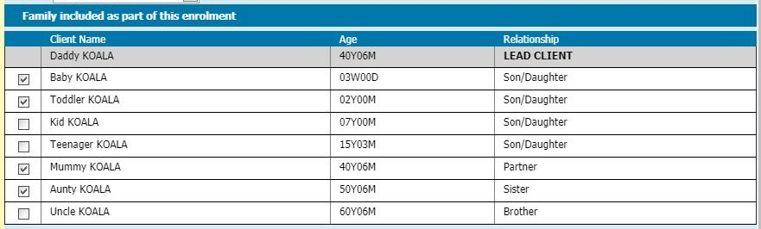
Figure 2: Which family members should I add to the case?
Daddy Koala is the primary caregiver and has already been selected as the lead client, so he is enrolled by default.
Baby Koala is experiencing issues that are the reason for this enrolment, so they will be enrolled.
Toddler Koala experiences related issues, so they will also be enrolled.
Mummy Koala is occasionally not present during consultations because she is working, but she will be actively participating in the behaviours necessary to meet the goals of the program, so she will be enrolled.
Aunty Koala lives with the family and will be actively participating in the behaviours necessary to meet the goals of the program, so she will be enrolled.

- Complete the rest of the Internal Referral screen and click Save.

Referral management (for managers/coordinators)
Access the Programs Active List and follow existing practice for accepting/assigning/declining referrals.
Note: there has been an update to the Actions available on the Programs Active List screen.
Action name | What records will be displayed in the search results | What the action does (for the records you select)
View | - All pending referrals  - All active cases, including:  Enrolments from a referral  Enrolments that bypassed referral | N/A. View only.
Accept Referral | - All pending referrals | - Enrol into program (Status becomes Active)
Accept and Assign Referral | - All pending referrals | - Enrol into program (Status becomes Active)  - Assign the selected clinician to the case
Decline Referral | - All pending referrals | - Update referral status to 'Declined'
Assign Clinician | - All active cases, including:  - Enrolments from a referral  - Enrolments that bypassed referral | - Assign the selected clinician to the case
Table 1: Actions on Programs Active List screen

Managing a case

Case Summary Screen

Summary
The Case Summary Screen shows the details of a Sleep & Settling - Outreach case and is a place to record the details of a Sleep and Settling Program Plan, replacing the need to keep a separate document outside of CDIS.

Accessing the Case Summary Screen
The Case Summary Screen can be accessed in the following ways:
From a client record: Access the client record of any client involved in the case.
- Go to Client Details > Summary Screen.
- Go to the Programs section, identify the relevant case, and click the View link on the right side of the screen.
From the Programs Active List: Access the Programs Active List
- Use the filters to search for and display the case (listed under the name of the lead client).
- Under the Program column on the right side of the screen, click the Sleep & Settling - Outreach link.
See Figure 11: Programs Active List, page 13.
From a Consultation Screen (Child Health Assessment):
- Open a new Consultation Screen (either scheduled or without booking) for a lead client who is already active in a Sleep & Settling - Outreach case.
- Select Sleep & Settling - Outreach as the Consultation Type.
- Click the View Case Summary link, which will have appeared near the top of the screen.

Layout of the Case Summary Screen
At the top of the Case Summary Screen it will say Sleep & Settling - Outreach and the case status; either Active or Closed.
See Figure 3: Case Summary Screen - details and status, page 9.
The Case Summary Screen includes the following sections:
Case
Conclusion (only visible once case has been closed)
Family included as part of this enrolment
Issues
Goals
Case Delivery
Scheduled appointments (upcoming Program appointments, made with lead client)
To exit the Case Summary Screen, click the “Close” button at the bottom to save all changes and return to your previous screen.

Case
This section shows case details such as the details of the lead client, the case start date, and (if the case was opened from a referral) referral details, including a link to view the Referral screen.
See Figure 3: Case Summary Screen - details and status, page 9.

Conclusion
This section appears to the right of the Case section, only if the case has been closed. It shows the end date and one of three program outcomes: Goals fully met / Goals partially met / Goals not met.
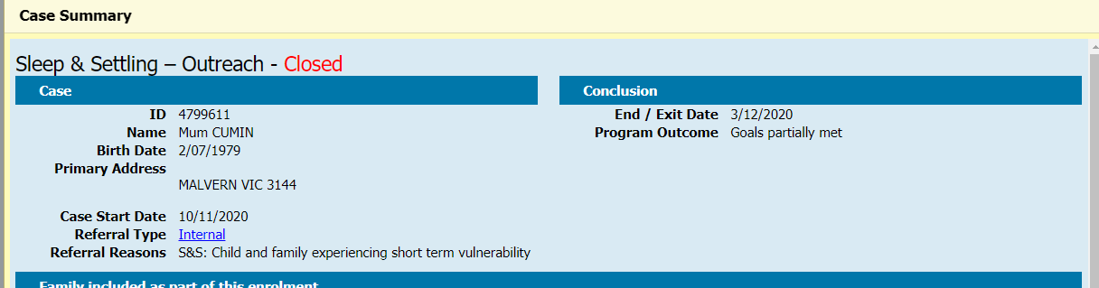
Figure 3: Case Summary Screen - details and status

Family included as part of this enrolment
This section lists the lead client, and then all related clients. Click or unclick the checkboxes next to the names of any related clients you wish to add or remove from this case.
See Figure 2: Which family members should I add to the case?, page 6.
When you close the Case Summary Screen, any case enrolment changes you have made will be actioned, with notes written to the affected client files.

Issues
This section lists categories of issues that indicate why the family has been enrolled in the program. The list is the same as the Referral Reasons that can be added to an Internal Referral, and initially will be pre-populated with any Referral Reasons that were provided in the Internal Referral.
Any issues from the list can be added or removed from the Case Summary screen at any time. The list should reflect the current understanding of the issues being addressed by the case, so if an issue that has previously been added is (upon review) not relevant to the case, it should be removed.
To add an Issue, select it from the Issues dropdown list and click the green plus symbol on the right. It will be listed as seen in the image below, if correctly added.
To remove an Issue, click the red cross on the right.
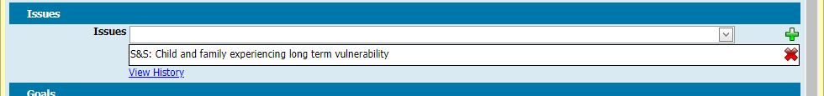
Figure 4: Case Summary – Issues section
To view a log of all additions and deletions from this list, click the History link below the Issues dropdown.
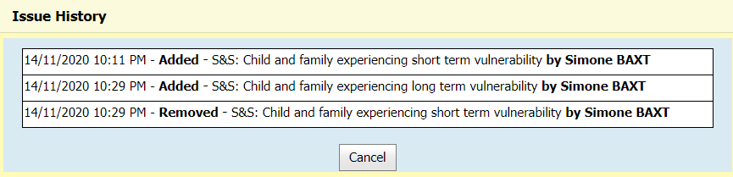
Figure 5: Case Summary - Issues section - History log

Goals
This section should record the goals that have been identified and agreed to as part of the Sleep and Settling Program Plan for this case.
To add a new goal, click the Add Goal button and a new Add/Edit Goal screen will popup.
To edit an existing goal, click the pencil icon on the right of the goal you wish to edit.
Once created, goals cannot be deleted, but all the fields within a goal can be edited.
To view a log of all changes to a goal, click the History link on the right of the goal.
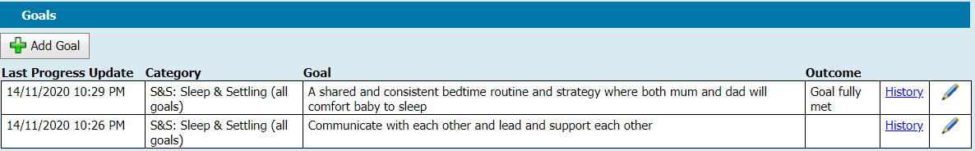
Figure 6: Case Summary - Goals section

Add/Edit Goal screen

Goal Creation fields
These fields would usually only be completed/edited when a goal is first created, although they can be edited at any time.
Category: This dropdown offers a list of high level categories for each Integrated Program. Sleep & Settling - Outreach has one single category at present “all goals”. This is the first in the list and is prefaced in the list with “S&S:”
This field is mandatory.
Description: This is where you should briefly describe the goal.
This field will appear on the Case Summary Screen so you can identify the goal.
This field is mandatory.
Nurse Actions: Add any actions that have been agreed the practitioner will undertake in pursuit of achieving this goal.
Actions added here would not usually change once agreed, although further actions could be added, and agreed actions can also be edited or removed.
Family actions: Add any actions that it has been agreed the family will undertake in pursuit of achieving this goal.
Actions added here would not usually change once agreed, although further actions could be added, and agreed actions can also be edited or removed

Goal Update fields
Progress: This free text field should contain nurse notes on the progress that is being made towards the goal.
After a goal has been created but before it is finalised, this field is the main field that nurses should be using to update the goal.
Once the Add/Edit Goal screen is saved, any note typed into this field will be saved with a date/time/user stamp at the top of the Progress section.
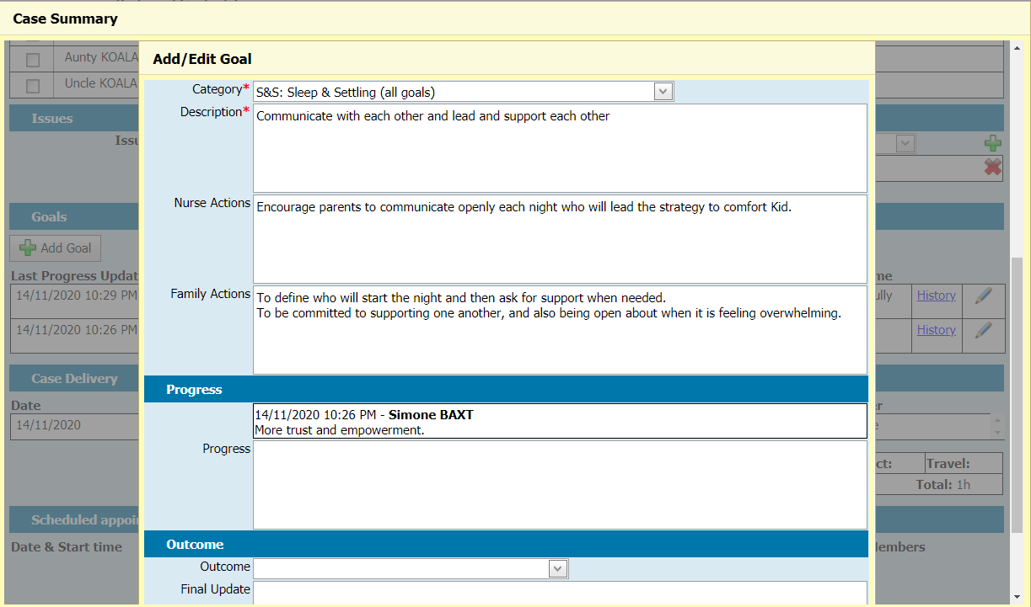
Figure 7: Case Summary - Add/Edit Goal - Creation and Update fields

Goal Closure fields
Goal closure fields should be left blank until the goal is to be closed.
Outcome: This dropdown list contains three options. Goal fully met / Goal partially met / Goal not met. Select the appropriate outcome when no further work will be undertaken on this goal.
Final update: Type your final update/summary here, when no further work will be undertaken on this goal.
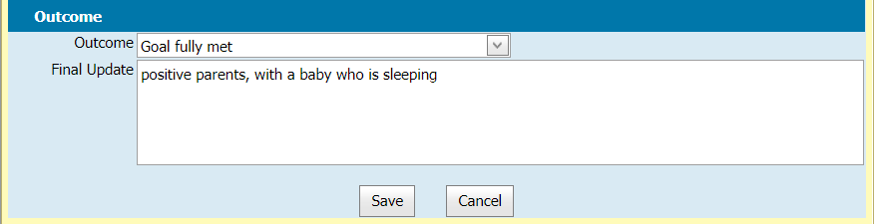
Figure 8: Case Summary - Add/Edit Goal - Closure fields

Case Delivery
This section lists all completed consultations and ‘Client Not Present’ actions that are associated with this case.
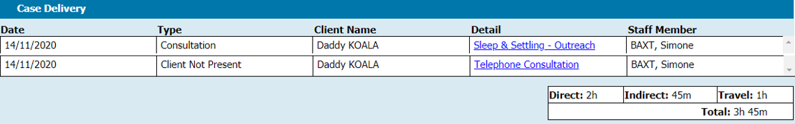
Figure 9: Case Summary - Case Delivery
To view the record of a completed consultation or ‘Client Not Present’ action, click the link in the Detail column.
This section also shows the accumulated time spent on the listed events, shown as Direct time, Indirect time, Travel time, and the total of all three.

Scheduled appointments (upcoming)
This section lists all upcoming appointments for all clients linked to the case. This is not limited to Sleep & Settling - Outreach consultations – all scheduled appointments (e.g. KAS consultations) will appear here.
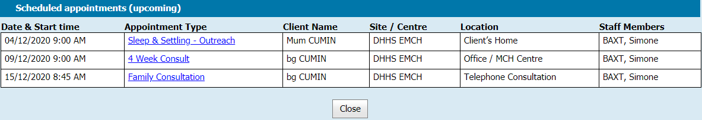
Figure 10: Case Summary - Scheduled appointments (upcoming)

Programs Active List
As well as using the Programs Active List to manage referrals into the Sleep & Settling - Outreach Program, it can also be used to manage and review all currently active cases in the program.
To view a list of all pending and active cases for a Program:
- Go to the Programs Active List (Home > General > Programs Active List)
- Filter the list by selecting:
Program (mandatory)
Site (optional)
Clinician (optional)
- Select Action: View and click Search. The screen will display all pending and active cases. This screen does not include closed cases.
The Programs Active List has some features that are specific to Integrated Programs:
Active and pending cases will only appear in the list once, even if there are multiple clients linked to the case. The “Name” column will display the name of the lead client, but not the names of any other clients linked to the case.
Column “Referral Type” will display “Internal” for cases that were accepted via referral, and “Bypassed” for cases that bypassed the referral process. Note: Bypassing the referral process must not be used unless endorsed by your MCH Service Provider.
Column “Delivered Hours” shows the actual delivered hours of a case, being the time taken in delivering all consultations and ‘Client Not Present’ actions linked to the case. Click the triangle below the Total value to see a breakdown of Direct time, Indirect time and Travel time.
Note: An earlier version of the Programs Active List included an “Hours” column that displayed scheduled hours according to the calendar. This column has been removed.
The Program name shown in the Program column is a link through to the Case Summary Screen for that case.

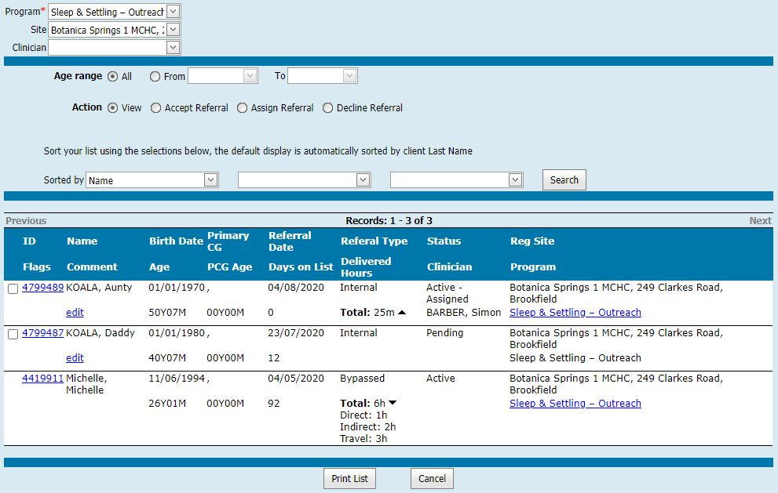
Figure 11: Programs Active List

Delivering consultations as part of an active case

Creating a consultation
Sleep & Settling - Outreach consultations must be created against the client record of the lead client in the Sleep & Settling - Outreach case. Once completed, the consultation record will be recorded in the clients records of all clients (lead and non-leads) enrolled in the case.
Note:
If you wish to record information that:
- relates only to a specific family member; AND
- is not related to the Issues and Goals of this case
then that information should be recorded in a different consultation.

Scheduling a consultation
- From the home screen, select a free time in the calendar for an appointment, and create a new client appointment.
- Search for and select the client record of the lead client for the active Sleep & Settling - Outreach Program, and then click Create client appointment.
- On the Schedule Appointment screen, in the Appointment type dropdown, select Sleep & Settling - Outreach.
Note: If you attempt to schedule a Sleep & Settling - Outreach consultation for a client who is not a parent/carer, you will be redirected to a screen offering alternative options. See 8 Non-lead client redirections, page 22.
- Complete the rest of the Schedule Client Appointment screen and click Save.

Creating a consultation without booking
- Access the client record of the lead client in the active Sleep & Settling - Outreach program.
- In the Clinical Activity dropdown, select Consultations, and then click the Consultation button to create a new consultation with no booking.

Selecting the Consultation Type
- Once you have opened a new consultation screen (Child Health Assessment), select Sleep & Settling - Outreach as the Consultation Type, from within the Assessment Details section.
- If the open client is a lead client in an active case in the Sleep & Settling - Outreach Program, a View Case Summary link will appear at the top of the screen. Click this to view and edit the Case Summary Screen for this case. (After closing the Case Summary Screen, you will return to the current screen.)
Note 1: If the open client record is a parent/carer, but is not currently a lead client in an active case in the Sleep & Settling - Outreach Program, then CDIS will not allow you to save this consultation without first enrolling the client in a new Sleep & Settling - Outreach Program case. In this circumstance, your choices would be:
Cancel the consultation screen and go through the Internal Referral process to create a new program enrolment. See 2.1 Referral into the Sleep & Settling - Outreach Program, page 6.
or
Complete the consultation, thereby creating an automatic enrolment, bypassing the referral process. See 10 Automatic enrolment (bypassing referral), page 25.
Note 2: If the open client is not a parent/carer, you will be redirected to a screen offering alternative options. See 8 Non-lead client redirections, page 22.

Family included as part of this enrolment
Once the Sleep & Settling - Outreach consultation type has been selected, this section will appear above the Assessment Details section. It lists the lead client, and then all related clients. Click or unclick the checkboxes next to the names of any related clients you wish to add or remove from this case.
See Figure 2: Which family members should I add to the case?, page 6.

Strategies and Approaches
Once the Sleep & Settling - Outreach consultation type has been selected, this section will appear below the Assessment Details section. It contains the strategies that can be undertaken as part of a Sleep & Settling - Outreach consultation, as per the Sleep & settling mode of care.
Figure 12: Strategies and Approaches- collapsed view
The choices are listed under “Sleep and Settling”; click the black triangle to expand the list and see the options.
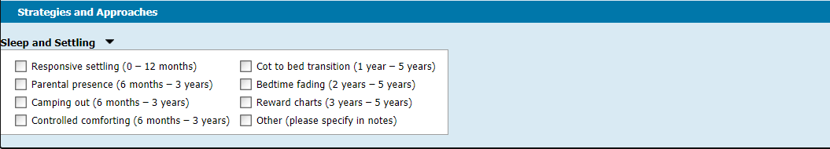
Figure 13: Strategies and Approaches - expanded view
It is mandatory to select at least one option from this list when completing a Sleep & Settling - Outreach consultation.

Weight and Growth
Any information entered in this section will apply to the lead client, and not one of the child clients. It cannot be used to add information to a child’s growth chart. This may be rectified in future system improvements.
If you need to add data to a child’s growth chart as part of this appointment, the recommended process is to open a second consultation in another browser tab/window, as per the instructions at 4.10 Delivering multiple consultation types at the same appointment, page 18.
If you are simultaneously delivering a KAS consultation for the child, enter the weight and growth information into that consultation.
Otherwise:
- In the new tab/window:
- Access the child’s client record and create a new consultation without booking
- Select ‘Additional Consult’ as the consultation type
- Select the most appropriate Reason (likely ‘Failure to Thrive/Faltering growth’)
- When completing the Time sections for both consultation screens, record all the time taken in the Enhanced MCH consultation, and record just 1 minute of Indirect time in the Additional Consult.

Nutrition
Any information entered in this section will apply to the lead client, and not one of the child clients. It cannot be used to add information to a child’s nutrition history. This may be rectified in future system improvements.
If you need to add data to a child’s nutrition history as part of this appointment, the recommended process is to open a second consultation in another browser tab/window, as per the instructions at 4.10 Delivering multiple consultation types at the same appointment, page 18.
If you are simultaneously delivering a KAS consultation for the child, enter the nutrition information into that consultation.
Otherwise:
- In the new tab/window:
- Access the child’s client record and create a new consultation without booking
- Select ‘Additional Consult’ as the consultation type
- Select the most appropriate Reason
- When completing the Time sections for both consultation screens, record all the time taken in the Enhanced MCH consultation, and record just 1 minute of Indirect time in the Additional Consult.

Sleep and Settling Program Plan
Once the Sleep & Settling - Outreach consultation type has been selected, this section will appear above the Assessments / Interventions section and requires users to indicate the type of action that is being undertaken at this consultation.
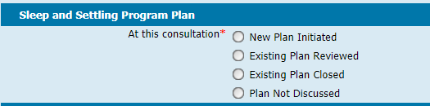
Figure 14: Sleep and Settling Program Plan section
New Plan Initiated should be selected at the first consultation of a new case. Nurses should ensure that as part of this consultation, they undertake the necessary plan commencement activities in line with program guidelines. Issues and Goals can be recorded on the Case Summary Screen for this case, and other notes can be recorded within this consultation.
Existing Plan Reviewed should be selected when a program plan is:
being formally reviewed, potentially amended or updated, and renewed, and
the case is expected to continue with further consultation(s).
Existing Plan Closed should be selected when the enrolment in the program will be closed with the completion of this consultation.
Plan Not Discussed should be selected when an existing plan is being carried out, but is not being initiated, closed, or actively reviewed and renewed.

Assessments / Interventions
When completing an Assessment Tool from within a Sleep & Settling - Outreach Consultation, the Assessment Tool will have an extra box at the top of the form. This box will list all clients linked to the case, and for each client, will allow the user to indicate how the Assessment Tool should be recorded against client records.
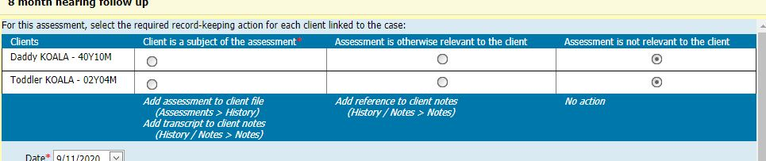
Figure 15: Client selector - Assessment Tools

Client is a subject of the assessment
Selecting this option will result in the Assessment Tool appearing in the client’s Assessment history (Assessments > History). A transcription of the assessment will also be added as a note in the client’s History / Notes (History / Notes > Notes).
Generally this option should only be used for the subject of the Assessment Tool. In most circumstances a child client is the subject.
It is mandatory that at least one client in the list has this option selected.

Assessment is otherwise relevant to the client
Selecting this option will only add a reference to the Assessment Tool as a note to the client’s History / Notes (History / Notes > Notes).
Generally this option should be used where it would be useful for a parent/carer’s record to have a reference showing that an Assessment has been undertaken, when the subject of the Assessment Tool is a dependant of the parent/carer.

Assessment is not relevant to the client
Selecting this option will result in the Assessment Tool not being recorded against the client’s record.
This is the default option for all clients in the list.
  - Counselling
Any counselling added in this section will be included in the consultation record, which will be recorded in the clients records of all clients (lead and non-leads) enrolled in the case.
When adding counselling in this section, specify the relevant family members in the Comments/Notes, so that it is clear which child(ren) or carer(s) the counselling applies to.
  - Referrals from this assessment
Any internal or external referrals created in this section will be referrals for the lead client. Referrals for child clients cannot be created from within this consultation. This may be rectified in future system improvements.
If you need to create a referral for a child as part of this appointment, you will need to access the client record for the relevant child, and then go to Clinical Activity > Referrals. You can do this by either:
- logging into CDIS in a second tab/window, whilst still delivering this consultation; or
- waiting until the consultation has been completed.
  - Notes
Remember when adding notes that this consultation will be added to the client records of all family members included in this case.
Take care when entering information in the notes to specify which client or clients the information pertains to.

Next Program Step
Once the Sleep & Settling - Outreach consultation type has been selected, this section will appear below the Time section at the bottom of the Consultation screen, and requires users to indicate if the case is continuing or ending.
Continue in program should be selected when the program enrolment / case is expected to continue with further consultations, or the user is otherwise not ready to close the case at this time.
Exit from program should be selected when the program enrolment / case will be closed with the completion of this consultation.
Note: selecting this option will result in:
The case being automatically closed, with an exit/end date matching the date of this consultation.
The case being removed from the Programs Active List
If Exit from program is selected, another dropdown box will appear, labelled Program Outcome, which requires users to select a Program Outcome:
Goals fully met
Goals partially met
Goals not met
Select the option that, in summary, best reflects the extent to which this program enrolment achieved or did not achieve the goals of the enrolment.
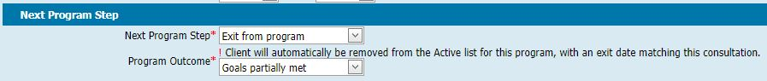
Figure 16: Next Program Step

Delivering multiple consultation types at the same appointment
Depending on the program guidelines for each program and the service delivery practise at each service provider, some appointments with clients may involve the delivery of more than one type of consultation. For example, KAS consultations may be delivered at the same time as delivering Sleep & Settling - Outreach consultations.
CDIS does not have the functionality to actively support the delivery of multiple consultation types at the same appointment. Regardless, it is important that client health records are recorded accurately against the appropriate consultation types, and that the Time recorded in each consultation record is accurate, and does not include time spent on other consultations.
The recommended process for recording multiple consultations:
- Schedule multiple consultations back-to-back in the calendar
- At the appointment, open the first consultation as per normal.
- Without closing or completing the first consultation, open another browser tab/window, log in to CDIS a second time, and open the second consultation.
- Switch back and forth between windows as required to record information for each consultation type as necessary.
- Save and close both consultations at the end of the appointment.
For impromptu extra consultation types, follow the following process:
- At the appointment, open the consultation as per normal.
- Without closing or completing the first consultation, open another browser tab/window, log in to CDIS a second time, access the client record for the relevant client, and create a second consultation without booking (Clinical Activity > Consultations > Consultation).
- Switch back and forth between windows as required to record information for each consultation type as necessary.
- Save and close both consultations at the end of the appointment.
Use your best judgement to allocate Direct, Indirect and Travel time accurately across multiple consultations. It is mandatory to populate either Direct or Indirect hours per consultation.
Example
Nurse Hermione attends a client family in their home and delivers a Sleep and Settling - Outreach Consultation and an 8 month KAS Consultation. It takes 10 minutes to drive to the appointment, 90 minutes to conduct both consultations, and 10 minutes to drive back. She saves both consultations as drafts, and later that day she reopens them, finishes her notes, fills out the Time sections, and saves and closes both consultations.
Direct time: During the appointment Nurse Hermione moved back and forth between topics relevant to the two consultation types, but she judges that around 60 minutes was spent on Sleep and Settling - Outreach matters, and 30 minutes on the KAS consultation.
Indirect time: She judges that she has spent about 10 minutes of her office time on Sleep and Settling - Outreach notes, and 5 minutes on KAS consultation notes.
Travel time: In this instance, the KAS consultation only occurred at the family home (instead of at a centre) because the Sleep and Settling - Outreach visit was already scheduled to occur at the family home. As such, none of the travel time is attributable to the KAS consultation, and so she allocates all 20 minutes of travel time to the Sleep and Settling - Outreach consultation.
Sleep and settling – outreach Consultation |  | 8 month KAS Consultation

 | Hours | Minutes |  |  | Hours | Minutes
Direct | 1 |  |  | Direct |  | 30
Indirect |  | 10 |  | Indirect |  | 5
Travel |  | 20 |  | Travel
Table 2: Consultation Time - multiple consultations

Delivering 'Client Not Present' actions as part of a case
Any time that you spend on a Sleep & Settling - Outreach case (outside of delivering a consultation) should be recorded in CDIS as a Client Not Present action.
- Go to the client record of the appropriate client, who is actively enrolled in a Sleep & Settling - Outreach case. They can be a lead client or non-lead client.
- Open a new Client Not Present screen (Clinical Activity -> Client Not Present)
- The Program dropdown lists all programs that the client is currently enrolled in. Select Sleep & Settling - Outreach.
- Complete all other fields as appropriate, then click save.
This Client Not Present record will now be linked to the client’s Sleep & Settling - Outreach case, and the time spent on this record (as recorded in the Time section) will contribute to the delivered hours for that case.

Closing a case
Sleep & Settling - Outreach cases should be closed in CDIS when the case ends, in accordance with program guidelines.
There are two ways to close a case; via a consultation screen or via the Edit Program screen.

Close a case via a Consultation screen
See 4.12 Next Program Step, page 18.

Close a case via the Edit Program screen
- Access the client record of any one of the clients (lead client or non-lead client) enrolled in the program you wish to end.
- Open the Programs screen (Clinical Activity > Programs)
- Click the Edit button for the relevant case.
- Select an End / Exit Date. This can be a date in the future or the past.
Note: any Sleep & Settling - Outreach Consultations and Client Not Present actions need to fall on or between the program Start and End dates to be included in the case.
- Once an end date is selected a dropdown box will appear, labelled Program Outcome, which requires users to select a Program Outcome:
- Goals fully met
- Goals partially met
- Goals not met
Select the option that, in summary, best reflects the extent to which this program enrolment / case achieved or did not achieve the goals of the case.
- Click Save.

Reopen a case via the Edit Program screen
Generally, once cases are closed, they should not be reopened.
There are two reasons why a case might be reopened:
- The case was mistakenly closed
- The lead client was temporarily transferred to another Service Provider (automatically closing the case), and then transferred back again.
How to reopen a case:
- Access the client record of any one of the clients (lead client or non-lead client) enrolled in the case you wish to reopen.
- Open the Programs screen (Clinical Activity > Programs)
- Click the Edit button for the relevant program.
- Select the arrow next to the End / Exit Date and the click the Clear button to remove the end date.
- Click Save. The case is open again and will appear on the Programs Active List.

Access the Case Summary Screen of a closed case
Case Summary Screens for closed cases can still be accessed (and updated) in the same manner as active cases.
See 3.1.1.1 Accessing the Case Summary Screen, page 8.

Transferring active clients
Programs and cases cannot be transferred between service providers.
When a client is transferred to a different provider, their involvement in any active Sleep & Settling - Outreach case will end:
- When a lead client in an active case is transferred, the case is closed for all clients, with the end date set to the current date.
- When a non-lead client in an active case is transferred, they are removed from the case but the case is not closed. A note is added to their file indicating their removal from the case.
Warning: if a client record is temporarily transferred to a different service provider before being transferred back again:
- For a lead client, the case will have closed and will need to be reopened. See 6.3 Reopen a case via the Edit Program screen, page 21.
- For a non-lead client, they will need to be re-added to the active case via the Case Summary Screen. See 3.1.1.1 Accessing the Case Summary Screen, page 8.

Non-lead client redirections
When in the record of a client who is not a parent/carer, you can attempt any of the following:
- Create a referral into the Sleep & Settling - Outreach Program
- Schedule a Sleep & Settling - Outreach consultation
- Create a Sleep & Settling - Outreach consultation (without booking)
- Directly add the client into the Sleep & Settling - Outreach Program
Because the client is a non-lead (not a carer), CDIS will block the above actions, but it will also offer you a range of shortcut alternative actions, dependent on who the client is related to.
These alternatives shortcuts may include:
- Creating a Sleep & Settling - Outreach referral with the child’s father as the lead client
- Scheduling a Sleep & Settling - Outreach consultation for an active Sleep & Settling - Outreach case that the child is already included in, led by the child’s guardian
- Opening the Case Summary Screen for an active Sleep & Settling - Outreach case that the child is not already included in (but can be added to), led by the child’s mother.
In the below example, a user tried to create a Sleep & Settling - Outreach consultation for Baby PLATYPUS and was redirected to this screen.
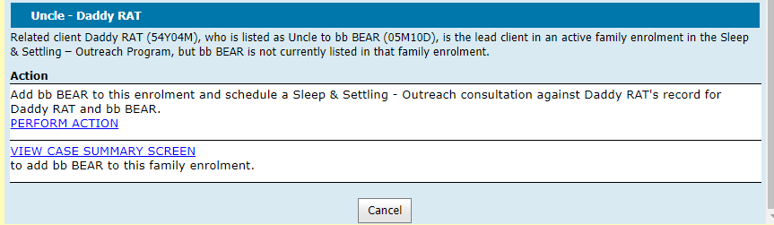
Figure 17: Alternative actions for clients not eligible to lead an Integrated Program enrolment
Note: Some of the actions offered on this screen may involve automatically creating a new Sleep & Settling - Outreach Program enrolment, bypassing the referral process. This may or may not be permitted practice at your Service Provider. See 10 Automatic enrolment (bypassing referral), page 26 for more information.
If there are no parent/carers related to the client, the redirection screen will provide no option other than to cancel and go back to the previous screen.
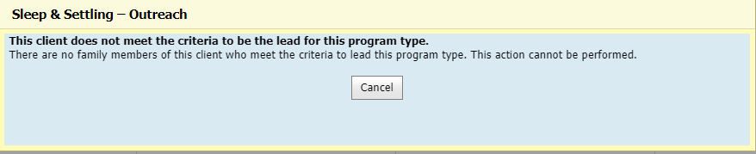
Figure 18: No alternative actions

Recording history / notes for Integrated Programs
To view a history of time stamped notes for consultations and entries documented in a client’s health record:
1. Access the client record of the client you wish to view the history of.
2. Open the Notes screen (History / Notes > Notes)

Lead clients

Notes as per other programs
In the following instances, lead clients of Integrated Programs get time stamped notes added to their history / notes in the same way as clients of other (non-Integrated) programs:
- when Internal Referrals are created / approved / denied
- when Programs are assigned / reassigned to clinicians
- when Consultations are saved
- when the lead client is transferred to a different provider and the case is automatically closed
At present, no time stamped notes are generated for clients / lead clients when:
- Programs are closed (by adding an end date), other than due to client transfer
- Programs are reopened (by removing the end date)
- Clients directly/automatically enrol in Programs (bypassing referral)

Notes specific to Integrated Programs
In the following instances, lead clients get Integrated-Program-specific time stamped notes added to their history / notes:
- when Goals on the Case Summary Screen are created / edited
- when an Assessment Tool is completed from with a program-related Consultation screen and the lead client is selected to receive a note. See 4.8 Assessments / Interventions, page 16.

Non-lead clients
Non-lead clients in Integrated Programs get time stamped notes added to their history / notes when:
- they are included as a non-lead client in the creation of an Internal Referral into an Integrated Program
- an Internal Referral they are already included in is approved or denied
- they are included as a non-lead client in an automatic enrolment (bypassing referral) into an Integrated Program
- an active case they are included in is assigned / reassigned to a clinician
- they are added to a pre-existing active case via the ‘Family included in the enrolment’ section located in:
  - The Case Summary Screen
  - A Consultation screen for a program-related case
  - The Edit Program screen
- they are removed from a pre-existing active case via the ‘Family included in the enrolment’ section located in:
  - The Case Summary Screen
  - A Consultation screen for a program-related case
  - The Edit Program screen
- when Consultations are saved
- when Goals on the Case Summary Screen are created / edited
- when an Assessment Tool is completed from with a program-related Consultation screen and the non-lead client is selected to receive a note. See 4.8 Assessments / Interventions, page 16.
At present, no time stamped notes are generated for non-lead clients when:
- Programs are closed (by adding an end date)
- Programs are reopened (by removing the end date)
Tip: Go to Client Details > Summary Screen and then look in the Programs section to see a list of Programs for a client, with start and end dates

Automatic enrolment (bypassing referral)
Depending on the service delivery practice at each service provider, it may be permissible to directly enrol a family into the Sleep & Settling - Outreach Program without submitting a referral for review by a manager/coordinator.
There are two ways to enrol a family into the Sleep & Settling - Outreach Program without first submitting a referral:
- Directly adding a family to the Sleep & Settling - Outreach Program (bypassing referral)
- Delivering a Sleep & Settling - Outreach consultation and creating a new case (bypassing referral)
These methods of enrolment are only to be used where permitted by established practice at each service provider. Managers and coordinators have the ability to distinguish between referred and bypassed enrolments.

Directly adding a family to the Sleep & Settling - Outreach Program (bypassing referral)
This will bypass the referral process and automatically create a new case.
- Access the client record of a client who is a parent/carer, who you wish to enrol as a lead client in the Sleep & Settling - Outreach Program.
- Open the Add Program screen (Clinical Activity > Programs > + Add Program)
- Select ‘Sleep & Settling - Outreach’ from the Program dropdown.
- The Add Program screen will now have an extra section, called “Family included as part of this enrolment”. This section will list the lead client, and then all related clients. Click the checkboxes next to the names of any related clients you wish to enrol in this program as part of this case.
- Select a Start Date for the Case.
- Click Save. A warning screen will popup, warning you that if you proceed, no referral will be recorded for this case.
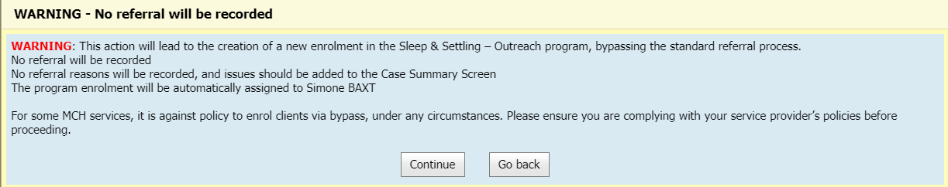
Figure 19: Referral bypass warning
  - If you click ‘Go back’ you will return to the previous screen.
  - If you click ‘Continue’ a Sleep & Settling - Outreach Program case will be created, and automatically assigned to the current user. Do not do this if it is against practice at your service provider.

Delivering a Sleep & Settling - Outreach consultation and creating a new case (bypassing referral)
This will bypass the referral process and automatically create a new case.
- Open a new consultation screen (Child Health Assessment) either from a scheduled appointment or without booking.
Note: CDIS will allow you to schedule a Sleep & Settling - Outreach consultation for a client who is a parent/carer, even if the client is not actively leading a Sleep & Settling - Outreach Program.
- On the new consultation screen (Child Health Assessment), select Sleep & Settling - Outreach as the Consultation Type, from within the Assessment Details section.
- Click the Enrol client into program link that will have appeared at the top of the screen. A warning screen will popup, warning you that if you proceed, no referral will be recorded for this case.
See Figure 19: Referral bypass warning, page 26.
  - If you click ‘Go back’ you will return to the previous screen.
  - If you click ‘Continue’ a Sleep & Settling - Outreach Program case will be created, and automatically assigned to the current user. You will be taken to the Case Summary Screen for this newly created case. Do not do this if it is against practice at your service provider.
- After you have finished editing the Case Summary Screen, click the ‘Close’ button at the bottom. You will then return to the consultation screen where you can continue to record consultation details.

