Community health pride
A toolkit to support LGBTIQ+ inclusive practice
in Victorian community health services

Aboriginal Acknowledgement
The Victorian Government acknowledges Victorian Aboriginal people as the First Peoples and Traditional Owners and Custodians of the land and water on which we rely. We acknowledge and respect that Aboriginal communities are steeped in traditions and customs built on a disciplined social and cultural order that has sustained 60,000 years of existence. We acknowledge the significant disruptions to social and cultural order and the ongoing hurt caused by colonisation.
We acknowledge the ongoing leadership role of Aboriginal communities in addressing and preventing family violence and will continue to work in collaboration with First Peoples to eliminate family violence from all communities.
Family Violence Support
If you have experienced violence or sexual assault and require immediate or ongoing assistance, contact 1800 RESPECT (1800 737 732) to talk to a counsellor from the National Sexual Assault and Domestic Violence hotline. For confidential support and information, contact Safe Steps’ 24/7 family violence response line on 1800 015 188. If you are concerned for your safety or that of someone else, please contact the police in your state or territory, or call 000 for emergency assistance.
To receive this publication in an accessible format, email Community Health <partnerships.primary@dhhs.vic.gov.au>
Authorised and published by the Victorian Government, 1 Treasury Place, Melbourne.
© State of Victoria, Department of Health, February 2021.
Where the term ‘Aboriginal’ is used it refers to both Aboriginal and Torres Strait Islander people. Indigenous is retained when it is part of the title of a report, program or quotation.
ISBN 978-1-76096-333-0 (pdf/online/MS word)
Available at health.vic - Community health <https://www2.health.vic.gov.au/primary-and-community-health/community-health/pride-lgbtiq-inclusive-practice-resources>
(2102906 images)

Acknowledgements
The suite of resources that this toolkit is a part of was developed in consultation with community health service providers, key experts in the LGBTIQ+ field, and staff from the Department of Health and Human Services.
The LGBTIQ+ pilot group comprised Albury Wodonga Health, Gippsland Lakes Community Health, and Your Community Health, which were the trial sites for pilot testing the resources.
The broader reference group comprised Cobaw Community Health Services, Merri Health, Your Community Health, Albury Wodonga Health, West Gippsland Healthcare Group, Monash Health, cohealth, DVP Health (formerly Dianella Community Health), Gippsland Lakes Community Health and representatives of the LGBTI Taskforce Health and Human Services Working Group.
The Department of Health and Human Services also thanks the LGBTI Taskforce Health and Human Services Working Group, and all others who generously volunteered their time and effort to plan and develop this toolkit and the broader suite of resources.

Contents
Acknowledgements 3
Introduction 7
Using the toolkit 7
1. Understand the change 10
Discrimination and health 10
Acknowledging diversity within diversity 10
About inclusive practice 13
2. Engage for change 14
Engage senior leaders 14
Find local LGBTIQ+ networks and develop partnerships 14
Establish a community advisory group 16
3. Assess your current practice 17
Self-assessment tool 17
Client survey tool 23
Staff survey on LGBTIQ+inclusive practice 25
Review policies 26
Review intake and assessment procedures 27
Develop referral pathways 28
4. Start the change 29
Consult with LGBTIQ+ communities 29
Codesign your service 32
Develop inclusive service standards 33
Document and manage risks 34
Ensure inclusive practice is part of your quality cycle 39
Consider Rainbow Tick accreditation 40
Support your workforce to provide inclusive services 41
Promote and communicate your work 42
Value LGBTIQ+ staff 43
Establish an inclusion portfolio 44
5. Create cultural safety 45
Promote cultural safety 47
Promote your service to the LGBTIQ+ community 48
Ensure intake and assessment is inclusive 48
Ensure person-centred disclosure and documentation policies 50
Create a safe environment 52
Use inclusive language 53
6. Evaluate your success 54
Resources 55
Key state and national LGBTIQ+ resources 55
Training providers, videos and online learning resources 56
Guidelines, fact sheets and frameworks 57
Appendix 1: Language and definitions 59
Appendix 2: Sample privacy policy 61
Northside Clinic: Our privacy policy 61
Appendix 3: Text-equivalent descriptions of graphics used in this document 64
Figure 1: The Rainbow Tick accreditation logo 64
Figure 2: Face the facts: lesbian, gay, bisexual, trans and gender diverse, and intersex people 64
Figure 3: Potential outcomes of professional networks and partnerships 64
Figure 4: LGBTIQ+ communities can support your inclusive practice 65
Figure 5: Gippsland Lakes Community Health quality cycle 65
Figure 6: Four-tiered approach to workforce development 65
Figure 7: Promoting cultural safety 65
Figure 8: Practising cultural safety 66
Figure 9: An example of client registration form for medical clinics from Gateway Health 66

Introduction
The Victorian Government values and celebrates diversity. We are committed to removing discrimination from Victorian laws, services and society.
We affirm the right to equality, fairness and decency for lesbian, gay, bisexual, trans and gender diverse, intersex, and queer (LGBTIQ+) Victorians, and we use the term LGBTIQ+ to denote all people living with diversity in sexual orientation, gender identity and intersex variations.
Inclusive practice recognises this diversity. It ensures that services are delivered in ways that are non-discriminatory and welcoming to LGBTIQ+ people. This is important because LGBTIQ+ people often experience poorer health and wellbeing outcomes than other Victorians, largely as a result of the discrimination they experience in their everyday lives.
Discrimination is not just wrong, it is against the law. In Victoria, you must not discriminate against someone because of their sex, sexual orientation, gender identity or lawful sexual activity. The Equal Opportunity Act also has a 'positive duty' to make sure organisations prevent discrimination happening in the first place, rather than responding after a complaint has been made.
In addition, the Victorian Charter of Human Rights and Responsibilities says that services funded by state and local governments, including hospitals and health services, must act in ways that are compatible with human rights, and must take relevant human rights into account when they make decisions.
For these reasons, health and community services need to acknowledge and respond to diversity in sexual orientation, gender identity and intersex variations – especially if people with these characteristics face barriers to accessing services.
Victoria’s community health services are well placed to be inclusive service providers, and to improve the health and wellbeing of LGBTIQ+ Victorians. Many are already well advanced in developing and implementing LGBTIQ+-inclusive practice models in the programs and services they deliver.
For those that would like to do more work in this area, this toolkit is designed to help you make your services more inclusive for LGBTIQ+ people.

Using the toolkit
This toolkit leads you through some of the steps you can take to ensure your community health service is inclusive.
It provides a set of tools to help you put in place the policies, processes, systems and standards you need to build an inclusive practice model.
This work is part of a suite of resources to help community health services provide LGBTIQ+-inclusive services.
The suite includes the following items:
- a client flyer available for double-sided printing, which you can provide for users of your service
- posters available for printing or displaying on screens in waiting areas as PDFs and Word templates that you can add your logo to.
Visit the Department of Health and Human Services website <https://www2.health.vic.gov.au/primary-and-community-health/community-health> for more information, and to download the resources.
The toolkit is intended as a prompt to get you started. It is a guide only, and you should feel free to adapt it to your local needs, in consultation with LGBTIQ+ clients, carers, communities and local LGBTIQ+ advisory bodies.
Broadly, it invites you to reflect on:
- the barriers LGBTIQ+ clients might face when accessing your services
- the work you have done so far towards inclusive practice
- adopting a systematic approach to LGBTIQ+ inclusion for your service.
The toolkit also provides a list of resources you can use in your own work towards greater inclusion for LGBTIQ+ people at your community health service.
The actions in the toolkit have been structured logically, but you do not have to do them in order. In fact, many of them can and should be done in parallel. For example, ‘Consult with LGBTIQ+ communities’ on
p. 29, could be your first action, to create a community advisory group.
You can use this document to complete the actions, or you can copy and paste actions, such as the self-assessment tool on p. 17, into a new Word document that you adapt for your own purposes.

Rainbow Tick accreditation
Rainbow Tick accreditation shows that your organisation meets recognised standards for LGBTIQ+-inclusive practice in Australia. It lets your LGBTIQ+ consumers, staff and community know they will receive inclusive services from the moment they step through the door.
Rainbow Tick accreditation is based on six Rainbow Tick standards <http://www.qip.com.au/standards/rainbow-tick-standards>.
These six standards are:
- organisational capability
- workforce development
- consumer participation
- a welcoming and accessible organisation
- disclosure and documentation
- culturally safe and acceptable services.
This toolkit is based on these standards, and the activities here can help you get started on the pathway to Rainbow Tick accreditation if this is something your organisation decides to pursue.
We acknowledge our use of and reference to:
- The Rainbow Tick guide to LGBTI-inclusive practice (GLHV 2016) and GLBTI inclusive practice: working with rural communities (GLHV 2012), <https://www.rainbowhealthvic.org.au/research-resources>. Note that GLHV is now known as Rainbow Health Victoria.
- Creating GLBTI-inclusive home and community care services (Val’s Café 2014) <http://www.mav.asn.au/__data/assets/pdf_file/0012/7131/Creating-GLBTI-Inclusive-HACC.pdf>.
Figure 1: The Rainbow Tick logo
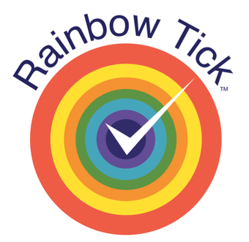

1. Understand the change
Inclusive practice takes into account the broader social determinants that affect people’s health and wellbeing. A key determinant for LGBTIQ+ health is systemic discrimination.

Discrimination and health
In Victoria, it is against the law for someone to discriminate against you because of your sex, sexual orientation, gender identity or lawful sexual activity. See the Victorian Equal Opportunity and Human Rights Commission <http://www.humanrightscommission.vic.gov.au> for more information about legal rights and obligations.
The Australian Human Rights Commission <http://www.humanrights.gov.au/education/face-facts/face-facts-lesbian-gay-bisexual-trans-and-intersex-people> also has information about discrimination against LGBTIQ+ people.
Discrimination – whether on the basis of sexuality, sexual orientation, gender or sex diversity, or other factors such as race, religion or ability – is widely recognised as a stressor that has broad effects on physical and mental health.
Discrimination affects physical health through changes in stress physiology, which influence immune, reproductive and cardiovascular health. The experience of discrimination can adversely affect everything from the body’s ability to fight infection to the ability to become pregnant. It has been specifically linked to breast cancer, obesity and high blood pressure.
Some LGBTIQ+ people, especially older LGBTIQ+ people, have experienced a lifetime of stigma, discrimination or invisibility. This has significant impacts, not only on individuals’ health, but also the way they interact with services and providers. The historical treatment of LGBTIQ+ people has caused a lot of mistrust and fear, which can be difficult to undo.
Discrimination and stigma can come in many forms.
While outright discrimination has been greatly reduced, more subtle and chronic forms are still very real for LGBTIQ+ people. Subtle biases may actually be more mentally damaging because they are experienced as chronic low-level stress – embedded in day-to-day life. For example, LGBTIQ+ people are often faced with the perception that only heterosexuality is normal.
These experiences can prevent people from talking openly about their sexual orientation, their gender diversity or their significant others. These perceived biases can lead to lower self-esteem and lower levels of life satisfaction.

Acknowledging diversity within diversity
LGBTIQ+ communities are not homogenous, and services must ultimately respond to the unique needs of individuals.
This includes acknowledging a broad range of personal differences such as gender identity, sexual orientation, religion, ethnicity, age, colour, nationality, language and communication requirements or disability. It also includes contextual differences such as socioeconomic status, geographic location, residency status and Medicare eligibility.
Many of these characteristics are common to a number of cohorts and communities, but they may affect individuals in different ways.
It is also important to recognise that if health and human services do not respond to diverse communities, the result is overlapping forms of discrimination, vulnerability and disadvantage. This is called, ‘intersectionality’, and it can further exacerbate barriers to engagement with services, leading to even poorer health and wellbeing outcomes.
Intersectionality recognises that individual characteristics that inform our social identity do not exist independently of each other. In certain population groups or people with specific characteristics this intersection creates complex forms of oppression as a result of systems and structures that devalue them.
Intersectionality recognises that people can belong to more than one diverse group. By actively practising inclusion –which means recognising the impact of marginalisation, valuing diversity and working to eliminate barriers, community health services can help to mitigate the adverse effects of multiple types of overlapping discrimination.
The Department of Health and Human Services’ Rainbow eQuality guide <https://www2.health.vic.gov.au/rainbowequality> provides information on working with diversity within LGBTIQ+ communities.
It addresses the needs of LGBTIQ+ people who are also:
- Aboriginal people
- people from culturally and linguistically diverse backgrounds
- children and young people
- older people
- families
- people with disabilities
- refugees and asylum seekers.
The department’s Designing for diversity framework can also help you embed responsiveness to diversity at the outset of any policy reform or service design process.
It provides an approach and suite of resources to address diversity, and identify gaps in the design process where diversity may not be adequately addressed.
See the Designing for diversity website <https://www2.health.vic.gov.au/about/populations/designing-for-diversity> for more information.

Figure 2: A snapshot of Australian Human Rights Commission’s Face the facts: lesbian, gay, bisexual, trans and gender diverse, and intersex people
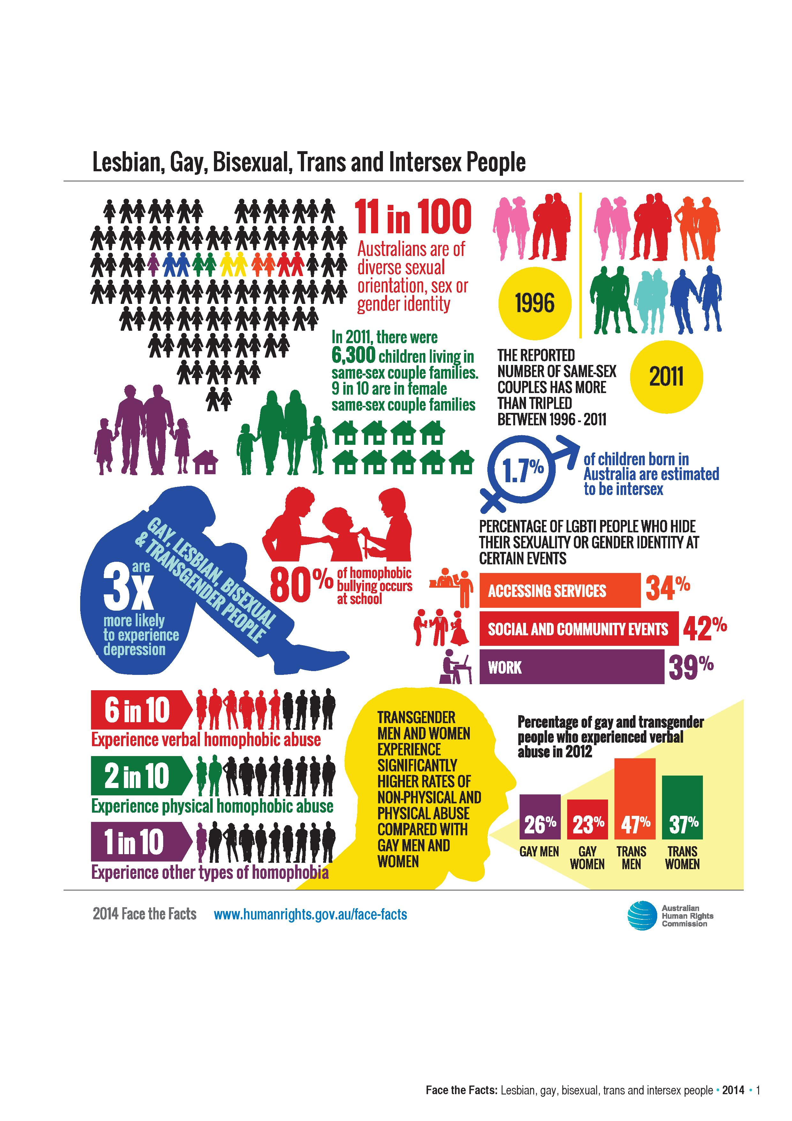
In addition to the statistics outlined at Figure 2, other key facts in relation to the Bisexual community include:
- Due to stigma and discrimination, bisexual people are less likely to be out to friends, family, colleagues and medical professionals.
- Within LGBT communities, trans and gender diverse and bisexual women face alarming rates of sexual and intimate partner violence².
Additional LGBTIQ+ statistics can be found in the Victorian Agency for Health Information report Findings from the Victorian Population Health Survey 2017: The health and wellbeing of the lesbian, gay, bisexual, transgender, intersex and queer population in Victoria. <https://www.bettersafercare.vic.gov.au/sites/default/files/2020-09/The-health-and-wellbeing-of-the-LGBTIQ-population-in-Victoria.pdf>

About inclusive practice
Inclusive practice means improving the experiences of LGBTIQ+ people who access your services so that they feel welcomed and affirmed. It does not mean anyone has to change their individual beliefs or personal values.
Any person using a community health service in Victoria might be LGBTIQ+, so all service providers should consider how they can be more welcoming and inclusive to LGBTIQ+ people. Most LGBTIQ+ people can have their needs met by mainstream services, and LGBTIQ+-inclusive practice should be part of mainstream service delivery.
While health services strive to treat all people with dignity and respect, it is important not to treat everyone as heterosexual or make assumptions about gender.
As part of designing and delivering inclusive services, you should reflect on your policies, procedures and practice – and the assumptions that are built into them – to consider how they might create barriers for LGBTIQ+ people.

Benefits of inclusive practice
Benefits to LGBTIQ+ people include: | Benefits for your health service include:
- increased feelings of cultural safety  - feeling valued and welcomed  - increased access to services and support  - reduced fear and anxiety to disclose information  - more holistic person-centred support  - opportunity to contribute to service improvement  - reduced social isolation. | - strengthened holistic, person-centred services  - improved wellbeing of LGBTIQ+ staff  - increased understanding of the effects of systemic discrimination on health  - increased service accessibility to LGBTIQ+ clients  - more equitable service planning  - increased reputation in LGBTIQ+ communities and networks  - working towards quality accreditation  - local community leadership  - new pathways and partnerships  - working towards eligibility for Rainbow Tick accreditation  - leveraging LGBTIQ+ funding opportunities.

Action 1.1: Inclusive practice
- Discuss the reasons why inclusive practice might be important for your community health service.

2. Engage for change
The first step towards building more inclusive services is engaging within your service, and also within your sector and communities.
Working with senior leaders within your organisation, and linking your service with local networks, will strengthen professional development, client care pathways and continuous quality improvement.

Engage senior leaders
Health service boards are leaders and advocates for the health of communities, and this includes the impact of discrimination and marginalisation on health and wellbeing.
The boards of community health services are in a strong position to support the development of LGBTIQ+ inclusive practice, policy and procedure.
As leaders in articulating a vision for high-quality, inclusive and safe care, boards:
- translate this vision into clear objectives for safety and quality at all levels of the organisation, and establish measures to assess progress
- provide a supportive and positive working environment for the workforce
- ensure that staff throughout the organisation are engaged in supporting this vision
- drive a culture that is transparent about performance, open to learning and continuously improving.
Action 2.1: Engage senior leaders
- Board members undertake inclusive practice leadership training – see ‘Support your workforce to provide inclusive services’ on p. 41, and the ‘Resources’ section on p. 55 for a list of providers.
- Board members endorse a diversity statement that is communicated across the organisation – see ‘Promote and communicate your work’ on p. 42.
- Board members understand their responsibility to promote inclusive practice as a condition of receiving government funding.

Find local LGBTIQ+ networks and develop partnerships
The LGBTIQ+ health and wellbeing practice landscape is always evolving and it is important to stay up to date, and to develop consistent and coordinated local approaches to support your LGBTIQ+ clients.
This step is relevant to every stage of the process, and should be considered from the very beginning of your inclusive practice project.

Figure 3: Potential outcomes of developing professional networks and partnerships
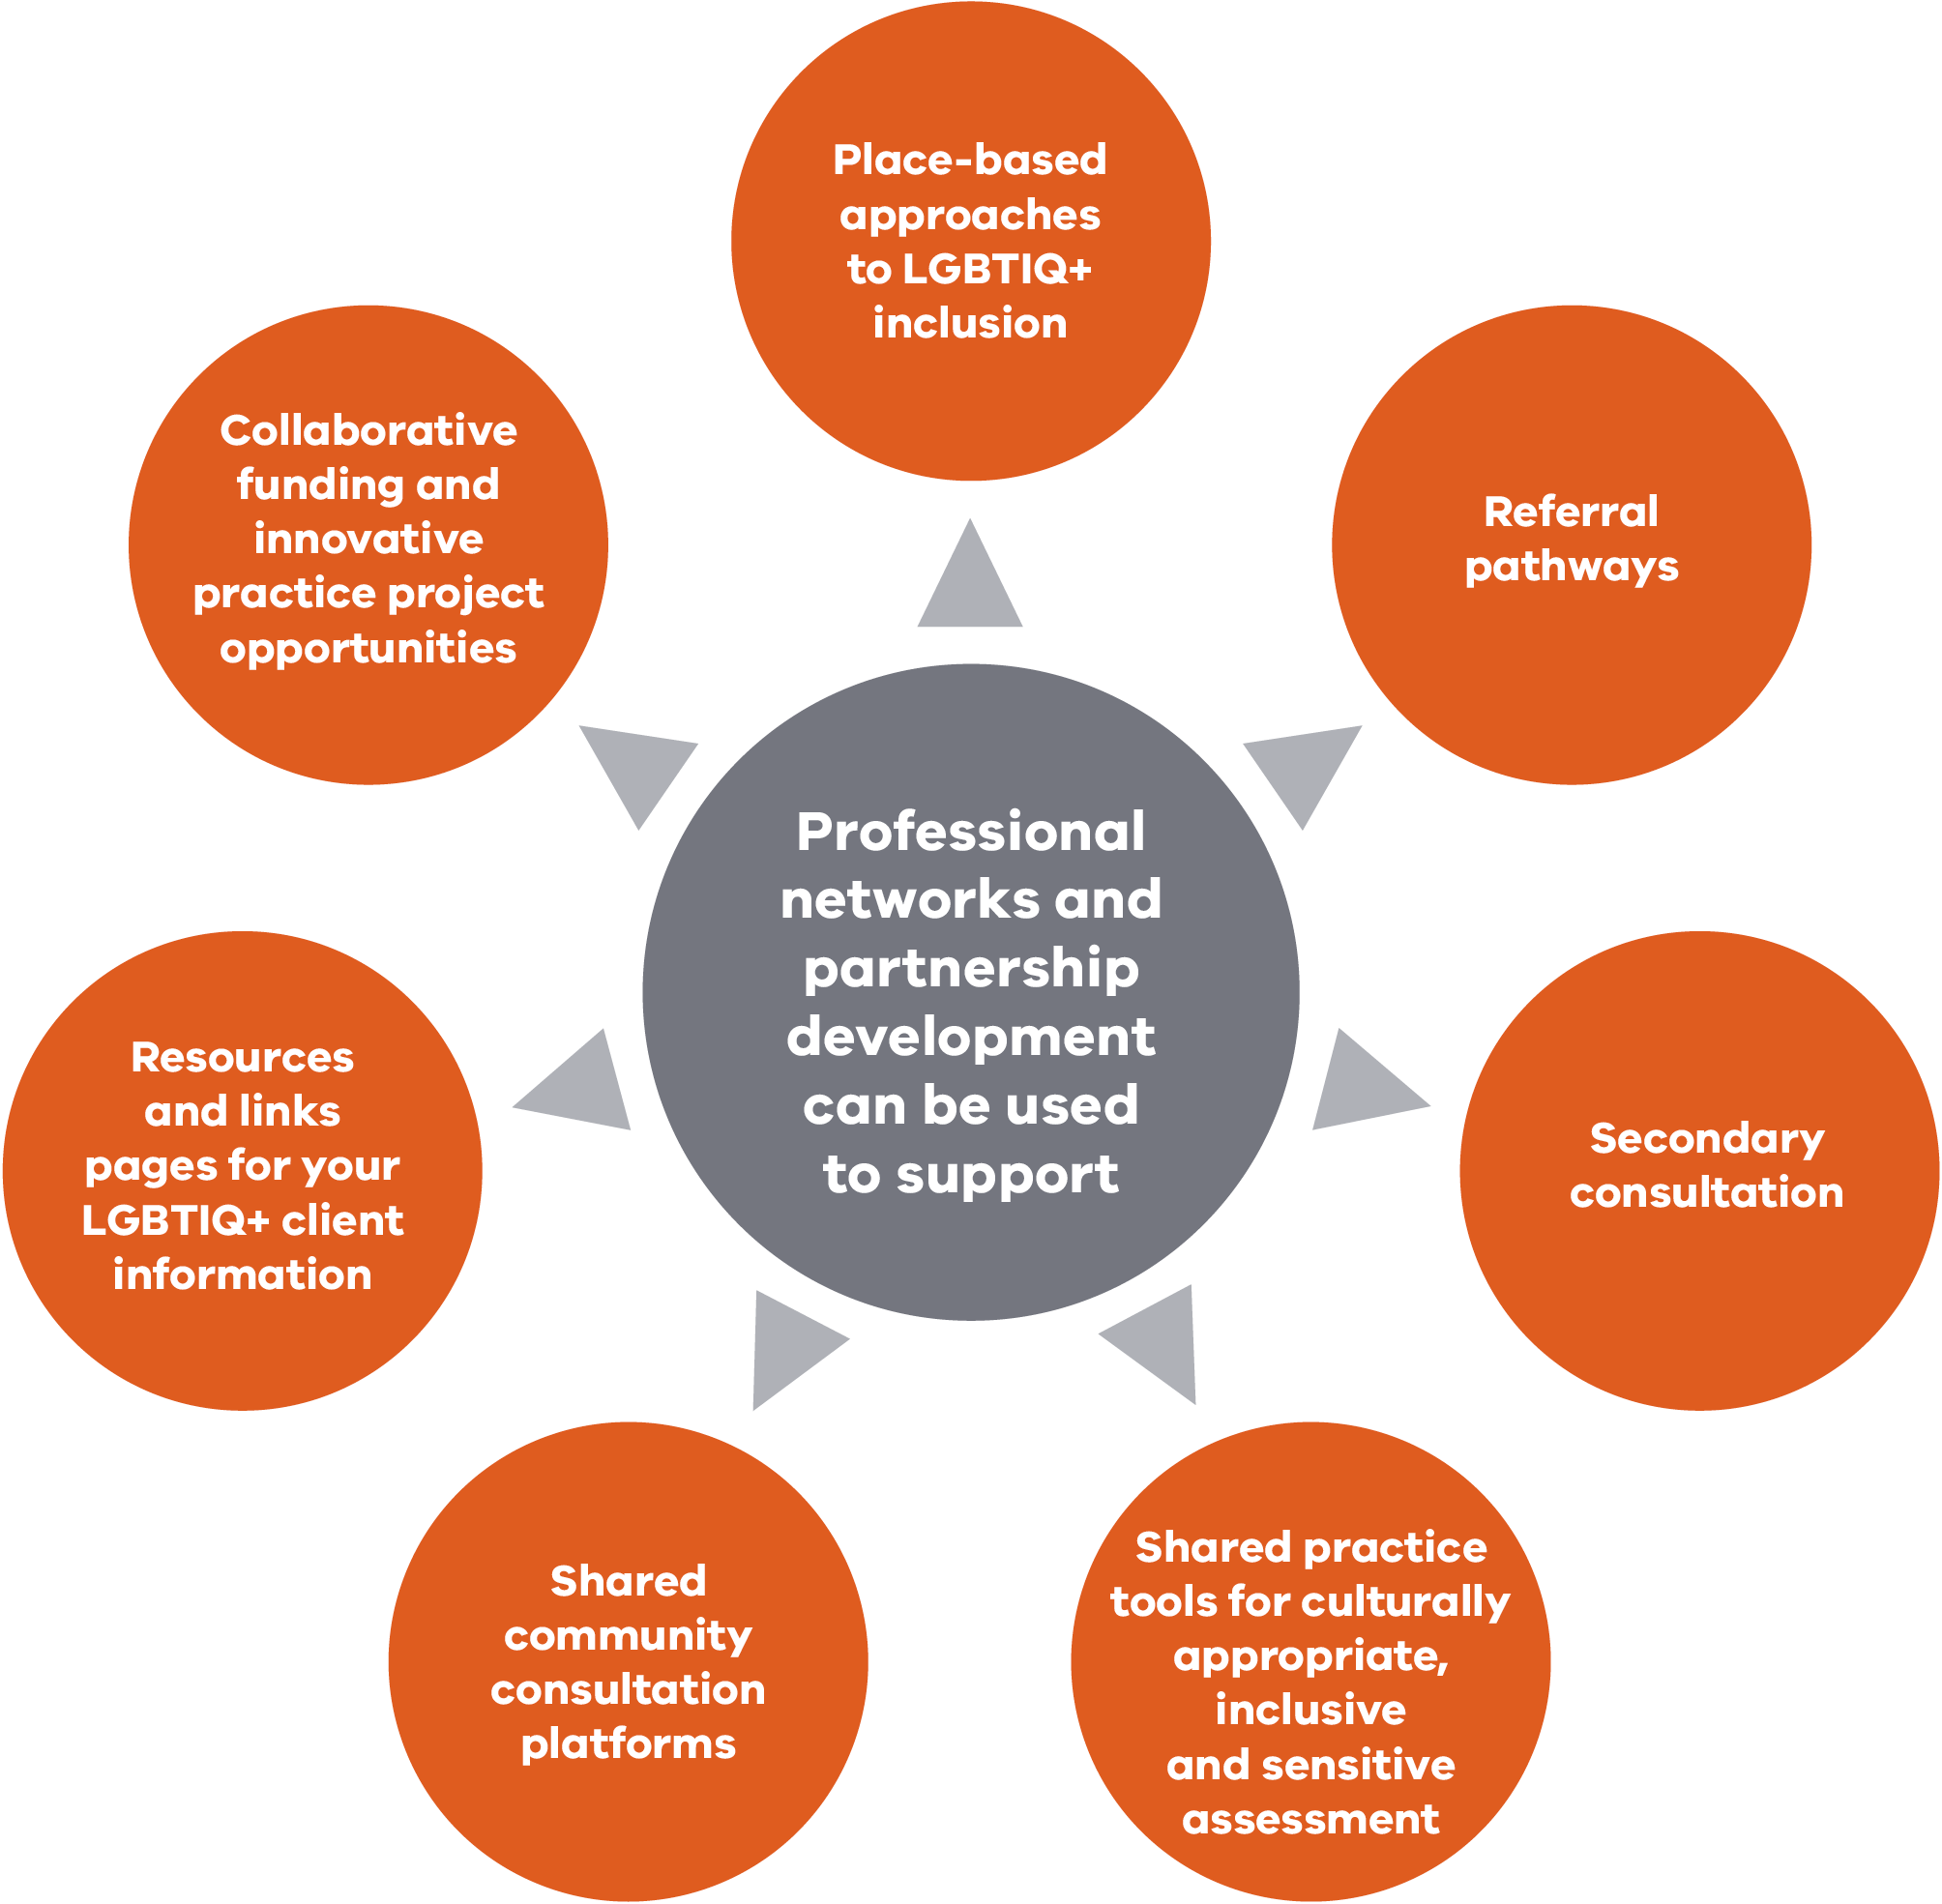
Some places you can look for LGBTIQ+ networks and organisations include:
- local LGBTIQ+ inclusion network or community of practice (if this does not exist, consider starting your own)
- local council
- primary health network
- primary care partnership
- youth services such as headspace
- secondary schools (especially Safe Schools)
- Victorian Police lesbian, gay, bisexual, transgender, intersex, and queer liaison officers
- Rainbow Network statewide network for youth providers.

Activity 2.2: Find LGBTIQ+ networks and organisations
- Use the list above as well as the ‘Resources’ section on p. 55 to identify relevant LGBTIQ+ networks and organisations that may be potential partners.
- This list could include LGBTIQ+ support groups, information networks, directories and LGBTIQ+-friendly providers and agencies.

Establish a community advisory group
Including a community advisory function within your organisation can help continuous quality improvement for LGBTIQ+ clients.
It brings the voice of clients and the community into decision making, and ensures your service is responsive to the various diverse community needs.
Depending on the size, capacity and context of your service, you can consider an independent LGBTIQ+ community advisory group, or ensure there is LGBTIQ+ representation on other service advisory groups.
Representation needs to be sensitive to the diversity of the LGBTIQ+ population, across each of the lesbian, gay, bisexual, trans and gender diverse, intersex, and queer segments, and inclusive of age and family structures, with consideration to intersections such as people who identify with cultural, linguistic or faith diversity, Aboriginal people and people with disabilities.
An LGBTIQ+ community advisory group can help you develop:
- local data and knowledge sources
- service standards, a charter of client rights and/or a cultural safety guide
- client and staff survey instruments
- inclusive client intake and assessment practices
- disclosure and privacy policies
- a means to assess whether you provide a welcoming environment
- sources of LGBTIQ+ community information and services
- assessment of translation and accessibility needs for communications
- risk assessments for service, client and community engagement
- local messaging and communications
- local partnerships.
Action 2.1: Establish an LGBTIQ+ advisory group
- Use your networks and other mechanisms to promote the establishment an LGBTIQ+ advisory group for your community health service.
- Some things to consider include:
  - format of meetings (online or face to face)
  - frequency of meetings
  - length of time members need to commit to the group
  - any other considerations.

3. Assess your current practice
Use the following tools to assess your service’s current practice. Keep the results as a baseline measurement, and use them track change over time.
Depending on the size and context of your community health service, you may want to undertake this work in partnership with an internal working group that includes representation from senior management.
If your organisation does not already have one, you can also form a community advisory group (see p.16) that includes LGBTIQ+ clients and community organisations.

Self-assessment tool
Assess whether each of the following statements is met, partially met, or not met.

1. Staff knowledge, skills and confidence
Area | Not met | Part met | Met
All staff, board members, volunteers and contractors are trained to ensure their interactions are respectful towards LGBTIQ+ service users and residents.
All staff, board members, volunteers regularly undertake LGBTIQ+ inclusive training as a standard of best practice to continue to gain familiarity with inclusive gender terminology as an element, to ensure that no one is misgendered.
Direct support staff are trained to identify and address the health issues that are particularly relevant to LGBTIQ+ service users.
Staff are aware of appropriate referral pathways for LGBTIQ+ community services.
Staff are confident to advocate for LGBTIQ+ service users, and respond to discrimination or prejudice towards LGBTIQ+ people they may encounter from other staff, service users or the general public.
Sufficient resources are allocated to build the capacity of staff to meet the specific needs of LGBTIQ+ service users.
Staff are encouraged and supported during supervision to undertake reflective practice about their work with LGBTIQ+ people.

Notes

2. Organisational policy and procedures
Area | Not met | Part met | Met
Sufficient resources are allocated to build staff capacity to meet the specific needs of LGBTIQ+ service users.
There is a designated staff position to improve inclusivity and safety of LGBTIQ+ people.
There is an accessible, written antidiscrimination policy that specifically references LGBTIQ+ people, or sexual orientation and gender identity, including intersex people.
There are accessible confidentiality and privacy policies that specifically reference sexual orientation and gender identity.
There are accessible, written inclusion, access and equity policies that specifically reference LGBTIQ+ people or sexual orientation and gender identity.
There are accessible, written policies and procedures about how to respond to bullying, abuse or inappropriate behaviour, including derogatory comments about someone’s sexuality or gender identity.
Prompt action is taken to deal with threats to the cultural safety of LGBTIQ+ service users from staff, service users, visitors and volunteers.
Human resources policies and procedures recognise same-sex partners and their families, which gives them equal access to provisions.

Notes

3. Safe, welcoming, inclusive and accessible environment
Area | Not met | Part met | Met
There are posters, pamphlets and symbols displayed in the reception and entry areas that clearly show that LGBTIQ+ people are included and valued by the service.
Organisational policies regarding access, equity and inclusion are displayed in the reception area, and clearly show that LGBTIQ+ people are included and valued by the service.
All first point of contact staff (phone and in person) are very comfortable interacting with LGBTIQ+ people.
Staff show service users they are welcome to discuss their sexual orientation, gender identity or intersex status.
The language, information and images on our websites, in user resources and in promotional material includes LGBTIQ+ people and their diversity.
Staff members are open about their sexuality, gender identity and/or intersex status, or feel they are able to be if they choose to.
All staff and volunteers regularly undertake LGBTIQ+-inclusive training to gain familiarity with inclusive gender terminology so that no one is misgendered.
Facilities reflect the non-binary compositions of clients.

Notes

4. Referral, intake and assessment
Area | Not met | Part met | Met
Staff inform LGBTIQ+ service users how personal details (including sexual orientation, gender identity or intersex status) are used and protected. They also inform clients how confidentiality is maintained at all stages of the referral, intake and assessment process.
Intake forms use questions that are gender neutral / inclusive when asking about relationships and sexual activity. Forms specifically ask about a person’s preferred pronoun.
Intake forms and databases allow for sex and gender identity to be recorded beyond male or female options.
Intake forms and databases allow for sexual orientation to be recorded.
Staff ask how service users would like information about sexual orientation, gender identity and other considerations to be recorded when asking about significant relationships and sexual behaviour.
Same-sex parents of a child or young person client are both able to be recorded as parents, and are included in the care and decision making about their child.
Questions about HIV, AIDS and other stigmatised health conditions are clearly marked as optional to answer. People living with HIV are under no legal obligation to disclose HIV status, and may be subject to discriminatory treatment by clinical staff if they disclose on an intake form. Best practice is to allow people to disclose their status when and to whom they feel comfortable.

Notes

5. LGBTIQ+ community consultation, engagement and promotion
Area | Not met | Part met | Met
LGBTIQ+ staff, service users and community are consulted in planning, development and review of the organisation and its services.
The organisation and staff have professional relationships with at least one key LGBTIQ+ organisation that can provide quick advice about service delivery to LGBTIQ+ people.
The organisation promotes itself and its services to the LGBTIQ+ community.
The organisation acknowledges and celebrates significant events, celebrations and dates in the lives and culture of LGBTIQ+ people.
Staff from the service participate in professional associations, networks and other forums to stay current with the best ways to support LGBTIQ+ people.
The organisation maintains an LGBTIQ+-accessible referral database, and has access to LGBTIQ+ resources for distribution.
Service promotion and health promotion material includes diverse sexuality and genders, identified in both language and images.

Notes

Action 3.1: Self-assessment tool
- Complete the self-assessment tool to gain baseline data that rates your organisation’s level of inclusivity.
- Regularly review the results to see where you are on the journey towards inclusive practice and service delivery.

Client survey tool
If your LGBTIQ+-inclusivity practice includes a community advisory group, or you have clients who identify as LGBTIQ+, you can use the following questions as the basis for a client survey on LGBTIQ+ inclusivity.
See ‘Establish a community advisory group’ on p. 16 and ‘Consult with LGBTIQ+ communities’ on p. 29, on how to work with your LGBTIQ+ clients to gain your organisation’s inclusivity baseline data.
Work area | Questions to ask LGBTIQ+ clients | Notes
1. A welcoming environment | - Are reception and intake staff confident and comfortable in discussing and asking about sexuality, gender diversity and intersex status?  - Do reception and waiting areas visibly show that service is inclusive to LGBTIQ+ people?  - Have you experienced service that makes you uncomfortable or has been discriminatory to you?  - Have you seen our service promoted in any LGBTIQ+ community spaces?
2. Service publications and communications | - Does our service provide information that welcomes and includes LGBTIQ+ clients?  - Have you seen information and brochures in our service about LGBTIQ+ health?
- 3. Policies and procedures that reflect an inclusive and welcoming service | - Have you been told about our service’s policy on collecting client information on sexual orientation and gender identity or intersex variations, including how information will be used, when it can be disclosed, how it will be stored?
4. Service feedback and participation | - Have you been given the opportunity to provide feedback about this community health service? Are you familiar with the various ways you can provide feedback?  - Have you been asked about your service and health needs as an LGBTIQ+ client?  - Do you have the opportunity to contribute to developing our service’s standards regarding LGBTIQ+ inclusion?  - Have you provided feedback about the service and seen that your feedback has been acted on?
5. Intake and assessment | - Are you able to adequately record your relationship status, gender identity or intersex status when desired and appropriate?  - Do our intake forms and procedures allow for diversity in relationships, sexualities, gender diversity and intersex status?
6. Service staff | Do you think staff could benefit from training and development in:  - attitudes and beliefs  - LGBTIQ+ people and communities  - LGBTIQ+ health  - making people feel welcome  - referrals and external services?
7. Your health needs | Have you received information and care that is relevant to your specific health needs?

Action 3.2: LGBTIQ+ client survey
- Undertake the LGBTIQ+ client survey.

Staff survey on LGBTIQ+inclusive practice
You can also gather information about the experience of your staff and board to inform your strategic direction, service planning and continuous quality improvements.
Staff and the board can be surveyed about:
- attitudes, values and beliefs about LGBTIQ+ inclusion
- knowledge, confidence and comfort regarding LGBTIQ+-inclusive practice and LGBTIQ+ health
- the relationship between policy and practice
- service issues or concerns
- opportunities for workforce development
- inclusion as LGBTIQ+-identifying staff.
You should provide different ways for staff to give feedback, including via an anonymous survey.
The survey data should be used to:
- generate baseline staff knowledge
- develop a staff training strategy
- develop an LGBTIQ+ staff inclusion strategy.
Data from the Victorian Public Sector Commission People Matter survey (see ‘Sample staff survey questions from the 2019 People Matter Survey’ below) can be used as a starting point.
You can also engage a staff LGBTIQ+ working group and/or community advisory group (see p. 16) to further develop the survey instrument.

Sample staff survey questions from the 2019 People Matter Survey
- About you:
Gender:
    - Woman
    - Man
    - Self-described (please specify)
    - Prefer not to say
Are you lesbian, gay, bisexual, trans or gender diverse, intersex, queer or questioning?
    - Yes
    - No
    - Prefer not to say
- Equal opportunity
    - Gender identity is not a barrier to success in my organisation (scale 1-5)
    - Sexual orientation is not a barrier to success in my organisation (scale 1–5)
- There is a positive culture within my organisation in relation to …
    - employees of different sexes/genders (scale 1–5)
    - employees who are LGBTIQ (lesbian, gay, bisexual, trans and gender diverse, queer or questioning) (scale 1-5)
- People in my workgroup actively support diversity and inclusion in the workplace (scale 1-5)
- My manager works effectively with people from diverse backgrounds (scale 1-5)
- Senior leaders actively support diversity and inclusion in the workplace (scale 1-5)
- My organisation encourages respectful workplace behaviours (scale 1-5)
It is important that you use inclusive language to empower people to correctly self-identify if they choose to. It also allows you to collect more accurate data for service development and planning.
Gender identity is often fluid, and gender and sexual identity questions should allow multiple options to be selected. You should also provide a free-text field that allows people to self-describe. See ‘Ensure intake and assessment is inclusive’ on p. 48 and ‘Using inclusive language’ on p. 53.
Action 3.3: Staff survey on LGBTIQ+ inclusive practice
- Undertake a staff and board member survey, and include volunteers and subcontractors.

Review policies
Review your policies to ensure they embed safe and inclusive practice.
Policies should:
- promote and value diversity
- outline codes of conduct, including non-discrimination
- demonstrate commitment to equity, outcomes and health for all
- affirm access to quality care and support as a fundamental human right
- acknowledge the impact of determinants such as discrimination and stigma on health and wellbeing
- emphasise your commitment to continuous improvement.
Examples of existing policies that you should review for inclusion of sexuality, gender diversity and intersex status include policies for:
- codes of conduct
- antidiscrimination
- confidentiality and privacy policy
- inclusion, access and equity
- workplace equal opportunity
- sexual harassment
- workplace bullying
- flexible work arrangements
- occupational health and safety
- workplace complaint resolution
- discipline procedure
- enterprise bargaining agreements
- feedback and complaints management.

Trans and gender diversity
Services need clear policy and clinical governance on providing inclusive healthcare for trans and gender diverse people. This is particularly important when people seek gender-affirming care, such as hormones, or preventive care, such as cervical screening, prostate checks and breast tissue screens.

Intersex
Services need clear policy and clinical governance related to the treatment of babies born with intersex variations. Services should adopt a human rights approach framework, with decisions made on a case by case basis that aims for the best possible outcomes for each baby / child.
Action 3.4: Review policies
- Review your organisation’s policies to ensure they reflect inclusive practice.

Review intake and assessment procedures
Review your intake and assessment procedures to ensure you use inclusive language, and that every person has the chance to acknowledge and affirm their identity and status.
Using inclusive language when collecting demographic information allows people to correctly self-identify if they want to, and it also enables more accurate data collection to inform service development and planning.
The same questions should be asked of all clients, irrespective of appearance, country of birth or whether the staff know the client or their family background.
Questions can be verbally asked (though not at reception or in a waiting room or other public environment), but people should also always be given the option to complete a form themselves.
See ‘Ensure intake and assessment is inclusive’ on p. 48 and ‘Use inclusive language’ on p. 53.
Action 3.5: Review intake and assessment
Review your intake and assessment processes and procedures to make sure they:
- allow people to identify their gender and/or self-describe
- allow people to record their intersex status
- allow people to record their sexuality
- are inclusive of various family and parenting structures.
- avoid assumptions of heterosexuality or gender status
- allow people to identify multiple relationships options to be inclusive of people who identify as being polyamorous as well as people with differing genders and/or identify as non-binary
- allow enough space on forms for people to provide further information if they choose

Develop referral pathways
Having a network or list of LGBTIQ+ support groups, information networks, directories and LGBTIQ+-friendly providers and agencies can feed into a process of developing referral pathways for LGBTIQ+ clients.
Having good referral pathways acknowledges that not all specialist care needs can be met within the community health context. It also means that LGBTIQ+ clients can get quick access to the care they need.
Without referral pathways in place, LGBTIQ+ people can experience delayed access to treatment, and may have to present to numerous clinicians.
Always ask clients who identify as LGBTIQ+ if they prefer referrals to LGBTIQ+-specific or mainstream community services.
For LGBTIQ+ people in rural and regional areas, being able to access support from inclusive organisations and services is particularly important.
See the ‘Regional LGBTIQ+ resources’ section on p. 55 for resources for community health services in regional areas.
Action 3.6: Develop referral pathways
- Establish clear referral pathways for LGBTIQ+ clients, including secondary consultation through specialist health and human services.
- Ensure referred services have a commitment to LGBTIQ+ inclusion to maintain cultural safety of clients.
- Ensure staff are aware of the referral pathways.
- Publish and maintain up-to-date contact information for referral pathways on the intranet.

4. Start the change
The next section of the toolkit offers a range of activities you can undertake to boost your organisation’s inclusive practice.
Not all of the activities in this section will be appropriate for all organisations and contexts. Feel free to adapt them to your needs.

Consult with LGBTIQ+ communities
Consulting with LGBTIQ+ clients, carers and community members will help to ensure your inclusive practice project, program or service is effectively planned and implemented.
Figure 4: LGBTIQ+ communities can support your inclusive practice
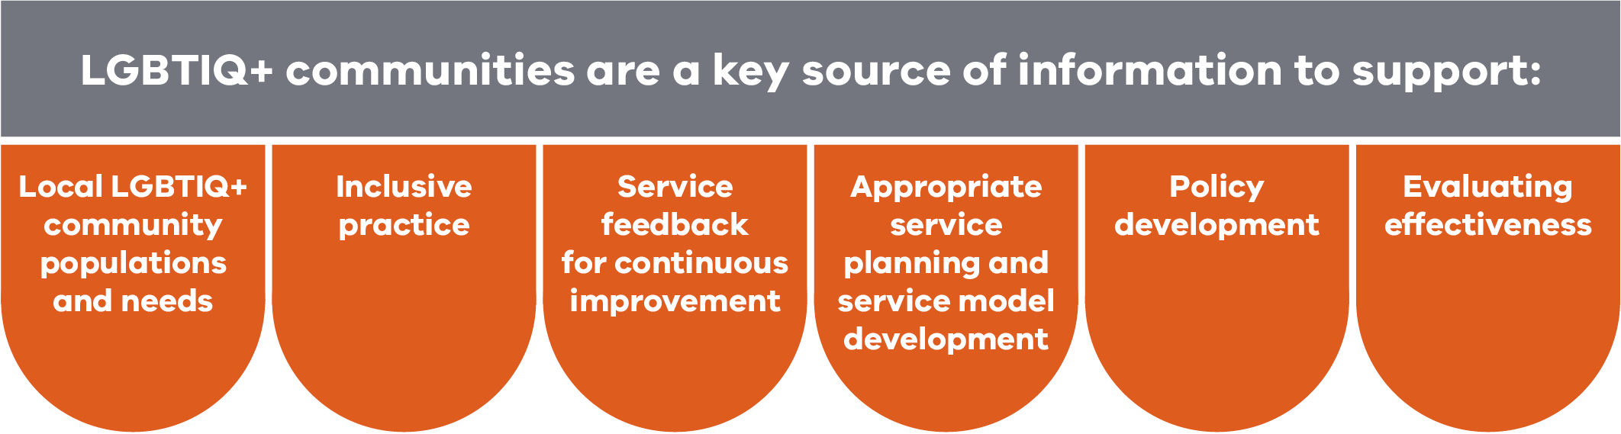

Person-centred care
The Australian Commission on Safety and Quality in Health Care places the person at the centre of its new model of clinical governance, the National Model Clinical Governance Framework <https://www.safetyandquality.gov.au/publications-and-resources/resource-library/national-model-clinical-governance-framework>.
The framework argues that services should partner with clients to drive improvements in:
- governance, leadership and culture
- patient safety and quality improvement systems
- clinical performance and effectiveness
- safe environment for the delivery of care.
This means speaking and working with LGBTIQ+ people about your services should be a key activity in boosting your organisation’s inclusive practice.

Things to consider when engaging with LGBTIQ+ communities

Language

Use inclusive language to recognise the diversity within LGBTIQ+ communities. It is important not to use gay or gay and lesbian as an umbrella term for LGBTIQ+ communities. Doing so can make people feel excluded.

Safety

Ensure channels for people for whom safety and anonymity are especially important, for example people in rural areas and or older LGBTIQ+ people.

Accessibility
Optimise the ways people can engage by finding appropriate times and venues for participation, and ensure people’s safety when attending. (See ‘Barriers to trans and gender diverse people giving feedback’ below.)

Celebration and acknowledgement
Ensure that the group provides opportunity for acknowledging the local LGBTIQ+ community and celebrating in its successes and history.

Consultation fatigue
Review your opportunities to share LGBTIQ+ community consultation platforms among local partner organisations. This may minimise the risk of consultation fatigue for LGBTIQ+ community members, and will strengthen local partnerships and develop more consistent place-based approaches to LGBTIQ+ inclusion.

Barriers for trans and gender diverse people giving feedback
Trans and gender diverse people may not give service feedback because they:
- believe it would not make a difference or be taken seriously
- are concerned about their ongoing relationship with a clinician or the service
- are concerned about hostile reactions from staff or clinicians
- are concerned it would affect access or referrals
- are concerned it would result in poorer quality care
- have had previous bad experiences when making complaints
- are unaware of the process or options for making complaints
- do not feel the issue was serious enough to require a complaint.
Trying to limit these barriers – or at least being aware of them – may improve the quality of feedback you receive from trans and gender diverse people.

Community engagement in rural service contexts
Rural services may provide specific challenges for community engagement.
Here are some things to consider:
- Prepare and communicate a diversity, equity and inclusion statement. Consider including a statement specific to LGBTIQ+ youth and older LGBTIQ+ people to improve health and wellbeing outcomes.
- Access the local LGBTIQ+ community. Identify local strengths, achievements, celebrations and sources of pride in the community.
- If there is no visible community, develop a communication strategy to encourage LGBTIQ+ contact.
- Take a participatory, long-term approach.
- Frame engagement in terms of diversity to provide safer channels for participation.
- Use local knowledge networks to advertise consultation (for example, the local library, neighbourhood house, post office and hairdresser). Consider using LGBTIQ+ radio or print media to advertise.
- Provide a range of options (survey, forum, focus group or email address, for example), including anonymous options.
- Partner for success: a local collaborative LGBTIQ+ community advisory group can support the local government, Primary Health Network, Primary Care Partnership and other state services.
- Consider accessing statewide LGBTIQ+ organisations for support.
- Be sensitive to risks for clients disclosing: consider appropriate management strategies. Build trust.
For more information, see GLHV 2012, GLBTI inclusive practice: working with rural communities <www.rainbowhealthvic.org.au/research-resources>. Note that GLHV is now known as Rainbow Health Victoria.
See also ‘Considerations for rural services’ in relation to risk management on p. 35, and ‘Confidentiality and disclosure for people in rural contexts’ on p. 52.
Action 4.1: Consult with LGBTIQ+ communities
- Actively promote ways for clients and community to be involved in your service.
- Some ways you can respectfully seek meaningful input from LGBTIQ+ clients include:
  - solicit general service feedback (by embedding LGBTIQ+-specific content into existing feedback instruments)
  - use client surveys (see p. 23)
  - create an LGBTIQ+ webpage and an LGBTIQ+-specific email feedback address (for example: LGBTIQ+@communityhealth.org.au)
  - host forums/events (for example, on LGBTIQ+ health)
  - hold focus groups and/or interviews with clients and/or staff
  - include LGBTIQ+ representatives on service advisory committees, your Consumer Consultants Register and working groups
  - establish an LGBTIQ+ community advisory group (see p. 16)
  - consult with local LGBTIQ+ partners, service providers, communities of practice
  - contribute to local LGBTIQ+ advisory bodies such as those hosted by local councils, primary health networks, primary care partnerships or inclusive practice networks (to share LGBTIQ+ client feedback across multiple services)
  - participate in or host LGBTIQ+ days of celebration or community events with LGBTIQ+ visibility (for example, pride carnivals, pride sports matches, pride school formals, LGBTIQ+ film festivals, events for older LGBTIQ+ people)
  - celebrate significant events important to the LGBTIQ+ community within your organisation (International Day Against Homophobia, Transphobia and Biphobia, and Wear It Purple Day).
The engagement needs to:
- be regular – for example, an annual survey or forum, bi-yearly advisory group meetings
- provide everyday opportunities for LGBTIQ+ clients to provide their feedback – and measure the outcomes
- act – embed feedback and suggestions for improvement into quality and continuous service improvement mechanism and cycles.

Codesign your service
Codesign means creating services with the people who use or deliver them – working with community members as active participants in the design process, to create shared value. Codesign is an effective way to ensure LGBTIQ+ people are active partners in the planning and implementation of their services.
Through codesign, you:
- explore problems with clients and service providers to determine what they need, expect and want
- develop proposed solutions in collaboration with clients and providers that meet clients’ goals and service providers’ business requirements (within constraints)
- build a solution ready for implementation and plan for testing and ongoing refinements
- test the solution to check it meets its aims – pre-implementation testing can involve other clients, service implementers, policy developers and decision-makers to test the robustness of the solution, while post-implementation testing can involve evaluation of the service or policy impacts with stakeholders
- empower clients and community members to shape the healthcare they receive
- evaluate and continuously improve as soon as the change or pilot has been initiated for learning and to measure changes.
For more information about stakeholder engagement and codesign, see the department’s Stakeholder engagement and participation framework and toolkit <https://dhhs.vic.gov.au/publications/stakeholder-engagement-and-public-participation-framework-and-toolkit>.
Action 4.2: Undertake codesign of services
- Use codesign as an approach for a standalone project as part of the wider quality and continuous improvement process to strength the delivery of inclusive services for LGBTIQ+ people.

Develop inclusive service standards
Your organisation’s service standards should promote an inclusive and respectful service environment. You could also consider developing specific service standards, a charter of client rights, or a cultural safety guide for LGBTIQ+ clients.
Below are examples of service standards from two different services.

Example of service standards from a primary care service
- All sexual orientation and gender diversity is regarded as normal.
- Our inclusive-practice environment welcomes all sexual orientation and gender diversity.
- Lesbian, gay, bisexual, trans and gender diverse, intersex, and queer people attend our practice.
- We avoid assumptions of heterosexuality.
- Our attitudes are openly non-judgemental, accepting and affirming.
- We have knowledge of specific health issues and sensitive, culturally appropriate referral networks for LGBTIQ+ people.
- We provide advocacy and support with issues regarding sexual orientation and gender diversity.
- Confidentiality is assured.

Example of client service expectations from an aged care setting
- Our LGBTIQ+ inclusion or diversity policy addresses each of L, G, B, T, I, Q and other gender and sexual orientations.
- We have an inclusive policy for employing staff who are LGBTIQ+.
- There is a code of conduct for staff and residents that states discrimination and harassment of older LGBTIQ+ people or their families and friends or staff will not be tolerated.
- We celebrate LGBTIQ+ events like IDAHOBIT, Mardi Gras, Midsumma, World AIDS Day, Intersex Awareness Day and others.
- Staff receive LGBTIQ+ inclusivity training and there is ongoing training regarding the experiences and needs of LGBTIQ+ people.
- We have LGBTIQ+ client consultants or liaison staff who people can talk to.
- We have a policy that supports trans and gender diverse people to maintain their affirmed gender or identity.
- We have a policy to support all relationships and all partners or carers and/or family of choice.
- We have a policy about maintaining privacy and confidentiality about intersex status and surgical transition, and staff know how to provide care that respects bodily autonomy.
- There are brochures or other information available from LGBTIQ+ services and LGBTIQ+ health.
Adapted from: 10 questions to ask about lesbian, gay, bisexual, transgender, intersex needs in residential aged care.
Action 4.3: Develop inclusive service standards
- Work with clients and/or a community advisory group to codesign or redevelop your organisation’s service standards.
- Develop a charter of client rights, or a cultural safety guide specifically for LGBTIQ+ clients.

Document and manage risks
The journey towards whole-of-organisation inclusive practice can bring with it risks to LGBTIQ+ clients, staff and your service. See example risk register below.
It is important to be aware of these risks and to plan accordingly and effectively.
The risks will vary according to program, site and service.

Developing a risk register
You can develop your own risk assessment report, risk register and risk management plans.
Clinical risk management plans need to document processes and responses to breaches of cultural safety for both staff and LGBTIQ+ clients by staff, clients, visitors or volunteers at the program and service levels.
A policy and procedure for disclosure, and developing documentation and workforce capacity in relation to disclosure, will support this.
This needs to be supported by compliance audits and a process for managing breaches.
Breaches to cultural safety such as confidentiality should be addressed through mechanisms including:
- incident response
- performance management
- privacy breach management
- staff recruitment, selection procedures and professional development processes
- a response that links directly to quality improvement and staff education.

Considerations for rural services
In addition to other concerns, rural community health services may need to be particularly sensitive to:
- difficulties in providing anonymity for LGBTIQ+ people in small communities (and discussing with clients the difference between confidentiality and anonymity – confidentiality means personal information is not immediately able to be linked to the person who supplied it, while anonymity means it can never be linked to the person)
- differences between people’s expectations of systemic LGBTIQ+ inclusion, and your service’s capacity to provide this
- the diversity of needs and experiences within the LGBTIQ+ community, and the unique needs of individuals
- the lack of referral pathways and community/peer support groups.

Other things to consider
- Manage the risks of consultation mechanisms and ensure clients and community members can participate safely.
- Ask your community advisory group (see p. 16) to identify potential risks (for example, the risk of personal information being inadvertently disclosed, the risk of encountering discrimination, differences between overt and covert behaviours).
- Services that run group programs should ensure all participants know their rights and responsibilities to maintain a respectful environment.
- Breaches of cultural safety during work with external stakeholders should be identified and addressed at the time, and reported internally through incident management processes.
- Consider risks when working with multiple intersectional identities. For example, breaching confidentiality may have greater impact on people from certain CALD communities or young people who rely on parents and family.
See the Rainbow Tick Standard on culturally safe and acceptable services on page 61 of the GLHV’s Rainbow Tick guide to LGBTI-inclusive practice (2016) <https://www.rainbowhealthvic.org.au/research-resources> for a more detailed discussion on identifying and mitigating risk at the whole-of-organisation level.
Example of a risk register
Priority | Potential risk | Risk minimisation strategy
1 | There is lack of strong consistent message from the board, CEO and leadership indicating endorsement of LGBTIQ+ inclusive practice. | Board to undertake inclusive practice training/engagement activity and issue endorsement statement to be used throughout organisational communications.
2 | The organisation assigns the role of project coordinator for LGBTIQ+‐inclusive practice to a LGBTIQ+ staff member. Staff then see the coordinator as ‘pushing their own barrow’, rather than facilitating a process in which the whole organisation needs to engage. | More than one LGBTIQ+ staff member take on the role of change champions, and they are supported by a diversity/quality committee or similar group to ensure they have support and gain traction for improvements.
3 | LGBTIQ+‐inclusive practice is not embedded in organisational systems, and the work ceases when the LGBTIQ+ champion leaves. | The LGBTIQ+ change champions take steps to ensure staff across the organisation are engaged in, and committed to, a range of activities to promote LGBTIQ+‐inclusive practice.
4 | An LGBTIQ+ employee, or staff member from an LGBTIQ+ family, is pressured to take on the portfolio of LGBTIQ+‐inclusive practice coordinator. | Check that LGBTIQ+ employees or staff with LGBTIQ+ family feel ready and able to take on the role of LGBTIQ+‐inclusive practice champion for the organisation, and provide the option for them to decline the invitation.
5 | An LGBTIQ+ inclusive practice coordinator is exposed to homophobic, biphobic or transphobic remarks from colleagues/the community about the LGBTIQ+ inclusive practice without adequate support from the organisation. | LGBTIQ+‐inclusive practice champions within the organisation need to be endorsed by the CEO, organisational managers and/or a group such as a diversity or quality committee.  Management needs to clearly indicate that homophobic, biphobic and transphobic views can be discussed as long as this is done in a respectful way.  The mandate for LGBTIQ+‐inclusive practice needs to be seen as coming from the organisation’s leadership team.
6 | Staff are reluctant to communicate homophobic, biphobic or transphobic views about LGBTIQ+ inclusive practice to the LGBTIQ+ person coordinating LGBTIQ+‐inclusive practice. | It may be useful to identify a range of people for staff to provide feedback to on LGBTIQ+‐inclusive practice, including anonymously.  This may be particularly important when conducting staff surveys.
7 | Activity to build LGBTIQ+‐inclusive practice incites public criticism, for example in rural areas, where there is a close relationship with the service. | The organisation provides the community with information on why LGBTIQ+‐inclusive practice is necessary. For example: data on the mental health of young LGBTIQ+ people.
8 | The organisation has LGBTIQ+‐inclusive assessment and intake processes that encourage LGBTIQ+ clients to disclose, but the organisation is not LGBTIQ+ inclusive as a whole. | Ensure that service is in process of developing LGBTIQ+ inclusive service standards before inviting clients to disclose their sexual orientation or gender diversity.
9 | That the organisation promotes itself as LGBTIQ+ inclusive and LGBTIQ+ clients disclose their sexual orientation and gender identity when it is not safe to do so. | Rather than promoting itself as LGBTIQ+ inclusive, an organisation could promote the activities it is undertaking to achieve LGBTIQ+‐inclusive practice.
10 | Staff develop an understanding of the evidence relating to the needs of LGBTIQ+ people and apply a ‘one size fits all’ approach, or stereotype LGBTIQ+ people. | Educators remind staff that the LGBTIQ+‐inclusive practice standards are intended as a benchmark and are not intended to replace person-centred care or identifying the unique needs of individual clients.
11 | A staff member inadvertently discloses a person’s sexual orientation or gender identity when it is not safe to do so. | The organisation ensures that all staff are familiar with standards relating to documentation and disclosure (and their own health privacy principles) and understand the potential consequences of disclosing sexual orientation and gender identity when it is not safe to do so.
12 | The process of working towards LGBTIQ+‐inclusive practice brings to the surface homophobia, biphobia and transphobia within staff. | Staff are able and supported to discuss their values and beliefs in a respectful way. Managers can model respectful ways such as challenging issues and not individuals; and using ‘I’ statements as in, ‘I think …’
13 | The organisation engages in community consultation about the needs of the LGBTIQ+ community and raises community expectations without delivering. | Consultation with the LGBTIQ+ community occurs after the organisation has established its capacity to work towards LGBTIQ+-inclusive practice.  The aims of LGBTIQ+ community consultation are made clear before consultation occurs.
14 | The organisation engages LGBTIQ+ clients in client consultation without adequately identifying risks to them. | Consider the risks to LGBTIQ+‐community members (and invite them to assist in identifying risks), for example, breaches of confidentiality, anonymity, and discrimination.
15 | The organisation doesn’t allocate sufficient resources to sustain LGBTIQ+‐inclusive practice initiatives and the process is abandoned leaving LGBTIQ+ clients and staff who have disclosed in a vulnerable position. | Management considers the resources (particularly staff time and financial costs) involved in undertaking a systemic approach to LGBTIQ+‐inclusive practice.
16 | Lack of consideration of gender, sexuality and intersex status with other vulnerable or at-risk groups such as Aboriginal people, people with disability and people from CALD communities. | Organisation ensures all staff undertake inclusive practice training with an emphasis on increasing staff understanding of the diversity within LGBTIQ+.

Notes

Action 4.4: Complete a risk register
- Complete a risk register to assess risks to LGBTIQ+ clients, staff and your service.

Ensure inclusive practice is part of your quality cycle
A comprehensive quality cycle ensures you have a system to improve the experience of clients.
The cycle links data and outcomes to a framework, and makes explicit the links between:
- improvement opportunities
- improvement initiatives
- workplans
- monitoring reports.
For example, the Gippsland Lakes Community Health quality cycle is included below.
Figure 5: Gippsland Lakes Community Health quality cycle
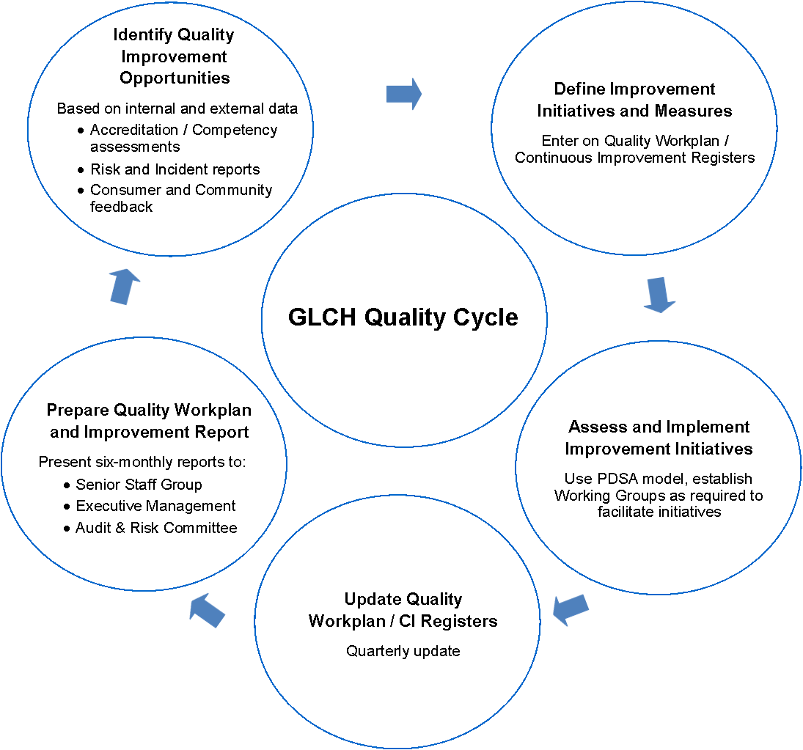
You can use many of the activities in this toolkit to feed into your service quality cycle, and to monitor the impact of LGBTIQ+ inclusive practice improvement activity.
Action 4.5: Embed inclusive practice in your quality cycle
- Ensure your work towards inclusive practice is embedded in your quality cycle. You can include:
  - client surveys
  - staff surveys
  - inclusivity audits
  - local communities of practice / LGBTIQ+ networks
  - community advisory groups
  - client feedback data and complaints data
  - organisational committees
  - risk management data (for example, breaches of privacy)
  - client engagement activities.
- Use LGBTIQ+ service standards to benchmark your performance, or measure feedback from LGBTIQ+ clients against that from all clients.

Consider Rainbow Tick accreditation
Your organisation may decide to pursue formal accreditation for your work in LGBTIQ+-inclusive practice. The Rainbow Tick is Australia’s only LGBTIQ+-inclusive practice accreditation program, based on six LGBTIQ+-inclusive practice standards.
The Rainbow Tick Standards were developed by Rainbow Health Victoria (formerly GLHV) in partnership with Quality Improvement and Community Services Accreditation (QICSA) with funding from the Victorian Department of Health and Human Services.
Quality Innovation Performance (QIP) is the accreditation provider for the Rainbow Tick Accreditation program in the health and community services sector.
Rainbow Tick accreditation can be completed by itself, or can be added to any existing accreditation program, for example, the QIC Standards, the Human Services Standards (Vic), the National Safety and Quality Health Service (NSQHS) Standards or the Aged Care Standards.
Accreditation can apply to a whole community health service, or to specific programs or sites.
You could use the outcomes of some of the activities in this toolkit to provide evidence for the standards, if you decide to pursue formal accreditation.
See the Rainbow Tick standards <http://www.qip.com.au/standards/rainbow-tick-standards> for more information.
Action 4.6: Consider Rainbow Tick accreditation
- Discuss with your working group or senior leadership whether seeking Rainbow Tick accreditation is something your organisation should pursue.

Support your workforce to provide inclusive services
Your organisation should provide training to ensure that all staff understand their responsibilities in providing services to and interacting with LGBTIQ+ clients.
All staff, volunteers and board members should have access to professional development on LGBTIQ+ awareness, culture, terminology, sensitivities and challenges.
Service delivery staff should be supported to gain skills in working with LGBTIQ+ clients, whether they disclose their LGBTIQ+ status or not, and have access to practical strategies relevant to LGBTIQ+-inclusive service delivery.
Reception, intake and assessment staff should be supported to provide welcoming and inclusive client environments, and to ensure inclusive practice is regularly reviewed and updated.
Key cross-organisational topics for education and training include:
- LGBTIQ+ populations and community diversity
- LGBTIQ+ health and wellbeing issues
- understanding discriminatory beliefs and behaviours
- the impact of discrimination and stigma
- cultural safety
- challenging stereotypes and assumptions
- inclusive language
- working with diversity within diversity
- evidence base and emerging practice
- legal responsibilities
- screening for mental health, drug and alcohol misuse, experiences of violence, family and intimate partner violence
- unconscious bias.
Service capacity building can comprise:
- training and professional development
- providing links to online resources
- engaging speakers with lived experience from the community
- participating in networks and committees
- consulting with local or state LGBTIQ+ community services.
Your staff intranet should include current information about LGBTIQ+-inclusive practice, services and links to LGBTIQ+ resources and referrals. See the ‘Resources’ section on p. 55, or visit the LGBTIQ+ inclusive practice resources website <https://www2.health.vic.gov.au/primary-and-community-health/community-health> for posters you can use in your practice.
Staff development officers could consider a four-tiered approach to workforce development, which includes an LGBTIQ+-inclusive module during induction, online resources on the intranet, one-hour training, and select half-day training for key staff.
Figure 6: Four-tiered approach to workforce development
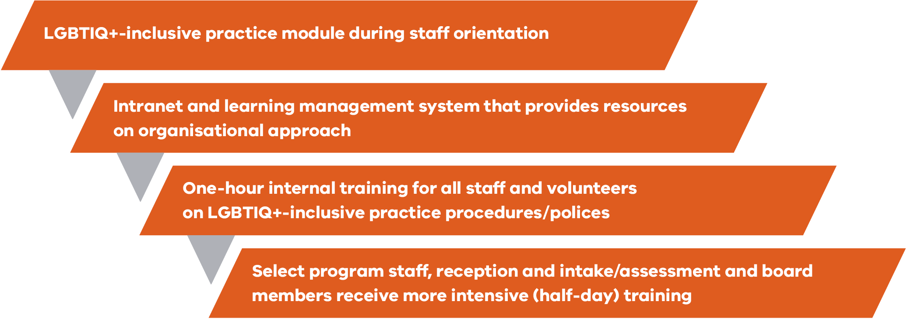
Staff development should be supported by
- clinical supervision
- reflective practice
- performance review processes.
A final note: do not assume that LGBTIQ+-identifying staff are willing to discuss or share lived experience, or are comfortable being a workplace champion.
Action 4.7: Develop a plan for staff development
- Work with your working group to develop a plan for staff development that includes LGBTIQ+ inclusion.

Promote and communicate your work
Promoting your organisation’s work towards LGBTIQ+-inclusive practice helps build support and engagement among staff.
This could include work to:
- embed messages or taglines in service and program communications
- give staff regular updates on inclusion activity
- display materials onsite
- work with local media.
It is important that staff understand the reason for strengthening inclusive practice. For example, you could use the following message:
Our service provides high-quality care to all our clients and community members. However, we know that more than one in three LGBTIQ+ people hide their identity when they use health and community services, and that some LGBTIQ+ people experience significant barriers to accessing care.
Building welcoming and trusting relationships with all our clients will ensure we can deliver genuine person-centred and comprehensive care.
Work with your LGBTIQ+ community advisory body to develop a communications strategy and to develop locally appropriate materials. For example, this might include translating client-facing materials into local languages.
Encourage feedback from the community and clients at every stage.
Action 4.8: Develop a communication strategy
- Work with your working group and community advisory group (see p. 16) to develop a communication strategy for your efforts to build inclusive practice.
- A communication strategy may include:
  - communication objectives
  - target audiences
  - key messages
  - targeted activity plan.

Value LGBTIQ+ staff
LGBTIQ+ inclusion needs to begin from within your community health service. As an organisation and employer, your service needs to have policies and procedures that acknowledge and value LGBTIQ+ staff.
A whole-of-organisation approach needs to systematically review documentation and processes to ensure:
- there are equal opportunity employment policies that acknowledge and value LGBTIQ+ staff
- diversity is modelled among staff, volunteers, governing body and committees
- LGBTIQ+ representation is encouraged on governance and advisory bodies
- policies and procedures recognise same-sex partners and families, and provide equal access to benefits
- organisational references to families and partners are inclusive of same-sex partners.
You also need to ensure there are clear performance management and risk management processes documented to address staff breaches of cultural safety. See ‘Document and manage risks’ on p. 34.
LGBTIQ+ cultural competence should be embedded into performance reviews.
Action 4.9: Redevelop policies and procedures based on principles of inclusion
- Redevelop the policies identified in ‘Review policies’ on p. 26, in consultation with your working group and community advisory group, to ensure LGBTIQ+ staff are valued and included.
- Ensure performance and risk management processes (p. 34) include ways to address staff breaches of cultural safety for LGBTIQ+ people, and embed LGBTIQ+ cultural competence in performance reviews.

Establish an inclusion portfolio
A dedicated LGBTIQ+ inclusion portfolio can work alone, or alongside an internal working group or cross-organisational advisors and champions, to drive and embed whole-of-organisation LGBTIQ+-inclusive practice.
The position develops specialist knowledge of LGBTIQ+ issues, and promotes them within your organisation and beyond into the community.
The position could be standalone, or part of an inclusion, diversity or equity portfolio.
Action 4.10: Establish an inclusion portfolio
- Use the position description in Champions of inclusion: A guide to creating LGBTI inclusive organisations as a guide to writing a position description for an inclusion portfolio.

5. Create cultural safety
LGBTIQ+ culture refers to cultural practices, worldviews and values within the LGBTIQ+ community. Creating cultural safety involves ensuring LGBTIQ+ people feel welcome and affirmed.
Cultural safety means providing an environment that:
- acknowledges and respects people living with multiple identities
- is socially, emotionally and physically safe
- does not challenge or deny people’s identity and needs
- promotes shared respect, shared meaning and shared knowledge
- values cultural diversity within the LGBTIQ+ community.
Figure 7: Promoting cultural safety
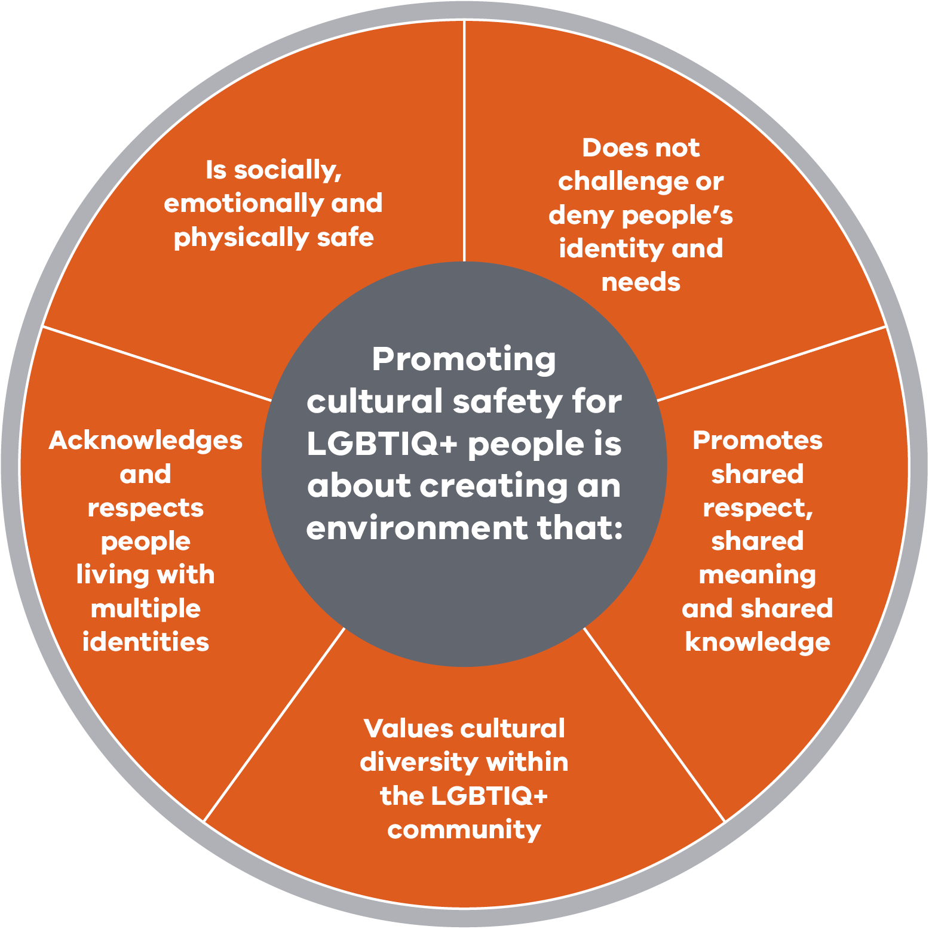
Practising cultural safety requires us to:
- reflect on our own attitudes
- develop trust
- avoid stereotypes and assumptions
- review biases
- learn from clients
- collect information only relevant to care
Figure 8: Practising cultural safety
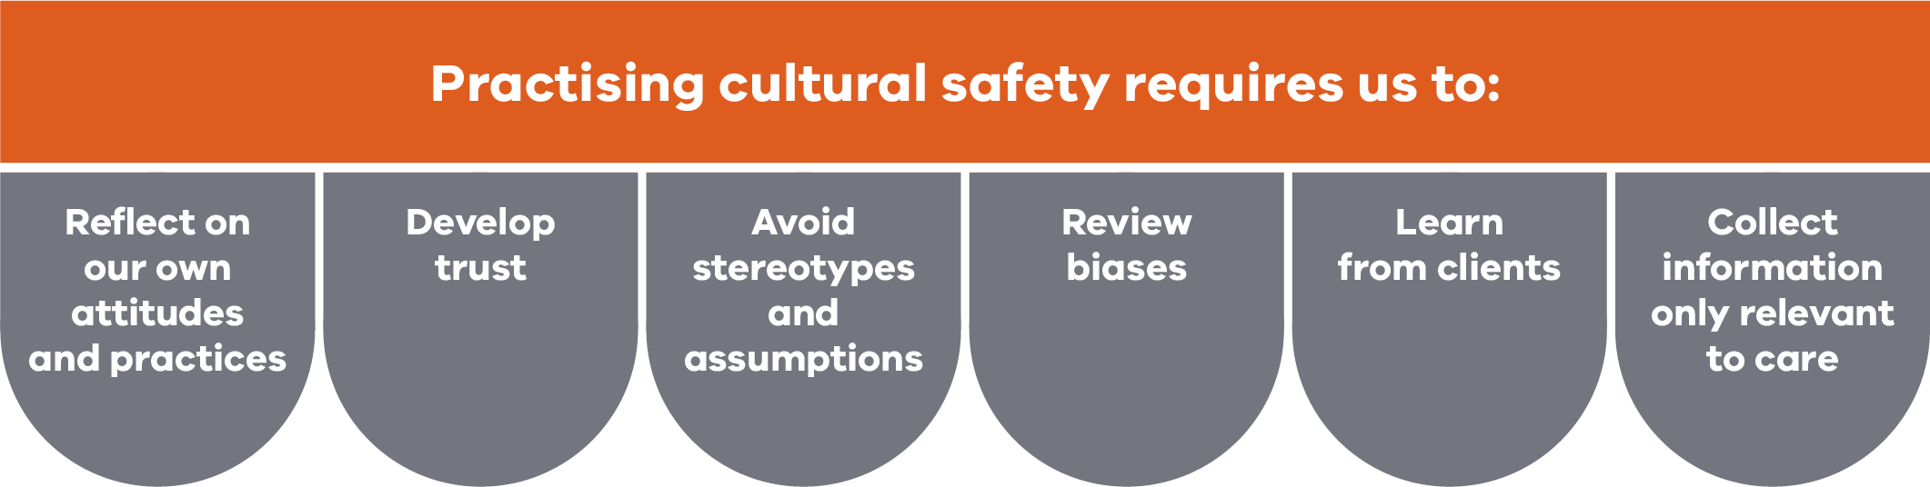
For community health services, cultural safety means acquiring skills in working with the LGBTIQ+ community as a cultural group. Things your service can do to promote cultural safety include:
- use inclusive language (see p. 53)
- support people’s relationships and families
- ensure staff are comfortable discussing sexuality, sex variations and gender diversity
- ensure staff do not deny gender diversity or refuse to support a transition process
- understand that intersex variations are natural diversity, and do not need intervention
- avoid sharing disclosed information with colleagues unnecessarily or without permission.
Action 5.1: Practising cultural safety
- Ensure culturally safe practice through actions that:
  - identify potential or actual risks to the cultural safety of LGBTIQ+ clients
  - ensure procedures are implemented to manage and respond to these risks
  - manage risk in a systematic way (see p. 34), for example in service design and review.

Promote cultural safety
One way to create cultural safety is through messages communicated throughout all parts of your community health service.
Action 5.2: Communicating cultural safety in your health service
- Ensure the physical environment is welcoming, for example:
  - display visible welcoming signs, such as posters, stickers, rainbow flag
  - display LGBTIQ+ brochures and posters in foyers and waiting rooms
  - display LGBTIQ+ community publications, newspapers displayed in foyers and waiting rooms, and promoting community events
  - ensure inclusive toilets, change rooms, showers are available, and promote their location clearly.
- Front desk and reception staff are trained to:
  - understand their role in welcoming LGBTIQ+ people
  - are non-judgmental
  - avoid assumptions of heterosexuality or being cisgender
  - avoid stereotypes
  - support disclosures.
- Communications are inclusive, including
  - a page on your website dedicated to LGBTIQ+ health information and community resources
  - promotional material, websites and fact sheets about your service explicitly mention LGBTIQ+ populations
  - images used in marketing and promotional materials include positive images of same-sex couples and trans and gender diverse people
  - your services are advertised in LGBTIQ+ press or through local LGBTIQ+ community organisations or websites (see ‘Promote your service to the LGBTIQ+ community’ below).

Promote your service to the LGBTIQ+ community
Community health services can promote their services to the LGBTIQ+ community through:
- local LGBTIQ+ groups
- LGBTIQ+ mainstream media (for example, Star Observer <http://www.starobserver.com.au>, Melbourne Community Voice) and social media
- LGBTIQ+ radio (JOY 94.9 has a strong community service announcement program that is free of charge for non-profit and public health campaigns, email Joy radio station <csa@joy.org.au> or visit Joy – Community service announcements <https://joy.org.au/community/> for more information
- LGBTIQ+ service directories
- LGBTIQ+ community festivals (examples include Midsumma, Chill Out Daylesford, Melbourne Queer Film Festival, Bendigo Queer Film Festival, Tilde Trans and Gender Diverse Festival, Goulburn Valley Pride, Ballarat Frolic, Out in the Open Shepparton, Pride Cup Yarraglen, Queer Expo St Kilda, Spring Migration Yackandandah, GLOBE Community Awards).
Action 5.3: Promote your service to the LGBTIQ+ community
- Check for opportunities for sponsoring and or participating events.
- Ask your LGBTIQ+ community advisory group or community consultants for more information on the above events and other local channels.

Ensure intake and assessment is inclusive
Another key aspect of cultural safety is using inclusive language in all your communications, forms and data collection activities. LGBTIQ+ people need to be able to acknowledge and affirm their identity and status.
This is particularly important during registration, intake and assessment, which is a critical touchpoint for many LGBTIQ+ service users. If a person does not feel welcome, included or safe while attempting to access a service, they may not return.
A person may feel comfortable acknowledging and affirming their identity, but not feel comfortable disclosing other information, like HIV status or injection-drug use. Answering such questions should be optional. Best practice is that service users should feel empowered to disclose such information when and to whom they feel comfortable.
Using inclusive language ensures people can correctly self-identify if they choose to. It also allows you to collect more accurate data for service development and planning.
Gender identity is often fluid, and gender and sexual identity questions should allow multiple options to be selected. You should also consider providing a free-text field that allows people to self-describe.

Considerations for inclusive data collections
At registration and intake and assessment, ask all clients questions to accurately record their gender, intersex status and relationship/partner status (and sexual orientation when appropriate). These questions should be placed in the context of other demographic and social history data.
Clearly explain on the form why the information is being collected (for example, ‘Collecting the following information will help us plan and provide appropriate and better health care and services’). Also explain how it will be used.
Below are some examples of questions and inclusive language you could use.

Intake data collection
- Preferred contact for emergencies (rather than next of kin)
- Sexual orientation: heterosexual, lesbian, gay, bisexual, queer, self-describe, prefer not to say
- Gender: woman, man, self-described (please specify), prefer not to say
- Do you identify as a person with an intersex variation? Yes, no, prefer not to say
- Optional: What are your pronouns? He/She, They/Them, other (please self-describe)

Demographic questions about partner and living arrangements
- Do you have a partner? (rather than ‘Are you married?’)
- What is your partner’s name?
- Is your partner a woman, man, non-binary, self-described, other (please specify) or would you rather not say?
- Do you live with anyone?
- Who do you regard as your close family?
- Are you co-parenting children with anyone? Avoid questions like who the real/natural mother is.

Sexual history
- Do you have a current sexual partner or partners?
- Do you need any information about safer sex?
- Do you have any need for contraception?
- Do you feel safe with your partner?

Gender classifications
Commonwealth Government guidelines recognise that any person, intersex or not, might identify as male, female or otherwise.
Three gender classifications are being introduced for Commonwealth services: F, M and X. This approach is recommended as a minimum.
The LGBTIQ+ space is rapidly evolving, and it is important to revisit your guidelines to see if there have been any changes in relation to collecting data about gender.
See the Designing for diversity minimum data set guide <https://www2.health.vic.gov.au/about/populations/designing-for-diversity> for more information.
Figure 9: An example of client registration form for medical clinics from Gateway Health
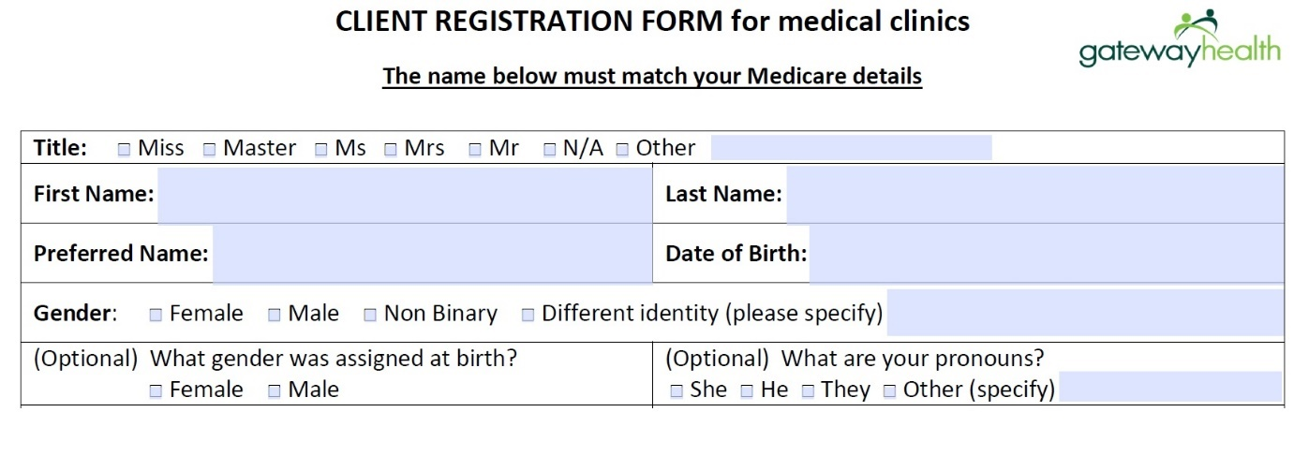See p. 5 of Making your service intersex friendly <https://ihra.org.au/services/> (Intersex Human Rights Australia 2014) for an example of an intersex-friendly intake form.
Action 5.4: Ensure inclusive intake and assessment
- Ensure your intake and assessment policy and procedures use inclusive language and reflect key approaches, including:
  - allow people to identify their gender
  - allow people to record their intersex status
  - allow people to record their sexuality
  - be inclusive of various family and parenting structures
  - avoid assumptions – the same questions should be asked of everyone, irrespective of appearance, country of birth, or whether the staff know of the client or their family background
  - questions can be verbally asked (though not at reception or in a waiting room or other public environment), but people should also always be given the option to complete a form themselves.

Ensure person-centred disclosure and documentation policies
Privacy and confidentiality are significant issues for everyone. For many LGBTIQ+ people, however, there may be additional concerns relating to stigma, discrimination and safety. These risks can be heightened if third-party disclosure occurs.
Here are some things to consider when developing policies and procedures for privacy and disclosure in community health settings:
- Many LGBTIQ+ people do not disclose their identities to their health provider. Fear of discrimination and of inadvertently having information disclosed to others is a key reason.
- LGBTIQ+ people often value the ability to disclose their sexuality and/or gender more than healthcare providers realise.
- It is an individual choice to disclose information – no one should feel obligated.
- LGBTIQ+ people should be given the opportunity to disclose information about themselves. All people have the right to self-report their identity / status, rather than have their identity / status assumed or recorded on their behalf.
- LGBTIQ+ people may need support when disclosing personal information. There is currently no Australian best practice to support disclosure, or for asking questions about gender diversity, intersex variation and sexuality. Disclosing sexual identity will likely be different from disclosing gender diversity, which will be different from disclosing intersex variation. A respectful and person-centred approach is key. Promote clients’ rights to privacy. It is the role of the community health service to make people feel safe and affirmed. For example, do not ask people about their identity/status in a crowded waiting room.
- Your service needs to know why it is asking for personal information. If you do not know why you are asking, do not ask.
Action 5.5: Disclosure, documentation and privacy
These tips can be modified depending on your local context.
- Ensure disclosure, documentation and privacy policies give staff and clients clear advice about:
  - sexual identity or gender orientation information being confidential
  - when it is appropriate for information about sexual orientation, gender or intersex variation to be collected, that is, only if it is directly related to, and reasonably necessary for, delivery of services
  - clients having a right not to disclose, but they should be informed when disclosure is likely to lead to improved outcomes
  - how information will be collected, that is, only from a client or a client’s nominated representative
  - when and how information will be shared – with family, other staff, other services (use of a release of information consent form), as per privacy policy and/or health information policy
  - how information will be used and stored
  - how the organisation maintains privacy when making referrals to other organisations.

Confidentiality and disclosure for older LGBTIQ+ people
Your approach to confidentiality and disclosure is particularly important for older LGBTIQ+ people.
Some older LGBTIQ+ people will not disclose their sexual orientation, gender or sex characteristics until they have a safe and secure relationship with a service provider. Others prefer never to disclose this information.
You should be sensitive to family members disclosing information on an elderly person’s behalf without permission.
Remember:
- Some older people have hidden their sexual orientation, gender diversity or intersex variation all their lives to escape discrimination and/or violence.
- Some older people will ‘safety test’ staff responses to LGBTIQ+ issues before disclosure.
- Some older people may not identify with any current identity terms (LGBTIQ+ or queer may not have any relevance).
- People with dementia may lose the capacity to maintain their ‘closet’ and no longer be able to hide their orientation or identity. Welcome and safety is paramount for these people.
- Some older trans and gender diverse people may have difficulty maintaining their physical gender expression. Welcome and safety is paramount.
Adapted from: GLHV 2013, Creating lesbian, gay, bisexual, transgender and intersex (LGBTI) inclusive residential aged care services. In 2019, GLHV rebranded to Rainbow Health Victoria.
Action 5.6: Confidentiality and disclosure for older LGBTIQ+ people
- Work with your community advisory group to consider the needs of older LGBTIQ+ people when developing confidentiality and disclosure policies and practices.

Confidentiality and disclosure for people in rural contexts
Anonymity, confidentiality and privacy are paramount in rural services.
People are unlikely to disclose their sexual orientation, gender or sex characteristics until your service has demonstrated safety, and described how it documents and manages risk (see p. 34).
Building trust and credibility as an LGBTIQ+-friendly environment is key.
People knowing service staff, and particularly intake and admissions staff, can be a barrier to disclosing information.
Third-party disclosures can have significant consequences for clients in small communities.
Action 5.7: Confidentiality and disclosure in rural contexts
- Work with your community advisory group to develop locally appropriate approaches to supporting and protecting disclosure.

Create a safe environment
Some further tips for creating a safe environment include:
- Use a person-centred approach. Create an affirming and supportive environment, from the client’s first contact with your service.
- Build trust and rapport. Use inclusive language, including the person’s correct name and pronoun. Be transparent with clients, explaining your questions or recommendations.
- Have verbal and visual prompts.
- Provide opportunities and invitations for people to disclose.
- Use open language and questioning during consultations, or directly ask the question.
- Be respectful and ‘normalise’ asking the question and react in an appropriate way.
- Do not give awkward, delayed, dismissive or inappropriate reactions upon disclosure (such as flinching, acting surprised, or immediately changing the subject).
- Communicating messages about your service’s journey towards LGBTIQ+-inclusive practice will likely increase the number of LGBTIQ+ clients disclosing.
- It can be a relief for clients when the provider asks questions in a conversational way; it builds confidence that disclosure will be positively received.

Action 5.8: Creating a safe environment
- Develop an organisational policy and procedure relating to disclosure, including a policy to guide staff on responding to disclosure.
- Encourage client feedback to support better approaches to disclosure and documentation. Consult with your community advisory group to finalise the policy.
- Educate staff about your policy, procedure to support disclosure and their responsibilities regarding respect and privacy.
See Appendix 2 for a sample privacy policy.

Use inclusive language
Inclusive language is language free from meanings or biases that reflect assumptions, discrimination or stereotypes.
Gender and sexuality are experienced and expressed in many diverse ways. Using language that excludes people or stereotypes them can cause harm to LGBTIQ+ people, whether you intended to or not.
Inclusive language avoids offence by using the same language that clients use to describe their gender, their bodies and their relationships.
Inclusive language ensures everyone is treated with respect.
Action 5.9: Use inclusive language
- Use appropriate terminology.
  - Only use the terms clients use to describe their sexual orientation or gender or sex characteristics.
- Avoid heteronormativity or heterosexism.
  - Avoid assumptions that everyone is heterosexual (for example, asking a woman about her husband if she has a partner).
  - Avoid language that assumes all relationships are heterosexual.
- Avoid misgendering.
  - Use the pronoun the client uses.
  - If uncertain, ask the client their pronoun directly and respectfully.
- Avoid offensive questions.
  - Avoid inappropriate questions about bodies (for example, about genitals) and avoid categorising people based on their medical or anatomical history (such as surgery).
- Check client preferences.
  - For example, a trans and gender diverse person may refer to their gender affirmation rather than transition to signal how they have always felt about their body.
- Acknowledge diversity within diversity.
- Acknowledge family structures and carers of choice.
- Ensure LGBTIQ+ people know that your services welcome them.
  - For example, a cervical cancer screening service could explicitly state in its materials that it provides services to anyone with a cervix (including trans men, gender diverse people and intersex people).

6. Evaluate your success
Change is an iterative process of assessing, developing, implementing and evaluating your work.
Using your initial work as a baseline, regularly measure the effectiveness of your efforts to ensure your community health service is undertaking inclusive practice for the LGBTIQ+ community.
Evaluation can also play a central role in planning, funding, monitoring and evaluating policy and service delivery initiatives.
Information gathered from evaluation activities should be a vital component of your community health service’s sharpened focus on patient and client outcomes. It defines accountability and, over time, builds a shared understanding of what works, what does not and why in terms of improving outcomes for LGBTIQ+ people.
Evaluation also supports continuous learning across your community health service. Your evaluation findings can be used in decision making to support ongoing improvement, policy and program development, and the best use of resources.
This work should be supported by planning and resourcing activities, and informed by monitoring and reporting activities.
You can use the outcomes of evaluation to celebrate your success, and demonstrate improvement to the board, executive and your community.
Action 7.1: Evaluate your work
- Collect and monitor information about your organisation’s approach to LGBTIQ+-inclusive practice.
- Use the evidence to continue to build on this work.

Resources

Key state and national LGBTIQ+ resources
- ACON <https://www.acon.org.au/>
  - HIV prevention, HIV support and LGBTIQ+ health, with national inclusion initiatives
- Bisexual Alliance Victoria Inc <http://www.bi-alliance.org/>
drummond street services <https://ds.org.au> – family services resources
Intersex Human Rights Australia <https://ihra.org.au> – intersex resources
- Home and Community Care Program for Younger People (HACC-PYP) and Commonwealth Home Support Programme (CHSP) - Diversity Advisors facilitate diversity planning and implementation in every departmental region
Minus18 <https://minus18.org.au> – youth resources
- National LGBTI Health Alliance <https://lgbtihealth.org.au/>
  - peak health organisation for LGBT and intersex organisations in Australia
- QLife <https://qlife.org.au/>
  - national telephone and web counselling service for LGBTIQ+ people, families and friends
  - provides LGBTIQ+ practice guides for health professionals
queerspace, drummond street <https://ds.org.au/our-services/queerspace> – mental health
Rainbow Families Council <https://www.rainbowfamilies.com.au> – LGBTIQ+ families
Rainbow Health Victoria (formerly GLHV) <https://www.rainbowhealthvic.org.au/> – LGBTIQ+ policy, research and resources
- Rainbow Network <https://www.rainbownetwork.com.au> – youth resources and LGBTIQA+ group and services directory
Rainbow Tick <https://www.rainbowhealthvic.org.au/rainbow-tick> – LGBTIQ+-inclusive practice standards
Switchboard Victoria <https://www.switchboard.org.au> – peer-based counselling
Thorne Harbour Health <https://thorneharbour.org> – formerly Victorian Aids Council
Transgender Victoria <https://tgv.org.au/> – trans and gender diversity
- Val’s LGBTI Ageing and Aged Care <https://www.latrobe.edu.au/arcshs/health-and-wellbeing/lgbti-ageing-and-aged-care>
Victorian Pride Centre <https://pridecentre.org.au> – LGBTIQ+ community resource centre
Ygender <https://www.ygender.org.au> – trans and gender diverse youth
Zoe Belle Gender Collective <https://zbgc.org.au/> – trans and gender diverse youth

Some regional LGBTIQ+ resources
- Cobaw Community Health <https://www.cobaw.org.au> – Kyneton
- Gateway Health <https://gatewayhealth.org.au> – Wodonga
- GASP <https://www.gaspgeelong.net.au> – Geelong
- UnitingCare Kildonan <https://www.kildonan.org.au/> – Shepparton
- SCIN South Coast Inclusion Network <http://scin.org.au/> – Bass Coast Shire
- Thrive <https://www.kildonan.org.au/programs-and-services/child-youth-and-family-support/diversity-project/thrive> – services connecting Aboriginal and CALD LGBTIQ+ communities - Hume

Training providers, videos and online learning resources
There are a number of training providers and professional development opportunities for LGBTIQ+-inclusive practice in Victoria. However, there is currently no accreditation process for LGBTIQ+ inclusion training, so the areas of expertise and focus of these organisations will vary.
There are many videos available online for staff and service providers to learn about the lived experience of LGBTIQ+ people. Videos can be watched individually or during staff meetings, providing opportunities for reflection and generating discussion. They can be particularly valuable for staff and services who do not work with many openly identifying LGBTIQ+ clients or staff.
- ACON <https://www.pridetraining.org.au/> – training to assist health, wellbeing, and community organisations increase knowledge of LGBTQ people, and provide guidance on inclusive practice
- Australian GLBTIQ Multicultural Council <https://www.agmc.org.au> - training to explore the intersections between race, culture, religion, and LGBTIQ identities
- beyondblue <https://www.beyondblue.org.au> – information and support to help everyone in Australia achieve their best possible mental health, whatever their age and wherever they live
- Blue Knot Foundation <https://www.blueknot.org.au> - training to foster knowledge, skills and tools to empower recovery with trauma clients, with a focus on complex trauma clients
- Celebrate Ageing <https://www.celebrateageing.com> – national program challenging ageism and building respect for older people
- Centre for Excellence in Rural Sexual Health (CERSH) <https://www.cersh.com.au> - FREE and accredited learning modules on rural sexual health care, including Avoiding Sexuality Assumption
- Cobaw Community Health <https://www.cobaw.org.au/services-a-z/lgbtiqa/lgbtiqa-training/> – Kyneton
- Connecting the pieces – video <https://www.youtube.com/watch?v=gXFovIL1q_I> and Connecting the pieces – facilitation resource <https://www.esdt.com.au/connecting-the-pieces.html>
- drummond street services <https://ds.org.au> - queerspace offer training and education on topics relevant to working with the LGBTIQ+ community and their families
- GASP Geelong <https://gaspgeelong.org.au/> - training for service providers to help build capacity and develop strategies for LGBTIQA+ inclusive practice in the Geelong area
- Gateway Health Wodonga <https://gatewayhealth.org.au>
- Healthcare under the rainbow <https://www.cobaw.org.au/healthcare-under-the-rainbow>– young LGBTIQ+ people talk about their healthcare experiences
- Intersex Human Rights Australia <https://ihra.org.au> - film, TV and video about intersex people and issues
- LGBTI inclusion: Walking in Rainbow Shoes (Pride in Diversity) <http://www.prideindiversity.com.au/e-learning/> FREE online learning module
- Minus18 <https://minus18.org.au> - youth social networking and training for workplaces and schools
- National LGBTI Health Alliance <https://lgbtihealth.org.au>, and FREE webinars at MindOUT National LGBTI Mental Health and suicide prevention <https://www.lgbtihealth.org.au/mindout_webinars>
- QLife <https://qlife.org.au> – QLives YouTube channel provides stories on LGBTI people’s perspectives and lived experiences
- Rainbow Health Victoria (formerly GLHV) <https://www.rainbowhealthvic.org.au/> – training includes an introduction to LGBTIQ inclusive practice
- Rainbow Network <https://www.rainbownetwork.com.au> - training includes LGBTIQ inclusive practice training for youth settings
Thorne Harbour Health <https://thorneharbour.org> – formerly Victorian Aids Council, providing a range of training to assist organisations in all areas of LGBTI inclusion and affirmative practice
- Transgender Victoria <https://tgv.org.au/> - training on trans and gender diverse and LGBTIQA+ inclusion and service provision
- UnitingCare Kildonan, Shepparton <https://www.kildonan.org.au>
- VAADA <https://www.vaada.org.au>
- Val’s LGBTI Ageing and Aged Care <https://www.latrobe.edu.au/arcshs/lgbti-ageing-and-aged-care> – health, wellbeing and social inclusion of older people
- Zoe Belle Gender Collective <https://zbgc.org.au/>
Your local Primary Health Network, Primary Care Partnership and/or local council may support initiatives in your local community that promote and provide a place-based approach to inclusive practice training.

Guidelines, fact sheets and frameworks
- Australian Research Centre in Sex, Health and Society (La Trobe University) 2015, Aged Care Assessment Service (ACAS) Lesbian, Gay, Bisexual, Transgender and Intersex (LGBTI) inclusive guide sheets <https://www.latrobe.edu.au/arcshs/health-and-wellbeing/lgbti-ageing-and-aged-care/resources-reports-and-training>.
- Department of Health 2017, National aged care diversity framework <https://www.health.gov.au/initiatives-and-programs/aged-care-diversity-framework-initiative> and including the Actions to Support LGBTI Elders: A Guide for Consumers <https://www.health.gov.au/resources/collections/aged-care-diversity-framework-action-plans> to support the framework
Department of Health and Human Services 2011, Well proud: a guide to LGBTI-inclusive practice for health and human services <https://www2.health.vic.gov.au/about/publications/policiesandguidelines/well-proud-practice-guide>.
Department of Health and Human Services 2013, Decision-making principles for the care of infants, children and adolescents with intersex conditions <https://www2.health.vic.gov.au/about/populations/lgbti-health/rainbow-equality/working-with-specific-groups/infants-children-adolescents-with-intersex-conditions>
- GLHV 2012, GLBTI inclusive practice: working with rural communities, <https://www.rainbowhealthvic.org.au/media/pages/research-resources/glbti-inclusive-practice-working-with-rural-communities/4198428499-1564984744/glbtiinclusivepracticeinruralcommunities.pdf >
- GLHV 2016, The Rainbow Tick guide to LGBTI-inclusive practice, <https://www.rainbowhealthvic.org.au/rainbow-tick>.
- GLHV 2013, Beyond a rainbow sticker: A report on How² create a gay, lesbian, bisexual, transgender and intersex (GLBTI) inclusive service <https://www.rainbowhealthvic.org.au/research-resources/beyond-a-rainbow-sticker>
- GLHV 2017, LGBTI-inclusive risk management: providing cultural safety <https://www.rainbowhealthvic.org.au/media/pages/rainbow-tick/1612345858-1564632551/lgbti-inclusive-risk-management_providing-cultural-safety-v001.pdf>
- Intersex Human Rights Australia 2014, Employers’ guide to intersex inclusion <https://ihra.org.au/wp-content/uploads/key/Employer-Guide-Intersex-Inclusion.pdf>
- Intersex Human Rights Australia 2014, Making your service intersex friendly <https://ihra.org.au/wp-content/uploads/key/OII-Australia-Inclusive-Service.pdf>
- National LGBTI Health Alliance 2015, Genders, bodies, and relationships passport <http://lgbtihealth.org.au/passport/>
- National LGBTI Health Alliance 2012, LGBTI Data: Developing an evidence-informed environment for LGBTI health policy <https://www.lgbtihealth.org.au/lgbti_data>
- National LGBTI Health Alliance 2013, LGBTI cultural competency implementation framework <https://www.lgbtihealth.org.au/cultural_competency_framework>
- National LGBTI Health Alliance 2014, Working therapeutically with LGBTI clients: a practice wisdom resource <https://www.lgbtihealth.org.au/working_therapeutically_lgbti_clients>
- National LGBTI Health Alliance and Mindout 2014, Champions of inclusion: a guide to creating LGBTI-inclusive organisations <https://www.lgbtihealth.org.au/championing_inclusion>
- Qlife 2016, Qlife guides <https://qlife.org.au/resources/qguides>
- State Government of Victoria 2019, Victorian public sector inclusive language guide <https://www.vic.gov.au/inclusive-language-guide>
- University of Melbourne and RACGP 2012, A guide to sensitive care for lesbian, gay and bisexual people attending general practice <https://rainbowhealthvic.org.au/media/pages/research-resources/a-guide-to-sensitive-care-for-lesbian-gay-and-bisexual-people-attending-general-practice/464311362-1582071339/a-guide-to-sensitive-care-for-lesbian-gay-and-bisexual-people-attending-general-practice.pdf>
- VAC and VAADA 2016, Policy and practice recommendations for alcohol and other drugs (AOD) service providers supporting the trans and gender diverse (TGD) community <https://thorneharbour.org/news-events/news/vac-launches-trans-and-gender-diverse-aod-reference-guide>
- Val’s Café 2014, Creating GLBTI inclusive home and community care services <http://www.mav.asn.au/__data/assets/pdf_file/0012/7131/Creating-GLBTI-Inclusive-HACC.pdf>
- VicHealth 2013, Guidelines for healthcare providers working with same-sex parented families <https://www.vichealth.vic.gov.au/media-and-resources/publications/guidelines-for-health-care-providers-working-with-same-sex-parented-families>
- Victorian Equal Opportunity and Human Rights Commission 2014, Guideline: transgender people at work <https://www.humanrights.vic.gov.au/resources/transgender-people-at-work-guideline/>
- Victorian Equal Opportunity and Human Rights Commission 2017, Guideline: family violence services and accommodation <https://www.humanrights.vic.gov.au/resources/family-violence-services-and-accommodation-guideline/>

Appendix 1: Language and definitions
+ | The + sign is generally used to represent genders and sexualities outside of the letters LGBTIQ, including people who are questioning their gender or sexuality.
Lesbian | This refers to a woman who is romantically and sexually attracted to other women.
Gay | This refers to someone who is romantically and sexually attracted to people of the same gender as themselves. It is usually used to refer to men who are attracted to other men but may also be used by women.
Bisexual | This refers to a person who is romantically and/or sexually attracted to individuals of their own gender and other genders.
Asexual | This refers to someone who does not experience sexual attraction. They may still experience feelings of affection towards another person.
Pansexual | This refers to people who are romantically and sexually attracted to people of all genders.
Queer | Queer is an umbrella term used by some people to describe diverse genders or sexualities.
Intersex | This refers to the diversity of physical characteristics between the stereotypical male and female characteristics. Intersex people have reproductive organs, chromosomes or other physical sex variations that are neither wholly female nor wholly male. Intersex is a description of biological diversity and may or may not be the identity used by an intersex person.
Intersectionality | A theoretical approach that understands the interconnected nature of social categorisations – such as gender, sexual orientation, ethnicity, language, religion, class, socioeconomic status, gender identity, ability or age – which create overlapping and interdependent systems of discrimination or disadvantage for either an individual or group.
Trans (Trans and gender diverse) | This refers to a person whose gender, gender expression or behaviour does not align with their sex assigned at birth. In Australia, at birth children are assigned male or female. Male children are raised as boys and female children are raised as girls. A person classified as female at birth who identifies as a man may use the label trans, transman or man. Similarly, a person classified as male at birth who identifies as a woman may use the label trans, transwoman or woman.
Gender diverse and non-binary | This refers to people who do not identify as a woman or a man. In the same way that sexual orientation and gender expression are not binaries, gender is not a binary either. It is important to challenge our thinking beyond the binary constructs of male and female.  Some people may identify as agender (having no gender), bigender (both a woman and a man) or non-binary (neither woman nor man). There is a diverse range of non-binary gender such as genderqueer, gender neutral, genderfluid and third gendered. It is important to be aware that language in this space is still evolving and people may have their own preferred gender that are not listed here.
Brotherboys and sistergirls | Aboriginal and Torres Strait Islander people may use these terms to refer to transgender people. Brotherboy typically refers to masculine spirited people who are born female, and sistergirl typically refers to feminine spirited people who are born male.
Cisgender | This refers to people whose gender is in line with the social expectations of their sex assigned at birth. It is a term used to describe people who are not transgender.

Appendix 2: Sample privacy policy

Northside Clinic: Our privacy policy
This privacy policy is to provide information to you on how your personal information (which includes your health information) is collected and used within Northside Clinic, and the circumstances in which we may share it with third parties.

What personal information do we collect?
The information we will collect about you includes:
- names, date of birth, addresses, contact details
- medical information including medical history, medications, allergies, adverse events, immunisations, social history, family history and risk factors
- Medicare number (where available) for identification and claiming purposes
- healthcare identifiers
- health fund details.

How do we collect your personal information?
Our practice will collect your personal information:
- When you make your first appointment, our practice staff will collect your personal and demographic information via your registration.
- During the course of providing medical services, we may collect further personal information.
- We may also collect your personal information when you visit our website, send us an email or SMS, telephone us, make an online appointment or communicate with us using social media.
- In some circumstances, personal information may also be collected from other sources. Often this is because it is not practical or reasonable to collect it from you directly.
This may include information from:
- your guardian or responsible person
- other involved healthcare providers, such as specialists, allied health professionals, hospitals, community health services and pathology and diagnostic imaging services
- your health fund, Medicare or the Department of Veterans’ Affairs (as necessary).

Why and when your consent is necessary
When you register as a patient of Northside Clinic, you provide consent for GPs and practice staff to access and use your personal information so they can provide you with the best possible health care. Only staff who need to see your personal information will have access to it. If we need to use your information for anything else, we will seek additional consent from you to do this. Why do we collect, use, hold and share your personal information? Northside Clinic will need to collect your personal information to provide healthcare services to you. Our main purpose for collecting, using, holding and sharing your personal information is to manage your health. We also use it for directly related business activities, such as financial claims and payments, practice audits and accreditation, and business processes.

Who do we share your personal information with?
We sometimes share your personal information:
- with third parties who work with our practice for business purposes, such as accreditation agencies or information technology providers – these third parties are required to comply with APPs and this policy
- with other healthcare providers
- when it is required or authorised by law (e.g. court subpoenas)
- when it is necessary to lessen or prevent a serious threat to a patient’s life, health or safety or public health or safety, or it is impractical to obtain the patient’s consent
- to assist in locating a missing person
- to establish, exercise or defend an equitable claim
- for the purpose of confidential dispute resolution process
- when there is a statutory requirement to share certain personal information (e.g. some diseases require mandatory notification)
- during the course of providing medical services, through Electronic Transfer of Prescriptions (eTP), MyHealth Record/PCEHR system (e.g. via Shared Health Summary, Event Summary).

Only people who need to access your information will be able to do so
Other than in the course of providing medical services or as otherwise described in this policy, our practice will not share personal information with any third party without your consent. We will not share your personal information with anyone outside Australia (unless under exceptional circumstances that are permitted by law) without your consent. Northside Clinic will not use your personal information for marketing any of our goods or services directly to you without your express consent. If you do consent, you may opt-out of direct marketing at any time by notifying our practice in writing.

How do we store and protect your personal information?
Your personal information may be stored at our practice in various forms. As paper records, as electronic records, as visual (X-rays, CT scans, videos and photos), as audio recordings. Northside Clinic stores all personal information securely. Information in electronic format is stored in protected information systems. Hard copy format records are stored in a secured environment. We use passwords, secure cabinets, for electronic data and confidentiality agreements for staff and contractors.

Dealing with us anonymously
You have the right to deal with us anonymously or under a pseudonym unless it is impracticable for us to do so or unless we are required or authorised by law to only deal with identified individuals.

How can you access and correct your personal information at our practice?
You have the right to request access to, and correction of, your personal information. We acknowledge patients may request access to their medical records. We require you to put this request in writing either by letter or email and we will respond within 30 days. Northside Clinic will take reasonable steps to correct your personal information where the information is not accurate or up to date. From time to time, we will ask you to verify your personal information held by our practice is correct and up to date. You may also request that we correct or update your information, and you should make such requests in writing to the reception team <info@northsideclinic.net.au>.

How can you lodge a privacy related complaint, and how will the complaint be handled at our practice?
We take complaints and concerns regarding privacy seriously. You should express any privacy concerns you may have in writing. We will then attempt to resolve it in accordance with our resolution procedure. All complaints should be addressed to <practicemanager@clinic.com.au>.

Appendix 3: Text-equivalent descriptions of graphics used in this document

Figure 1: The Rainbow Tick accreditation logo
The logo comprises concentric circles with rainbow colours, and a tick in the middle. The text ‘Rainbow Tick’ appears across the top.

Figure 2: Face the facts: lesbian, gay, bisexual, trans and gender diverse, and intersex people
The infographic contains the following information:
- 11 in 100 Australians are of diverse sexual orientation, sex or gender identity.
- In 2011, there were 6,300 children living in same-sex couple families. 9 in 10 are in female same-sex couple families.
- The reported number of same-sex couples has more than tripled between 1996 and 2011.
- 1.7 per cent of children born in Australian are estimated to be intersex.
- The percentage of LGBTIQ+ people who hide their sexuality or gender identity when:
  - accessing services – 34 per cent
  - attending social and community events – 42 per cent
  - at work – 39 per cent
- 6 in 10 experience verbal homophobic abuse.
- 2 in 10 experience physical homophobic abuse.
- 1 in 10 experience other types of homophobia.
- Transgender men and women experience significantly higher rates of non-physical and physical abuse compared with gay men and women.
- Percentage of gay and trans gender and diverse people who experience verbal abuse in 2012:
  - gay men – 26 per cent
  - gay women – 23 per cent
  - trans men – 47 per cent
  - trans women – 37 per cent.

Figure 3: Potential outcomes of professional networks and partnerships
- Professional networks and partnership development can be used to support:
- place-based approaches to LGBTIQ+ inclusion
- referral pathways
- secondary consultation
- shared practice tools for culturally appropriate, inclusive and sensitive assessment
- shared community consultation platforms
- resources and links pages for your LGBTIQ+ client information
- collaborative funding and innovative practice project opportunities.

Figure 4: LGBTIQ+ communities can support your inclusive practice
- They are a key source of information to support:
- local LGBTIQ+ community populations and needs
- inclusive practice
- service feedback for continuous improvement
- appropriate service planning and service model development
- policy development
- evaluating effectiveness.

Figure 5: Gippsland Lakes Community Health quality cycle
  - The image shows a flow chart with a series of circles connected by arrows pointing to the next one. There is a central circle containing the text ‘GLCH Quality Cycle’.
  - Clockwise from the upper right, the circles are:
- Define improvement initiatives and measures – enter on quality workplan / continuous improvement registers
- Assess and implement improvement initiatives – use PDSA model, establish working groups as required to facilitate initiatives
- Update quality workplan / CI registers – quarterly update
- Prepare quality workplan and improvement report – present six-monthly reports to senior staff group, executive management and audio and risk committee
- Identify quality improvement opportunities – based on internal and external data including accreditation/competency assessments, risk and incident reports and consumer and community feedback.

Figure 6: Four-tiered approach to workforce development
The four tiers are:
- LGBT-inclusive practice module during staff orientation
- Intranet and learning management system that provides resources on organisational approach
- One-hour internal training for all staff and volunteers on LGBTIQ+-inclusive practice procedures/policies
- Select program staff, reception and intake/assessment and board members receive more intensive (half-day) training

Figure 7: Promoting cultural safety
- Promoting cultural safety for LGBTIQ+ people is about creating an environment that:
- is socially, emotionally and physically safe
- does not challenge or deny people’s identity and needs
- promotes shared respect, shared meaning and shared knowledge
- values cultural diversity within the LGBTIQ+ community
- acknowledges and respects people living with multiple identities

Figure 8: Practising cultural safety
- Practising cultural safety requires us to:
- reflect on our own attitudes and practices
- develop trust
- avoid stereotypes and assumptions
- review biases
- learn from clients
- collect information only relevant to care

Figure 9: An example of client registration form for medical clinics from Gateway Health
- The Gateway Health client registration form includes the following fields:
- Title – Miss, Master, Ms, Mrs, Mr, N/A, Other
- First name
- Last name
- Preferred name
- Date of birth
- Gender – Female, Male, Non-binary, Different identity (please specify)
- Optional: What gender was assigned at birth? Female, Male
- Optional: What are your pronouns? She / He, They / Them, Other (please self-describe)

GLHV@ARCSHS, La Trobe University (2016) The Rainbow Tick guide to LGBTI-inclusive practice Prepared by Pamela Kennedy, Melbourne: La Trobe University. In 2019, GLHV rebranded to Rainbow Health Victoria.
Leonard W, Pitts M, Mitchell A, Lyons A, Smith A, Patel S, Couch M, Barrett A 2012, Private Lives 2: The second national survey of the health and wellbeing GLBT Australians, GLHV, accessed 8 April 2018, <https://www.latrobe.edu.au/arcshs/publications>
Polyamorous is characterized by or involved in the practice of engaging in multiple romantic and or sexual relationships with the consent of all the people involved.
Champions of inclusion:A guide to creating LGBTI inclusive organisations <https://www.lgbtihealth.org.au/championing_inclusion>

