Face masks for environmental hazards
Know which mask to choose
OFFICIAL

The Department of Health has developed this information to help members of the community choose the right face mask for environmental hazards. Please note this guidance is not applicable for choosing a mask for occupational settings (including in healthcare settings) or for protection against lead dust, gases and vapours.
Whether you’re protecting yourself against bushfire smoke, dust, or mould spores, it’s important to match the mask to the airborne hazard. For information about masks and COVID-19 go to https://www.coronavirus.vic.gov.au/face-masks.
While face masks can help protect you from breathing in airborne hazards and may be necessary at times, steps to reduce, minimise, or avoid exposure should always be taken to protect yourself and others.

Use a respirator mask for environmental hazards
Respirator masks (commonly known as P1/P2/N95 masks, or simply ‘respirators’) can reduce or minimise exposure to most environmental hazards, but it’s important to ensure they are fitted correctly to cover the mouth and nose. The table below shows common environmental hazards that respirators and other masks should or should not be used for.
Hazard | Cloth mask¹ | Surgical mask¹ | P1 | P2/N95 | P2/N95 with exhalation valve
Fine particles (PM_{2.5}, e.g. in smoke and air pollution) | ✗ | ✗ | ✗  (80% effective) | ✓  (94-95% effective) | ✓  (94-95% effective)
Dust, grass clippings, wood dust generated by sanding | ✗ | ✗ | ✓ | ✓ | ✓
Mould spores (when cleaning mould) | ✗ | ✗ | ✓ | ✓ | ✓
Legionella in potting mix | ✗ | ✗ | ✓ | ✓ | ✓
Lead paint removal ² | ✗ | ✗ | ✗ | ✗ | ✗
Gases and vapours (e.g. painting, varnishing, other components of smoke) ³ | ✗ | ✗ | ✗ | ✗ | ✗
¹ See information below on loose-fitting masks.
² For advice on lead paint removal, refer to Lead Alert: The six step guide to painting your home: https://www.environment.gov.au/protection/publications/lead-alert-six-step-guide-painting-your-home.
³ Ensure product safety precautions on the label are followed.

Respirators
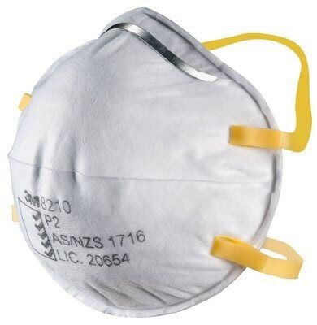
Respirators are specifically designed to protect the wearer from breathing in fine airborne particles, such as those in smoke or dust. Respirators may be disposable or reusable. The information in this factsheet refers only to disposable respirators. Respirators include the commonly known P1, P2 and N95 respirators and a range of other, less common international varieties.
Respirators, can, to varying degrees, filter fine particles called PM_{2.5}, which measure 2.5 micrometres in diameter (about 25 times smaller than the diameter of a hair). These fine particles are one of the harmful components of smoke. Used properly, P2 and N95 respirators can filter 94% and 95% of PM_{2.5} fine particles respectively. P1 respirators filter approximately 80% of fine particles and are therefore more suitable for hazards such as dust.
A respirator must be fitted properly to filter fine particles. This means it should be sealed over the mouth and bridge of the nose with no gaps between the mask and face. This will avoid those particles going around the sides of the mask and into the lungs. Men should be clean shaven to get a good facial seal. A fit guide can be found on the Guidelines for use of face masks factsheet, available from the Health.Vic website: https://www2.health.vic.gov.au/about/publications/Factsheets/bushfire-guidelines-use-face-masks.
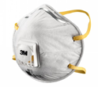
Respirators can be hot and uncomfortable and can make it hard to breathe normally. As the respirator becomes loaded up with particles, it will become less effective. The length of time they are effective will vary depending on the level and duration of exposure to the hazard. If you notice difficulty breathing, remove yourself from the hazard and remove your respirator. If you are still having difficulty breathing, seek medical advice.
Some respirators have valves fitted to make it easier for the wearer to breathe out through the mask and to prevent heat build-up. However, this means respirators with valves can’t be used when infection control is important because the valve allows droplets and aerosols exhaled by the user to escape into the surrounding air, exposing other people. The valves do not affect the respirator’s ability to filter incoming particles.

Certification
In Australia, disposable respirators are required to be certified to Australian Standard AS/NZS 1716:2012. These details may be printed on the respirator and should be on the packaging. Some respirators for sale in Australia have been certified using international standards and will have different classification codes. Make sure a respirator is certified to one of the following standards before purchasing:
- AS/NZS 1716:2012
- NIOSH-42 CFR84
- EN 149:2001
- GB2626-2006

Loose-fitting masks
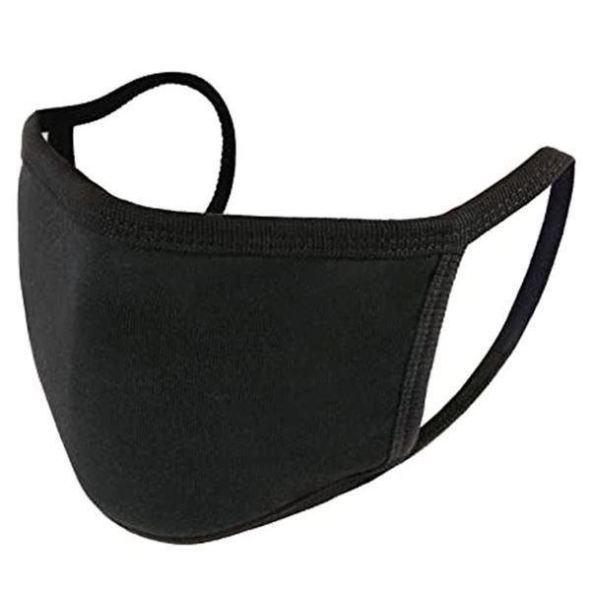
These masks do not provide adequate protection against the environmental hazards listed above as they are not made from suitable materials and don’t provide a good facial seal. However, they help prevent the spread of airborne viruses such as COVID or influenza from the person wearing the mask to others. For information about masks and COVID-19 go to https://www.coronavirus.vic.gov.au/face-masks.

Cloth masks
Cloth face masks do not form a facial seal like respirators. They are homemade or commercially available and include those sold by fashion retailers. These masks have not been certified according to a regulatory standard unless otherwise specified by the manufacturer.

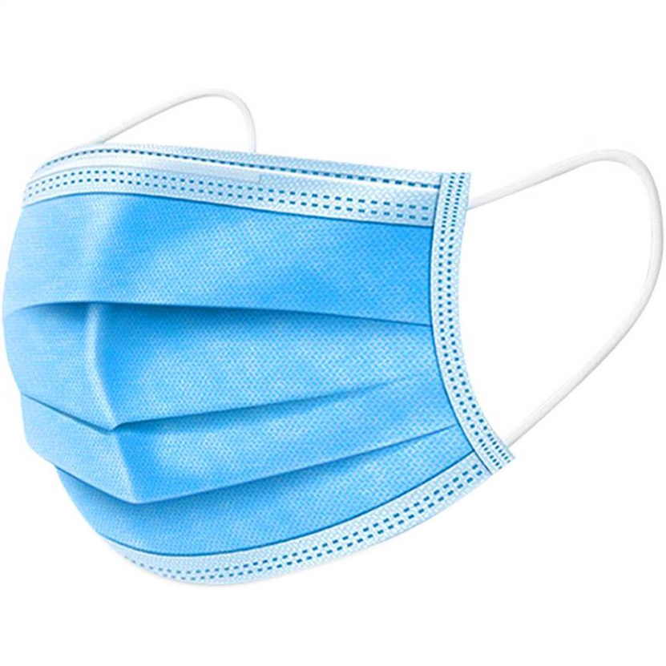
Surgical masks
Surgical masks do not form a facial seal like respirators. They are disposable and are designed for use in medical and surgical settings. Surgical masks must be certified to Australian Standard 4381:2015.

Some important tips to remember:
- Before purchasing, check that the respirator is certified.
- A respirator must be fitted properly to be effective in filtering out fine particles.
- Avoid touching the front of the mask or respirator while wearing it.
- Respirators should only be worn for a few hours, or less if they become moist, wet, soiled, or difficult to breathe through. Be prepared and have enough respirators available for the task.
- Replace single-use masks or respirators after each use.
- Dispose of masks or respirators if they are damaged in any way. For example, if the straps are broken or the fabric is torn.
- Respirators are not designed for children.
- Consider seeking medical advice before using a respirator if you have a pre-existing heart or lung condition.

To receive this document in another format, phone 1300 761 874 or email <environmental.healthunit@health.vic.gov.au>.
Authorised and published by the Victorian Government, 1 Treasury Place, Melbourne.
© State of Victoria, Australia, Department of Health, September 2021.

Available at <https://www2.health.vic.gov.au/public-health/environmental-health>

