Mental Health Carer Support Fund guidelines
July 2020

To receive this publication in an accessible format email Lived Experience Engagement <lived-experience-engagement-team@dhhs.vic.gov.au>.
Authorised and published by the Victorian Government, 1 Treasury Place, Melbourne.
© State of Victoria, Australia, Department of Health and Human Services, July 2020.
ISBN 9780731173020 (online/PDF/Word). First issued August 2017. Reissued July 2020
Available on health.vic – Consumer and carer financial support <https://www2.health.vic.gov.au/mental-health/working-with-consumers-and-carers/financial-support-consumers-carers>
(2008776 – figures)

Contents
Carer Support Fund overview 5
Aim 5
Objective 5
Governance 5
Roles and responsibilities 6
Independent advisory group terms of reference 8
Meeting specifics 8
Who can access the fund? 11
Eligible beneficiaries 11
Ineligible applicants 11
Priority applications 11
Other funding sources, concessions and benefits 12
Expenses covered under the fund 13
Exclusions 14
Assessing requests 14
Payment caps 15
Carer applications 15
Caps on voucher applications 15
Voucher policy 16
Voucher applications 16
Voucher distribution to carers 16
Voucher reporting 16
AMHS procedures for processing applications 18
Tandem procedures for processing applications 18
Overspend and underspend policy 20
Complaints policy 21
Appendix 1: Voucher distribution record template 22
Appendix 2: Voucher accountability guide 23
Appendix 3: Transcript of Figure 3 24
Required governance arrangements for AMHS (local CSF administrator) 24

Carer Support Fund overview

Aim
The aim of the Mental Health Carer Support Fund (CSF) is to help carers in their role of caring for a person who is receiving services from a public area mental health service (AMHS) in Victoria.

Objective
The CSF will assist carers by providing financial support to:
- reduce the costs associated with the caring role
- support the carer’s own health and wellbeing.

Governance
Figure 1 outlines the CSF’s governance structure. Within this structure, carers receive CSF financial support. AMHS, as local CSF administrators, submit online applications on behalf of carers (with their involvement). The central CSF administrator processes these applications and distributes financial support.
Figure 1: Structure of the Carer Support Fund
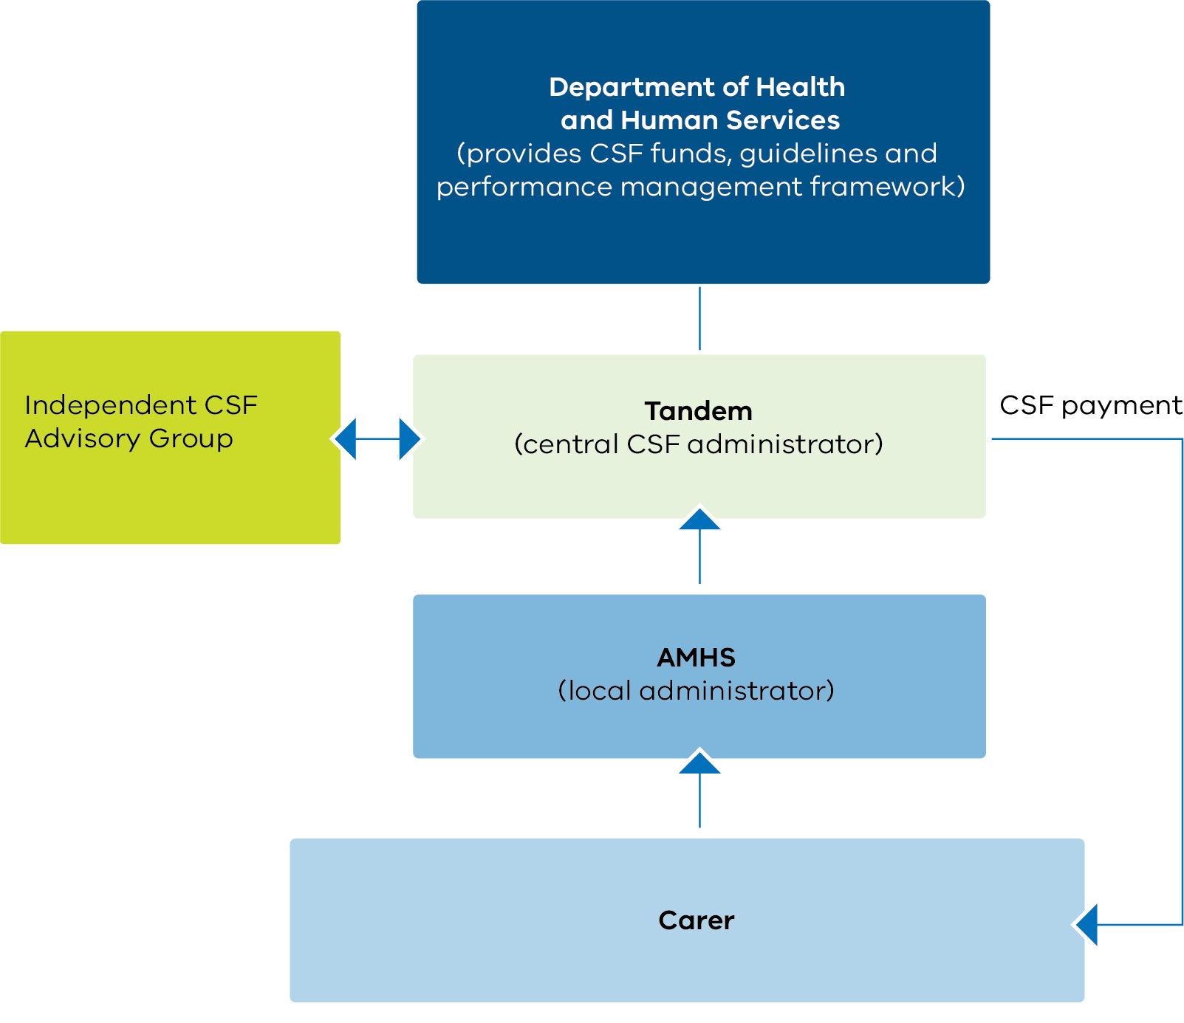

Roles and responsibilities
The four key parties of the CSF are:
- AMHS (as local CSF administrators)
- Tandem (as the central CSF administrator)
- the Independent CSF Advisory Group
- the Department of Health and Human Services.
AMHS, as local CSF administrators, are responsible for establishing an internal committee of registered CSF approvers. This committee is led by a coordinator and includes carer consultants to:
- raise awareness of the CSF among mental health staff, carer consultants and carers
- assist case managers and other AMHS staff with the registration process
- review and monitor CSF applications, approvals and expenditure
- inform the CSF central administrator about budget issues or if the AMHS anticipates restrictions on applications as a result of budget shortage
- maintain an electronic voucher distribution record (see Appendix 1)
- establish a local appeal process at the AMHS consistent with the CSF guidelines, and process external appeals through Tandem, as appropriate
- provide support to carers to engage in the CSF application process
- promote the online CSF application system
- ensure compliance with CSF guidelines
- inform the central CSF administrator (Tandem) of relevant CSF contacts at the AMHS (that is, the CSF coordinator and registered CSF approvers) and maintain a list of approvers
- ensure carer consultants are involved in the management, decision making and administration of the CSF committee.
Tandem, as central administrator of the CSF, is responsible for:
- administering the CSF equitably, responsibly and transparently, in accordance with the department’s CSF guidelines
- coordinating, chairing and minuting quarterly Independent CSF Advisory Group meetings
- supporting independent CSF appeal processes via the advisory group
- ensuring appropriate representation on the advisory group
- identifying and addressing gaps in promoting the CSF to carers, carer consultants and AMHS
- timely communication with AMHS about annual CSF allocations
- supporting Victorian AMHS to implement the CSF, including registering AMHS staff to prepare an application and training to use the online CSF application
- providing detailed monthly, quarterly and annual CSF expenditure reports to AMHS, identifying overspend and underspend issues quarterly
- maintaining the online CSF system
- maintaining positive working relationships with Victorian AMHS
- participating in quarterly CSF meetings with the department about administering the CSF
- providing timely quarterly reports to the department on CSF administration, and annual expenditure reports
- raising issues about budget and/or expenditure in a timely manner:
  - seeking clarifications from the department, in writing, to inform decision making
  - responding to requests from the department about administering the CSF.

The Independent CSF Advisory Group is responsible for:
- meeting quarterly to monitor and to provide input, ideas and feedback about CSF administration
- offering advice to the department on emerging issues affecting the uptake and administration of the CSF
- reviewing and resolving CSF appeals escalated to the group. (A minimum of three group members
(excluding Tandem representatives) will manage appeals and a majority decision will apply. Appeals will be completed within 14 days and can be processed out of session.)
The department funds the CSF and is responsible for:
- providing funding to the central CSF administrator for timely administration of the CSF
- observing the Independent CSF Advisory Group (as a non-voting member)
- providing CSF guidelines that articulate:
  - the aims and objectives of the CSF
  - governance arrangements for the CSF, including the roles and responsibilities of key parties
  - administrative processes including funding criteria, carer eligibility and reporting arrangements
- timely communication to the central administrator about AMHS allocations
- helping to promote the CSF to carers, carer consultants and AMHS.

Independent advisory group terms of reference
The CSF helps carers in their role of caring for a person who is experiencing mental ill-health.
The fund helps carers by providing financial support to reduce the costs associated with the caring role and to support the carer’s health and wellbeing.
The purpose of the Independent CSF Advisory Group is to provide advice and guidance in relation to CSF administration.
Membership of the advisory group includes:
- two representatives of Tandem including CSF administration staff
- two AMHS representatives (one rural, one metropolitan)
- two carer workforce representatives (one rural, one metropolitan)
  - one carer representative
  - one departmental representative (as a non-voting observer).
Advisory group members will:
- meet quarterly to monitor and support the administration of the CSF
- provide input, ideas and feedback about administering the CSF
- offer advice to the department on emerging issues affecting the uptake and administration of the CSF
- receive updates and monitor the number of CSF applications, appeals and expenditure
- review and resolve CSF appeals escalated to the advisory group:
  - A minimum of three advisory group members will manage appeals (excluding Tandem representatives).
  - Appeals will be processed out of session and completed within 14 days.
  - A majority decision will apply to appeals.
  - The CSF manager will be notified of the outcome of appeals and the rationale.

Meeting specifics
- Independent CSF Advisory Group meetings will be held quarterly, with a quorum of four (not including the departmental observer).
- Teleconference opportunities will be provided to members wherever possible.
- Tandem will provide secretariat support to the meetings including minute-taking. Tandem will circulate the minutes to members and the department within a fortnight of each meeting.
- Where appropriate, the carer representative should be offered reimbursements in line with the Victorian Government’s Appointment and remuneration guidelines <https://www.vic.gov.au/guidelines-appointment-remuneration>.
Figure 2 shows the required governance arrangements for Tandem.
Figure 2: Required governance arrangements for Tandem (central CSF administrator)
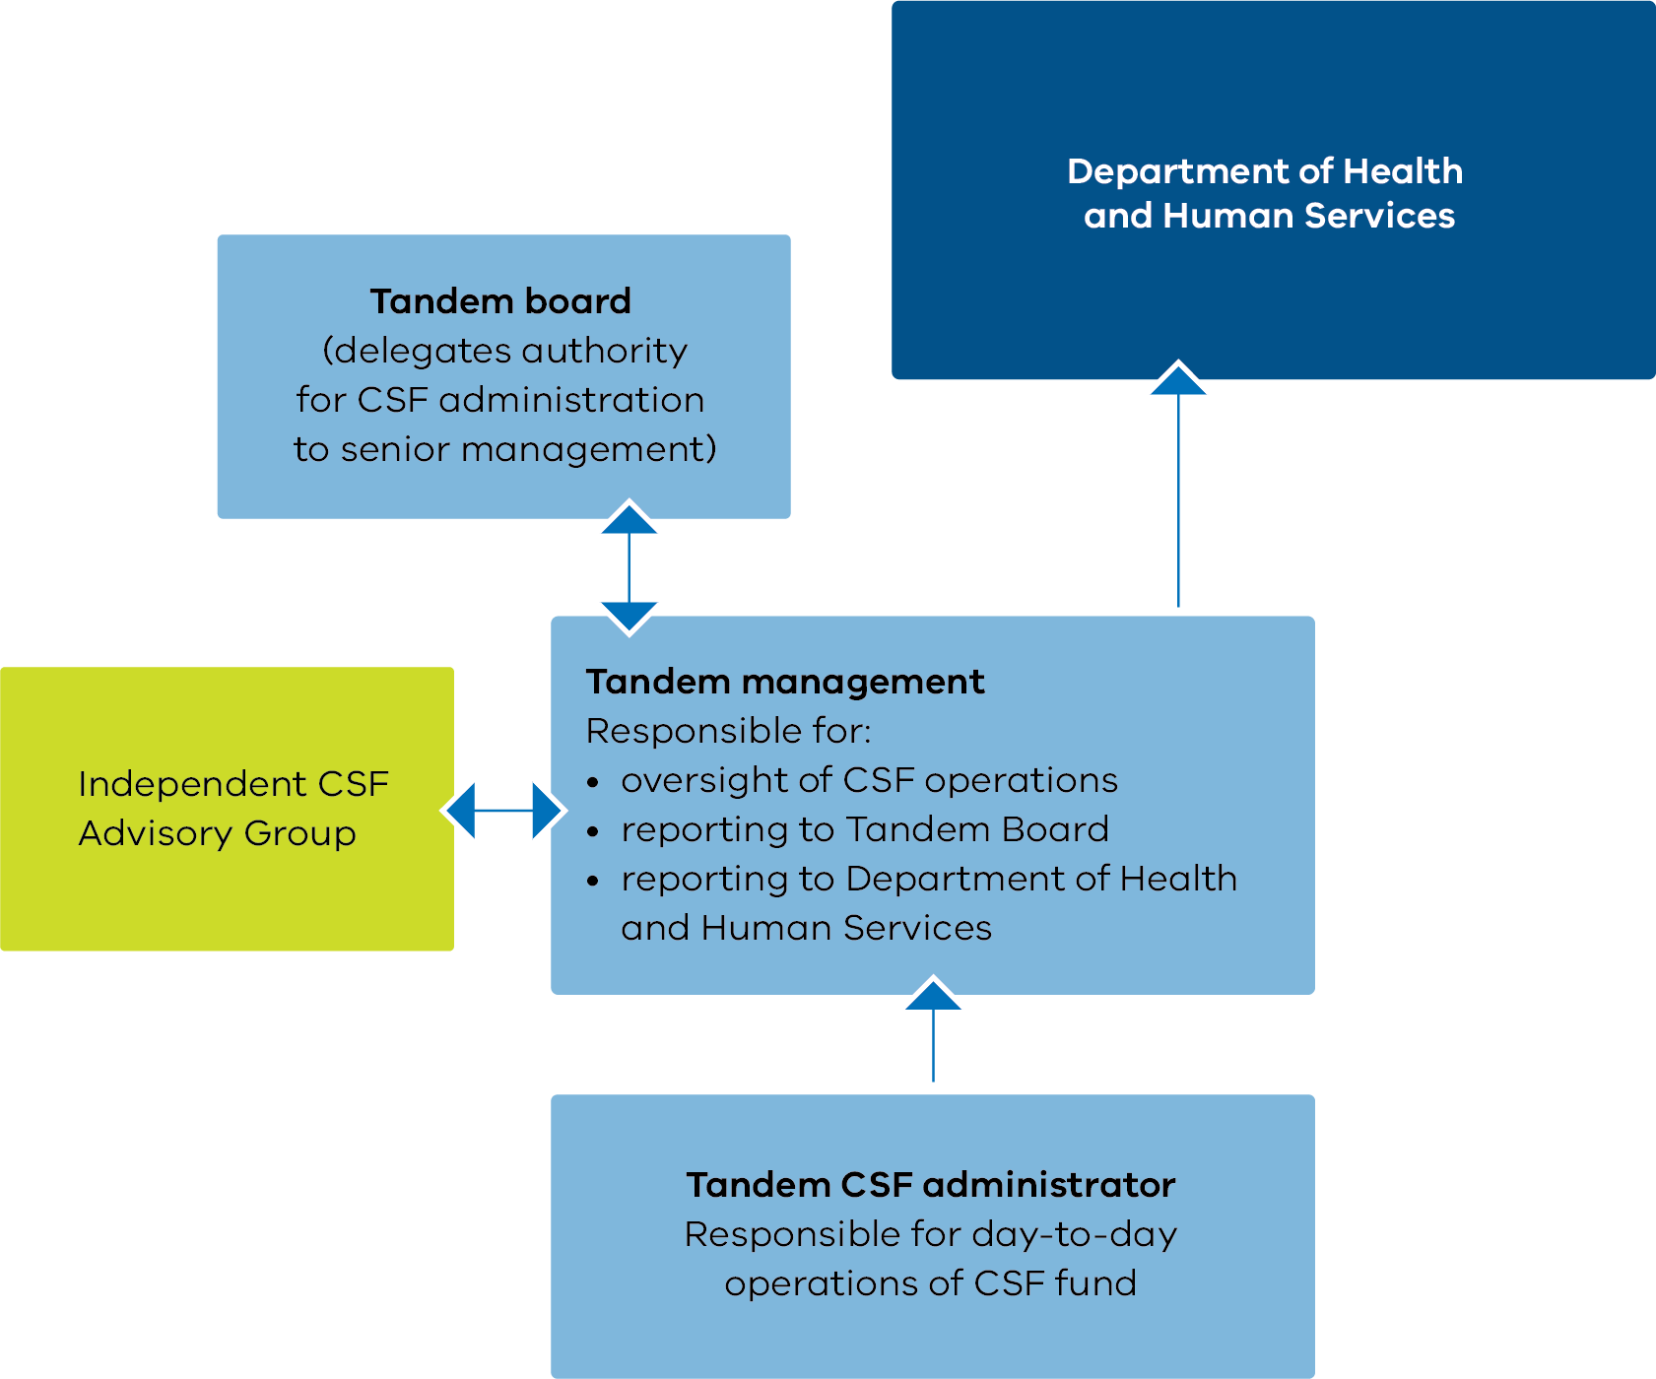

Figure 3 shows the governance arrangements for AMHS.
Figure 3: Required governance arrangements for AMHS (local CSF administrator)
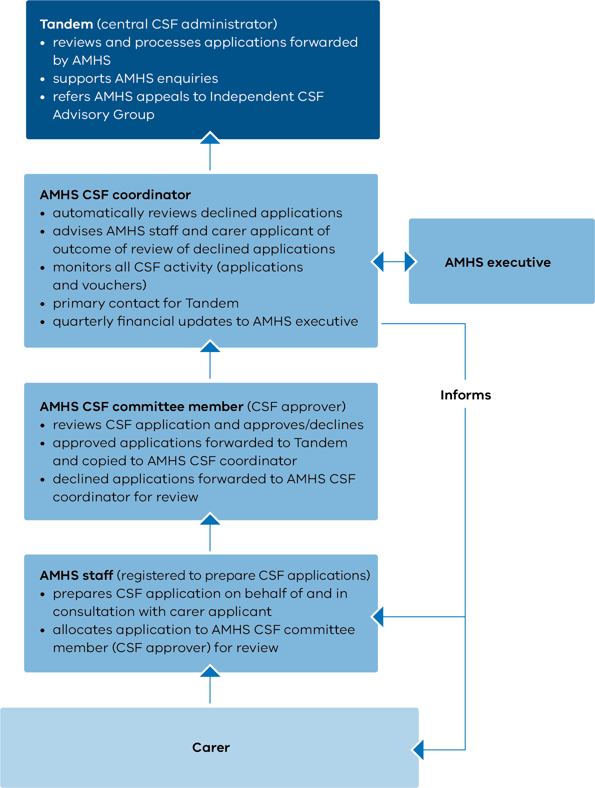

Who can access the fund?

Eligible beneficiaries
CSF beneficiaries must be carers (see definition in footnote on p. 1) of a person who is receiving services from a Victorian public mental health service or program, identified via their statewide UR number. Multiple applications are accepted, up to a limit of $1,000 (excluding GST) per applicant per year (see ‘Payment caps’ section).
Applications may also benefit the person with the mental illness, provided the carer is the main beneficiary.
Eligible workers may make applications on behalf of families and carers they are supporting. Eligible workers include:
- clinicians
- carer peer workers
- carer consultants.

Ineligible applicants
A person employed to care for a client is not eligible to access the CSF. Examples include:
- disability support workers
- personal care attendants
- staff from supported residential services and rooming houses.

Priority applications
Priority processing of CSF applications may be warranted in specific cases of carer need. AMHS might prioritise cases where the CSF application is urgent (for example, if electricity is about to be cut off or if a carer does not have food available).
In prioritising CSF applications, AMHS should consider:
- periods of heightened carer need, such as consumer admission or instability
- previous CSF payments to the carer and consumer
- the principles of fairness and equity.
AMHS may also need to consider prioritising applications in times where available funds are low. During these periods, applications for basic life needs should be prioritised over others.
Note: Should the available funding become limited, the CSF central administrator should be informed.

Other funding sources, concessions and benefits
A range of concessions <https://services.dhhs.vic.gov.au/concessions-and-benefits> are available to all Victorians on an low income or experiencing hardship who need help meeting the cost of living.
The Utility Relief Grant Scheme <https://services.dhhs.vic.gov.au/utility-relief-grant-scheme> and the Non-Mains Utility Relief Grant Scheme <https://services.dhhs.vic.gov.au/utility-relief-grant-scheme-non-mains> provide assistance for domestic customers who cannot pay their utility bills due to temporary financial difficulties.
A small, specific trust fund called the Psychiatric Illness and Intellectual Disabilities Donations Trust Fund <https://www2.health.vic.gov.au/about/publications/policiesandguidelines/Psychiatric-Illness-and-Intellectual-Disabilities-Donations-Trust-Fund-PIIDDTF-general-guidelines> benefits consumers who are receiving case management support from designated AMHS. Applications are via the case manager.

Expenses covered under the fund
Table 1 lists the expenses that the CSF may cover. However, expenses must relate to the caring role and to supporting the carer’s health and wellbeing.
Table 1: Expenses covered by the Carer Support Fund
Eligible CSF expenses | Examples
Accommodation | Accommodation costs associated with visiting the consumer in hospital or accompanying to medical appointments
Carer conference, education/training and meeting expenses | Carer conference and training registration fees and expenses (note exclusions below) for non-paid carers (this excludes carers in lived experience positions applying as part of their work role or those providing care on a fee-for-service basis)
Clothing and shoes | As identified by carer
Food and groceries | As identified by carer
Funeral expenses | Or part thereof, as related to the consumer’s funeral
Health and wellbeing expenses | These can include physical, dental, optical, mental health and pharmacy expenses  Short-term counselling for a carer provided by a practitioner outside the mental health service to address the emotional and relationship impacts of caring for someone with a mental illness  Wellbeing activities for carers, either individually or in groups, to access yoga, meditation, sport, art, music or other social/recreational activities to support their personal wellbeing
Household items | Bedding, electrical appliances, white goods, computers (including hardware, internet fees, software)
Household repairs and maintenance | Cleaning, lawn mowing, repairs
Household utility bills and rates | Includes telephone (mobile and landline fees, rental), gas, electricity, water and rates
Insurances | Includes health, home and contents, income, Ambulance Victoria membership and charges
Rent/mortgage payments | For the family home
Respite expenses | Opportunities for carers to have a break from the caring role (can include support in the home or in the community)
Sitting fees | Until the end of December 2020, sitting fees will be paid for carers who participate as carer representatives on advisory groups as part of the local service participation  From 1 January 2021, sitting fees cannot be paid by the fund – these fees should be paid for by the service as part of their consumer carer participation
Transport | Airfares or train, bus, tram, taxi or other transport costs associated with visiting the person in hospital or accompanying them to medical appointments
Vehicle expenses | Insurance, repairs, registration, petrol
Vouchers | Vouchers including taxi petrol vouchers, store cards and movie tickets  Voucher caps apply to carers, consumers and larger AMHS – refer to CSF voucher policy
Where an initial application has been unsuccessful, applications may be revised and resubmitted. Carers and staff should ensure such applications fall clearly within the CSF guidelines.

Exclusions
The fund may not be used:
- to fund expenses beyond the eligible CSF expenses (identified in Table 1)
- to fund a service or activity already funded by the department or the Commonwealth
- to fund costs covered by other material aid providers (see the department’s list of Individual Assistance Available in Victoria <http://www.dhs.vic.gov.au/for-individuals>)
- for services that are the responsibility of the AMHS
- to benefit consumers only
- for items or activities arising from criminal activity or in breach of the law
- to fund carers employed by mental health services to attend professional development activities or work-related conferences (this type of expense is the responsibility of the AMHS).
Note, however, that the fund may be used to fund applications to attend a carer-directed event where the carer will be attending for their personal benefit as a carer.

Assessing requests
As CSF funds allocated to AMHS are limited, the following considerations may assist in assessing requests:
- Has the availability of other funding sources been considered?
- Do the goods or services assist the carer in relation to their caring role and in supporting their health and wellbeing?
- Does the assistance meet an immediate need or avert a potential crisis?
- Are the goods or services of reasonable standard and cost?
- Is the application within the recommended carer cap, consumer cap and AMHS cap? (see CSF payment caps below).
Should an AMHS’s overall CSF funds be fully allocated, the AMHS should contact the CSF administrator at Tandem.

Payment caps

Carer applications
CSF applications from individual carers have a recommended cap of $850 per application. AMHS may apply a lower cap. Apart from exceptional circumstances, applications for carers must not go over $1,000 in a financial year.
If a carer is responsible for more than one consumer, they are eligible for $1,000 per financial year for each consumer.
Where there are multiple carers for a single consumer, the upper limit of $1,000 applies per consumer each financial year (see details in Table 2).
The local AMHS CSF coordinator is responsible for ensuring compliance with the carer cap. Services may apply lower caps to maximise funds reach across the year.
Tandem will also oversee compliance.
Table 2: Annual caps for carer payments
Carer status | Cap per year
Carer of a mental health consumer | $1,000 excluding GST
Carer of multiple mental health consumers | $1,000 per consumer excluding GST
Multiple carers of a mental health consumer (the $1,000 will be divided between those carers who provide support to the one consumer family member or friend) | $1,000 per consumer excluding GST
Carer claims over $850 per application will be considered when exceptional circumstances are documented. Written information supporting the circumstances must be included with the application. AMHS staff should prepare this statement in consultation with carers.
AMHS approve applications with exceptional circumstances. Part or full payment of the application over the $850 limit should be assessed according to what is reasonable and along normal decision-making lines. Appeals against AMHS decisions should be directed to the AMHS and, if needed, escalated to the central administrator.
AMHS may reduce the cap to manage expenditure throughout the year. AMHS should discuss this with the central CSF administrator before doing so. The central CSF administrator should raise this as an issue at the next Independent CSF Advisory Group meeting.

Caps on voucher applications
AMHS may pre-purchase CSF vouchers to distribute to carers. AMHS applications for CSF vouchers must not exceed 50 per cent of the AMHS annual allocation. Tandem will calculate this amount for each AMHS and advise services accordingly. Services receiving an annual allocation under $3,500 are exempt from this cap.
AMHS are responsible for monitoring voucher distribution within the 50 per cent cap. AMHS must record every voucher distribution using the template provided in Appendix 1. This is in line with the voucher policy outlined in the next section of these guidelines. Before distributing vouchers to carers, AMHS should check that caps have not been exceeded for the individual carer or primary consumer (identified by the statewide UR number). Tandem monitors compliance with voucher caps.

Voucher policy
The CSF voucher policy outlines the core features of voucher application, distribution and reporting.

Voucher applications
- CSF vouchers include taxi and petrol vouchers, movie tickets and store gift cards, among others.
- AMHS may pre-purchase CSF vouchers for carers.
- AMHS applications for CSF vouchers are capped at 50 per cent of AMHS annual allocation.
- Tandem will calculate AMHS voucher caps and advise individual services accordingly.
- Individual AMHS must comply with voucher caps. Tandem will oversee compliance. Tandem will provide quarterly reports to the department.
- End-of-year voucher applications for unexpended annual AMHS allocations will only be supported where they represent less than 10 per cent of the annual AMHS allocation.

Voucher distribution to carers
- AMHS must distribute vouchers to carers at the point of service.
- Before distributing vouchers to carers, AMHS should check that caps have not been exceeded for the individual carer or primary consumer (identified by the statewide UR number).
- Appendix 2 outlines the process for voucher accountability.

Voucher reporting
- AMHS must record all voucher distributions electronically (see Attachment 2 for a voucher distribution record template).
- By recording the consumer statewide UR number, AMHS will be able to monitor and comply with voucher caps for individual carers and consumers and ensure equitable distribution of funds.
- The voucher distribution record must be submitted to Tandem (the central CSF administrator) at the end of each quarter, to account for AMHS distribution of CSF vouchers.
- Tandem will collate and analyse voucher data to monitor organisational and statewide patterns of voucher use. Patterns of use will be reported to the department.
- AMHS should review their own voucher data to determine whether the distribution of CSF vouchers to carers is occurring fairly and equitably.
The CSF decision process is shown in Figure 4.
Figure 4: Carer Support Fund decision process
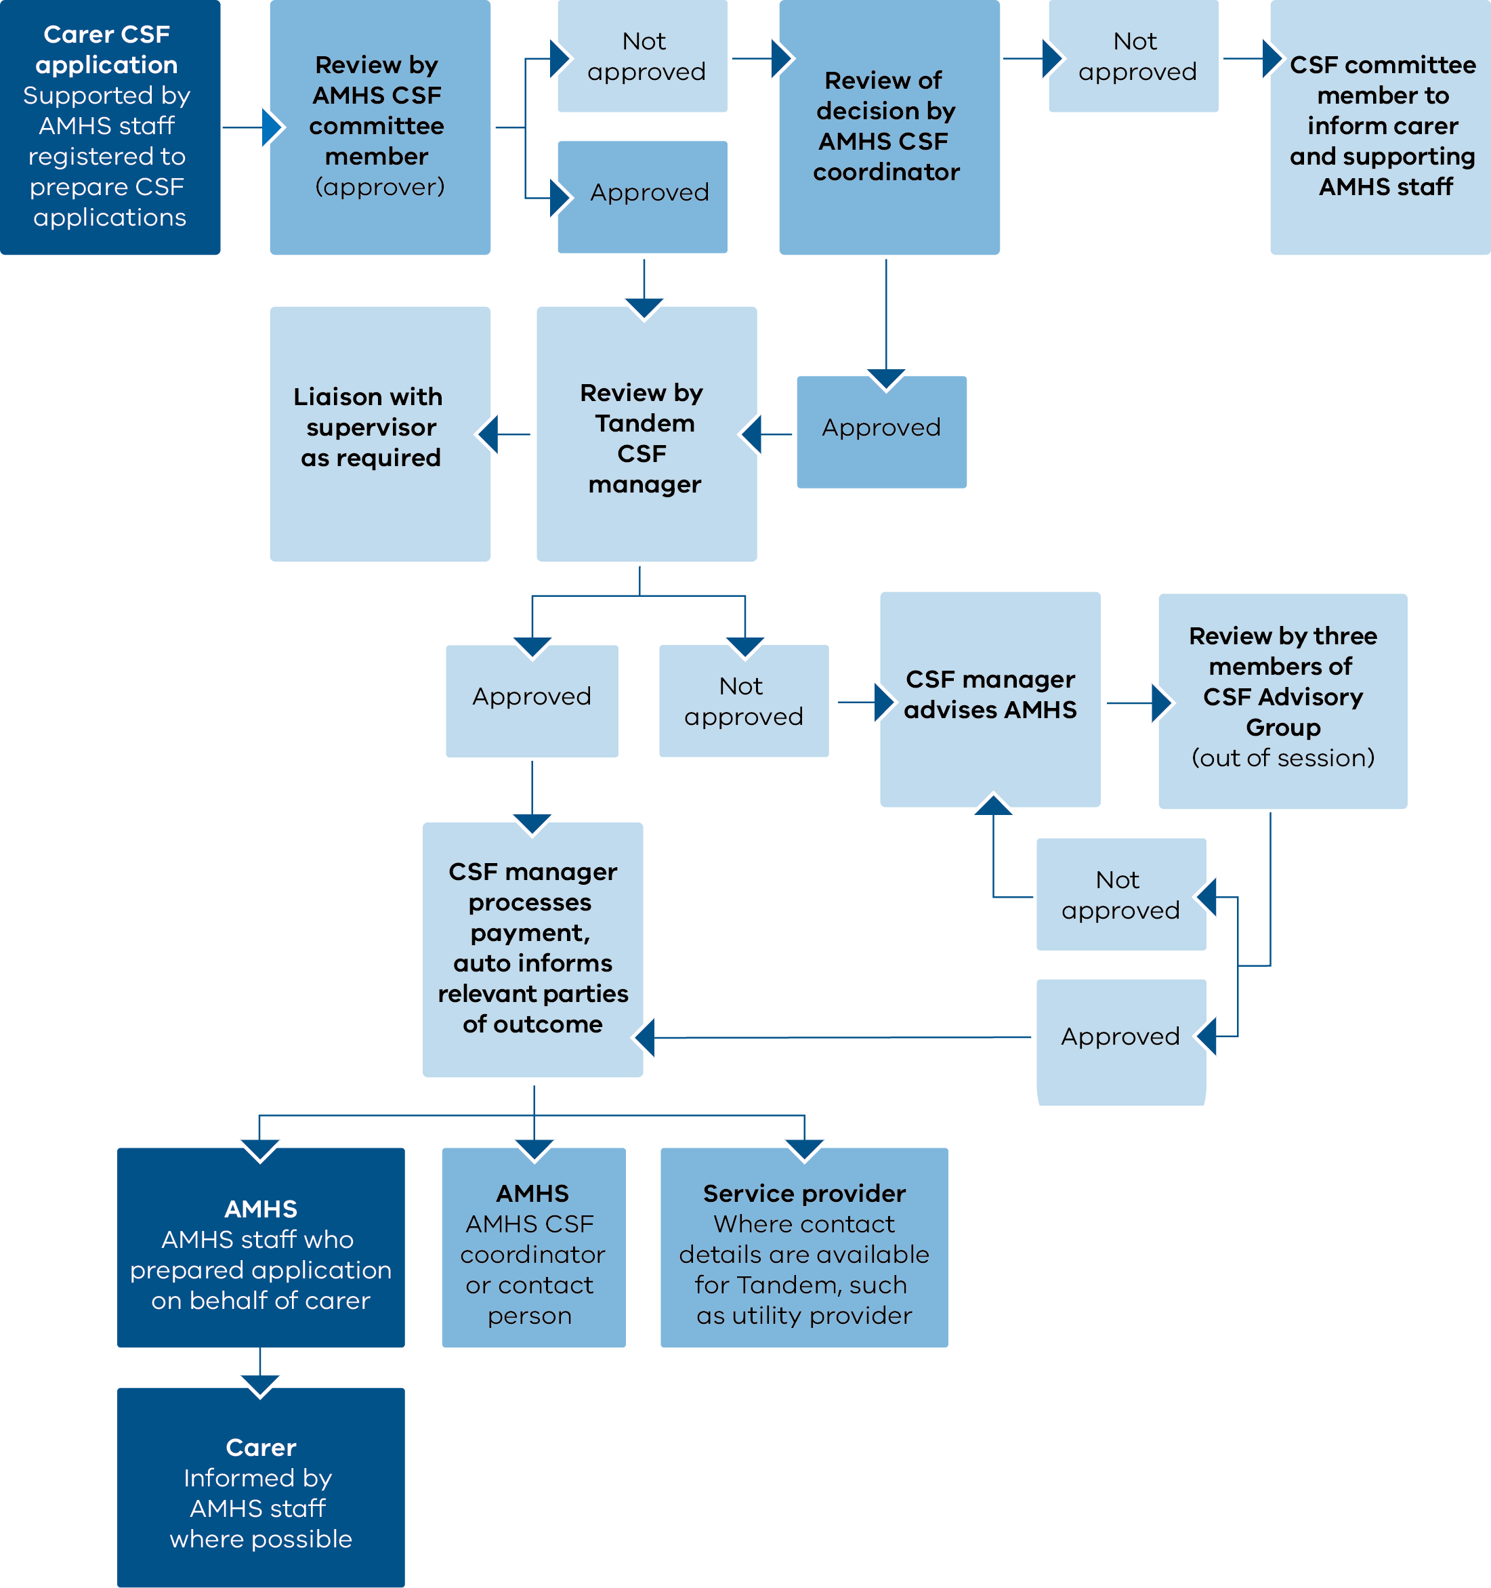

AMHS procedures for processing applications
AMHS will comply with the following procedure:
- AMHS staff registered to prepare CSF applications will do so on behalf of and in consultation with carers via an online application <https://carersupportfund.tandemcarers.org.au/dotnetnuke/>.
- Staff will submit CSF applications to a CSF committee member (approver).
- The CSF committee member will review the application against CSF eligibility criteria, relevant funding caps and available funds.
- The CSF committee member will approve/decline the application within 10 working days of receiving the application (via hard copy or online).
- Where approved, the committee member will:
  - forward the application to Tandem (the central CSF administrator) for processing
  - provide a courtesy copy to the CSF coordinator
  - advise the staff member who prepared the CSF application, who will in turn inform the applicant.
- Where the application is declined, the committee member will refer the application and feedback to the AMHS CSF coordinator for review.
- The AMHS CSF coordinator will review and approve/decline.
- The AMHS CSF coordinator will provide feedback to the committee member and relevant staff member on the outcome of their review.
- The relevant staff member will inform the applicant of the outcome.
The CSF coordinator is responsible for declaring and managing conflicts of interest that might arise.

Tandem procedures for processing applications
Tandem, as the central CSF administrator, will:
- respond to enquiries and issues within five working days
- receive CSF applications online
- review submitted applications against eligibility criteria and required fields, and approve/decline applications within 10 working days of receiving the application
- advise AMHS when data fields (such as banking details) are missing or incomplete (the AMHS may have to resubmit)
- where approved:
  - process payments for approved applications within 10 working days of receiving the application from the AMHS
  - advise AMHS (the local administrator) of the outcome of application within 10 working days
- where not approved, provide written advice to the relevant AMHS that the application was unsuccessful, provide feedback and note that:
  - revised applications that clearly comply with CSF guidelines may be processed as usual by the AMHS via the CSF coordinator
  - appeals against a Tandem decision should be submitted by AMHS in writing to the central administrator
- where an appeal is lodged:
  - forward the application and decision feedback to three members of the Independent CSF Advisory Group (excluding Tandem representatives) for review and resolution within 14 working days
  - resolve appeals out of session, where necessary
  - apply a majority decision
  - notify the central CSF administrator of the outcome of appeals and inform the AMHS
  - where the application is successful, process the CSF payment within three working days.
The central administrator and Independent CSF Advisory Group will declare and manage any conflicts of interest that might arise regarding relationships between carer applicants and CSF decision-makers (Tandem and Independent CSF Advisory Group members).
The CSF payment pathway is depicted in Figure 5.
Figure 5: Carer Support Fund payment pathway
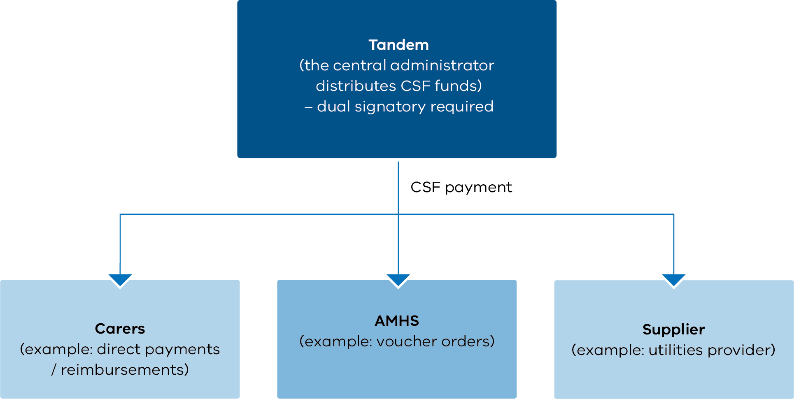

Overspend and underspend policy
AMHS hold primary responsibility for managing their CSF expenditure. This includes managing and monitoring CSF underspend and overspend throughout the financial year. The following applies:
- AMHS must monitor their cumulative CSF expenditure for over- and under-expenditure.
- The central administrator (Tandem) will provide monthly, quarterly and annual expenditure statements to AMHS to assist with monitoring.
- The central administrator will also provide quarterly written advice to AMHS that are tracking at more than 30 per cent above or below expenditure during the financial year. Tandem should raise this as an issue for the Independent CSF Advisory Group.
- If AMHS have an underspend of more than 30 per cent at any point during the year, they must ensure the full and equitable disbursement of the CSF to carers by financial year’s end. Should these funds not be fully expended, remaining budget is to be returned to Tandem for reallocation. Tandem can provide advice and support regarding underspend issues.
- AMHS may not exceed their annual CSF allocation. Tandem will not process CSF applications beyond the annual allocation. AMHS should ensure CSF applications fall within available budget allocations.

Complaints policy
Complaints and concerns about local AMHS administration of the CSF may be directed to:
- the AMHS in the first instance
- Tandem as the central administrator, if required, on (03) 8803 5504 or email the CSF administrator <csf@tandemcarers.org.au>.
Complaints about the centralised Tandem administration of the CSF may be directed to:
- Tandem on (03) 8803 5504 or email the CSF administrator <csf@tandemcarers.org.au>
- the Independent CSF Advisory Group via the Tandem chief executive officer on (03) 8803 5555.
More information about the Mental Health Carer Support Fund is available from Tandem:
- Tandem website <www.tandemcarers.org.au>
- email the CSF Administrator <csf@tandemcarers.org.au>
- call (03) 8803 5504.

Appendix 1: Voucher distribution record template
Area mental health services must keep records of their voucher distribution to monitor whether the distribution of CSF vouchers to carers is occurring fairly.
AMHS are responsible for monitoring voucher distribution within cap, if applicable. Before distributing vouchers to carers, AMHS should check that the individual carer/family cap has not already exceeded their annual cap. Tandem will oversee cap compliance.
AMHS must record every voucher distribution electronically using, at a minimum, the template provided below.
At the end of each quarter, AMHS must provide voucher distribution records to Tandem (the central CSF administrator). Tandem will collate and analyse this data to monitor organisational and statewide patterns of voucher use. Patterns of use will be reported to AMHS and the department quarterly and annually.
Submit this voucher record quarterly by emailing the CSF administrator <csf@tandemcarers.org.au>.
For phone enquiries, call (03) 8803 5504.
AMHS name:

Date | Carer name (first name, surname) | Consumer UR number | Voucher for… (for example, petrol, groceries, taxi) | Voucher value ($) | Tandem notified of voucher receipt (triggers activation) | Carer signed for voucher  Y/N

Appendix 2: Voucher accountability guide
Area mental health service CSF coordinators will receive their vouchers via Australia Post. The vouchers are bundled by type, with a copy of the CSF voucher application and a packing slip detailing the individual vouchers by type and serial number.
The applicant will also receive an email advising of the dispatch, including the tracking number and CSF application number(s). A soft copy of the packing slip will be attached to the email.
On receiving the parcel the AMHS must:
- open and review the contents as soon as possible
- check the individual vouchers, ticking each one off in the ‘Received’ column of the packing slip
- notify the Tandem CSF administrators via email that the package has been received and all is correct
  - Tandem will then activate the vouchers and confirm once activation is complete
  - AMHS staff will distribute the vouchers to carers only after receiving confirmation from Tandem that the vouchers have been activated
- keep the packing slip to be marked off as vouchers are distributed to carers
- return the completed packing slip to Tandem at the end of each quarter via email.

Appendix 3: Transcript of Figure 3

Required governance arrangements for AMHS (local CSF administrator)
Tandem (central CSF administrator)
- reviews and processes applications forwarded by AMHS
- supports AMHS enquiries
- refers AMHS appeals to the Independent CSF Advisory Group
AMHS CSF coordinator
- automatically reviews declined applications
- advises AMHS staff and carer applicant of declined applications
- monitors all CSF activity (applications and vouchers)
- primary contact for Tandem
- quarterly financial updates to AMHS executive
AMHS CSF committee member (CSF approver)
- reviews CSF application and approves/declines
- approved applications forwarded to Tandem and copied to AMHS CSF coordinator
- declined applications forwarded to AMHS CSF coordinator for review
AMHS staff (registered to prepare CSF applications)
- prepares CSF application on behalf of and in consultation with carer applicant
- allocates application to AMHS CSF committee member (CSF approver) for review
The AMHS executive interacts with the AMHS coordinator.
The AMHS coordinator informs AMHS staff and the carer.

A carer is a family member, partner or friend whose primary relationship with a person with a mental illness is a supportive, caring relationship.
Registered mental health consumers are identified by a statewide unit record (UR) number, generated via the Client Management Interface / Operational Data Store (not a local hospital UR number).
AMHS staff can register to prepare online applications by contacting Tandem and providing relevant supporting details.

